SIL Verification Summary

Hybrit Pilot Plant

REV | DATE | APPROVED | DESCRIPTION OF CHANGE
 | 4/24/2022

Automatically generated by ProSa

Table of Contents
1 Purpose and Scope 7
1.1 General Project Information 7
2 SIF-001 SIL1 Low Pressure (254PI330|L1) nitrogen system, CO2 cleaning 8
3 SIF-002 SIL1 Low differential pressure (254PI330 / 347PI306) Nitrogen system 10
4 SIF-003 SIL1 High level (347LZ302) in Absorber (347YM100) 12
5 SIF-004 SIL2 Low level (347LZ300) in Absorber (347YM100) 14
6 SIF-005 SIL1 High level (347LS305) filter separator 347SE101 stop 346PU101 16
7 SIF-006 SIL1 Differential pressure treated gas - sour gas (347XI308)-> 347SV672 close and 347SV673 close 18
8 SIF-007 SIL2 High Temperature (347TI338) after lean MEA cooler close 347SV674 suction side MEA pumps 20
9 SIF-008 SIL1 High level (347LZ329 H1) in MEA reboiler (347HE201) close 347RV608 22
10 SIF-009 SIL2 Low differential pressure 347PD339 Pump discharge and absorber (347YM100) close 347SV671 lean MEA to Absorber 24
11 SIF-011 SIL2 Gastryck toppgas (320PZ320, 320PZ321 & 320PZ322|H2) 26
12 SIF-011 Beräkning av SIF-011 "open" 28
13 SIF-011 Beräkning av SIF-011 "close" 30
14 SIF-012 SIL2 Gastryck toppgas (320PZ320, 320PZ321 & 320PZ322|L2) 32
15 SIF-013 Gastryck toppgas (320PZ320, 320PZ321 & 320PZ322|H3) 34
16 SIF-015 SIL2 Temp toppgas (320TZ323, 320TZ324 & 320TZ325|H2) 36
17 SIF-016 SIL1 Temp överhettad ånga (271TI552|L2) 38
18 SIF-017 SIL1 Tryck överhettad ånga (271PI552|L2) Close Avstängningsventil 2 överhettad ånga till PGH (271SV556 SIL2) 40
19 SIF-018 SIL1 Tryck överhettad ånga friblåsning (271PI320 < (343PZ305/7/8 + 0,1 barg)) Permissive Avstängningsventil 2 överhettad ånga till PGH (271SV556 SIL2) 42
20 SIF-019 SIL2 Flöde reduktionsgas till PGH (343XI302|L2) 44
21 SIF-020 SIL2 Difftryck O2-transferline (251XI313) 46
22 SIF-021 SIL1 Gastryck transferline (344PZ321|L2) 48
23 SIF-022 SIL2 Tryckvakt O2-inj (251XI312 |L2) 50
24 SIF-023 SIL2 Flödesmätare O2 inj (251XI554|L2) 52
25 SIF-024 SIL2 Beräkning difftryck 253XI364|L1 (Skydd mot backflöde processgas till N2 och/eller O2 vid syrgasinjektion) 253XI364 = (2oo3(253PZ362, 253PZ363, 253PZ364) - 344PZ321) 54
26 SIF-025 SIL2 Gastemp transferline (344TZ316, 344TZ317 & 344TZ318|H2) 56
27 SIF-026 SIL3 Gastemp transferline (344TZ316, 344TZ317 & 344TZ318|L2) 58
28 SIF-027 SIL1 Temperatur konvektionsdel (344TZ303, 344TZ304 & 344TZ305|H2) 60
29 SIF-028 SIL1 Temperatur konvektionsdel (344TZ303, 344TZ304 & 344TZ305|L2) 62
30 SIF-029 SIL1 Temperatur strålningssdel (344TZ310, 344TZ311 & 344TZ312|H2) 64
31 SIF-031 SIL1 Tryck förbränningskammare (344PZ306, 344PZ307 & 344PZ308|H2) 66
32 SIF-032 SIL2 Flamvakt (344YS314|SG1) 68
33 SIF-033 SIL2 Gastemp transferline efter O2-inj (344TZ322, 344TZ323 & 344TZ324|H2) 70
34 SIF-034 SIL3 Gastemp transferline efter O2-inj (344TZ322, 344TZ323 & 344TZ324|L2) 72
35 SIF-035 SIL2 Difftrycksmätning över syreinjektionslans (344XI340_DEV|H2/L2) 74
36 SIF-036 SIL1 Gastryck N2 (253PZ362, 253PZ363 & 253PZ364|L2) 76
37 SIF-037 SIL2 Tryckvakt efter N2 bufferttank 253TA005 (253PZ323, 253PZ324, 253PZ325|L2) 78
38 SIF-038 SIL2 Hög vätskenivå WESP (345LI354/5/6|H2) 80
39 SIF-039 SIL2 Tryck efter WESP red. gaskrets (345PI361|H2) 82
40 SIF-040 SIL2 Tryck efter WESP processgaskrets (353PI361|H2) 84
41 SIF-041 SIL1 Temp kondensor reduktionsgas (345TI301|H2) 86
42 SIF-042 SIL1 Temp kondensor processgas (353TI301|H2) 88
43 SIF-043 SIL2 Skintemp förquench reduktionsgas (345TI307|H2) 90
44 SIF-044 SIL2 Skintemp quench reduktionsgas (345TI308|H2) 92
45 SIF-045 SIL2 Skintemp förquench processgas (353TI307|H2) 94
46 SIF-046 SIL2 Skintemp quench processgas (353TI308|H2) 96
47 SIF-047 SIL1 Flödesmätare till förquench reduktionsgaskrets (345FI305|L2) 98
48 SIF-048 SIL1 Flödesmätare till förquench processgaskrets (353FI305|L2) 100
49 SIF-049 SIL1 Hög Nivå kondesseparator inlopp red.gaskompressor (346LI300|H2) =>Trip red.gaskompressor (346PU101 SIL2) 102
50 SIF-050 SIL2 Gastryck inlopp red.gaskompressor (346PI304|L2) =>Trip red.gaskompressor (346PU101 SIL2) 104
51 SIF-051 SIL2 Gastemp eft. kylare red.gaskompressor (oberoende) (346TI410|H2) =>Trip red.gaskompressor (346PU101 SIL2) 106
52 SIF-052 SIL1 Hög Nivå kondensseparator utlopp red.gaskompressor (346LI311|H2) =>Trip red.gaskompressor (346PU101 SIL2) 108
53 SIF-053 SIL2 Lågt oljetryck red.gaskompressor (346PI334|L2) =>Trip red.gaskompressor (346PU101 SIL2) 110
54 SIF-054 SIL1 Hög Nivå kondensseparator inlopp proc.gaskompressor (354LI300|H2) =>Trip proc.gaskompressor (354PU101 SIL2) 112
55 SIF-055 SIL2 Gastryck inlopp proc.gaskompressor (354PI304|L2) =>Trip proc.gaskompressor (354PU101 SIL2) 114
56 SIF-056 SIL1 Hög Nivå kondensseparator utlopp proc.gaskompressor (354LI311|H2) =>Trip proc.gaskompressor (354PU101 SIL2) 116
57 SIF-057 SIL2 Lågt oljetryck proc.gaskompressor (354PI354|L2) =>Trip proc.gaskompressor (354PU101 SIL2) 118
58 SIF-058 SIL1 Syrehalt gasväg (345AZ362|H2) => Trip Högspänningsenhet (345EC015) 120
59 SIF-059 SIL2 Vätsketryck nedströms pump (345PI326 < (320PZ320/1/2 + 0,5 bar)) => Close Avblödning slamvatten(345SV566) 122
60 SIF-060 SIL2 Vätskenivå sludge tank (345LS310|H2) => Close Avstängning tillopp spolvatten (345SV634) 124
61 SIF-061 SIL2 Vätskenivå sludge tank (345LS312|L2) => Close Avblödning slamvatten (345SV566 ) 126
62 SIF-062 SIL2 Hög vätskenivå WESP (345LI354/5/6|H2) => Close Avstängning tillopp spolvatten (345SV634) 128
63 SIF-063 SIL2 Position avstängning venturihals (345SV520 & 345SV521) => Open avstängning venturihals(345SV522) 130
64 SIF-064 SIL2 Position avstängning venturihals (345SV520 & 345SV522) => Open avstängning venturihals(345SV521) 132
65 SIF-065 SIL2 Position avstängning venturihals (345SV521 & 345SV522) => Open avstängning venturihals(345SV520) 134
66 SIF-066 SIL2 Tryckmätare hydrofor ((345PI420/1 )< (320PZ320/1/2 + 0,5 bar)) => 136
67 Close Avstängning tillopp spolvatten (345SV634) 137
68 138
69 SIF-067 SIL1 Syrehalt gasväg (353AZ362|H2) => Trip Högspänningsenhet (353EC015) 140
70 SIF-068 SIL2 Vätsketryck nedströms pump (353PI326 < (320PZ320/1/2 + 0,5 bar)) => Close Avblödning slamvatten(353SV566 ) 142
71 SIF-069 SIL2 Vätskenivå sludge tank (353LS310|H2) => Close Avstängning tillopp spolvatten (345SV635) 144
72 SIF-070 SIL2 Vätskenivå sludge tank (353LS312|L2) => Close Avblödning slamvatten (353SV566 ) 146
73 SIF-071 SIL2 Hög vätskenivå WESP (353LI354/5/6|H2) => Close Avstängning tillopp spolvatten (345SV635) 148
74 SIF-072 SIL2 Position avstängning venturihals (353SV520 & 353SV521) => Open avstängning venturihals(353SV522) 150
75 SIF-073 SIL2 Position avstängning venturihals (353SV520 & 353SV522) => Open avstängning venturihals(353SV521) 152
76 SIF-074 SIL2 Position avstängning venturihals (353SV521 & 353SV522) => Open avstängning venturihals(353SV520) 154
77 SIF-075 SIL2 Tryckvakt efter N2 bufferttank 253TA005-reduktionsgastryck ((253PZ323, 253PZ324, 253PZ325) - (343PZ305, 343PZ307, 343PZ308) < 0,5) => Close N2 till reduktionskrets (254SV582) 156
78 SIF-076 SIL2 Hög nivå i ångpanna 271AG001 (271LZ316|H2) => 158
79 Close Avstängningsventil 2 överhettad ånga till PGH (271SV556) 159
80 SIF-077 Temp efter O2-förångare vid tankparken (251TI300 |L2) => 161
81 Close Avstängningsventil O2 efter tankpark (251SV520) 162
82 SIF-078 SIL2 253PZ352 (TRYCKMÄTNING 320YM005) => Close 253SV631 164
83 SIF-079 SIL2 341PZ401 (H2/L2) => close H2 166
84 SIF-080 SIL1 271XI323 Ånga ej tillräckligt överhettad => close 271SV556 168
85 169
86 SIF-081 SIL2 Mätvärde på tillsatt flöde naturgas 252XI565*K 171
87 SIF-082 SIL2 252PZ337 (H2/L2) => close NG 173
88 SIF-083 Beräkning difftryck 253XI364|L2 (Skydd mot backflöde processgas till N2 och/eller O2 vid syrgasinjektion) 253XI364 = (2oo3(253PZ362, 253PZ363, 253PZ364) - 344PZ321) 175
89 SIF-084 SIL2 Hög vätskenivå WESP (353XI354) (353LI354/5/6|H2) 177
90 SIF-085 SIL2 Reduktionsgasvärmare trip/ej i drift (344MA001_RUN_N) 179
91 180
92 SIF-086 SIL1 | Lye Temperature H2 A (341TZ300 TZA HH) => Stop electrolyzer A 182
93 SIF-087 SIL1 | Lye Temperature O2 A (341TZ303 TZA HH) => Stop electrolyzer A 184
94 SIF-088 SIL1 | Lye Temperature H2 B (341TZ320 TZA HH) => Stop electrolyzer B 186
95 SIF-089 SIL1 | Lye Temperature O2 B (341TZ323 TZA HH) => Stop electrolyzer B 188
96 SIF-090 SIL2 | O2 Separator A Level Transmitter 2 (341LZ306 LZA LLL) => Stop electrolyzer A 190
97 SIF-091 SIL2 | O2 Separator B Level Transmitter 2 (341LZ326 LZA LLL) => Stop electrolyzer B 192
98 SIF-092 SIL1 | O2 in H2 A Analyzer (341QZ319 QA HH) => Stop electrolyzer A and successfull nitrogen purging 194
99 SIF-093 SIL1 | O2 in H2 B Analyzer (341QZ339 QA HH) => Stop electrolyzer B and successfull nitrogen purging 196
100 SIF-094 SIL1 | Lye Flow A (341FZ538 FZA LL) => Stop electrolyzer A 198
101 SIF-095 SIL1 | Lye Flow B (341FZ578 FZA LL) => Stop electrolyzer B 200
102 SIF-096 SIL1 | H2 Gasholder waterseal (341LZ365 LZA LL) => Stop electrolyzer A+B+341PU132+341PU133 202
103 SIF-097 SIL1 | Compressor Waterseal Level (341LZ366 LZA LL) => Stop electrolyzer A+B+341PU132+341PU133 204
104 SIF-098 SIL1 | Comp. A Separator 1 level switch H (341LS428 LZA H) => Stop Comp. A motor 341PU132 206
105 SIF-099 SIL1 | Comp. A Separator 2 level switch H (341LS438 LZA H) => Stop Comp. A motor 341PU132 208
106 SIF-100 SIL2 | Comp. A Condensate level switch LL (341LS449 LZA LL ) => Close 341SV926 210
107 SIF-101 SIL1 | Comp. A Outlet pressure transmitter (341PS442 PZA HH) => Stop Comp. A motor 341PU132 212
108 SIF-102 SIL2 | Comp. A Inlet pressure transmitter (341PS420 PZA LL) => Stop Comp. A motor 341PU132 214
109 SIF-104 SIL1 | Comp. B Separator 1 level switch H (341LS468 LZA H) => Stop Comp. B motor 341PU133 216
110 SIF-105 SIL1 | Comp. B Separator 2 level switch H (341LS478 LZA H) => Stop Comp. B motor 341PU133 218
111 SIF-106 SIL2 | Comp. B Condensate level switch LL (341LS489 LZA LL) => Close 341SV966 220
112 SIF-107 SIL1 | Comp. B Outlet pressure transmitter (341PS482 PZA HH) => Stop Comp. B motor 341PU133 222
113 SIF-108 SIL2 | Comp. B Inlet pressure transmitter (341PS460 PZA LL) => Stop Comp. B motor 341PU133 224
114 SIF-110 SIL2 | Dryer drain level switch (341LZ499 LZA LL) => Close 341SV999 226
115 SIF-111 SIL2 | Comp. A Inlet filter level switch H (341LS423 LZA H) => Stop Comp. A motor 341PU132 228
116 SIF-112 SIL2 | Comp. B Inlet filter level switch H (341LS463 LZA H ) => Stop Comp. B motor 341PU133 230
117 SIF-113 SIL2 | Pressure after dryer (341PZ371 not H (6 times) during Nitrogen flushing sequence) => Stop electrolyzer A+B (prevent start) 232
118 SIL2 | Pressure after dryer (341PZ371 L2) => Stop electrolyzer A+B (prevent start) 233
119 SIF-114 SIL1 | High temperature Kanthal 354TI442 => stop heater 354HE240 235
120 SIF-115 SIL1 | High temperature Kanthal 354TI443 => stop heater 354HE240 237
121 SIF-116 SIL1 | High temperature Kanthal 354TI444 => stop heater 354HE240 239
122 SIF-117 SIL1 | Temp kondensor processgas (321XI319|H2) 241
123 SIF-118 SIL1 | High temperature Chromalox 354TI331 and 354TI332 (1oo2) => stop heater 354HE230 243
124 SIF-119 SIL1 | High temperature Chromalox 354TI335 and 354TI336 (1oo2) => stop heater 354HE230 245
125 SIF-120 SIL1 | High temperature Chromalox 354TI339 and 354TI340 (1oo2) => stop heater 354HE230 247
126 SIF-121 SIL2 Gastryck nedre krets (321PI315, 321PI316 & 321PI317|H2) 249
127 SIF-122 SIL2 Gastryck nedre krets (321PI315, 321PI316 & 321PI317|L2) 251
128 SIF-123 SIL2 Gastryck nedre krets (321PI315, 321PI316 & 321PI317|H3) 253
129 SIF-124 SIL1 | Low flow to O2 in H2 A Analyzer (341FS315 FZA LL) => Stop electrolyzer A and successfull nitrogen purging 255
130 SIF-125 SIL1 | Low flow to O2 in H2 B Analyzer (341FS335 FZA LL) => Stop electrolyzer B and successfull nitrogen purging 257
131 SIF-126 SIL1 | Dryer heater outlet temperature transmitter (341TI341 TZA HH) => Stop heater 341HE266 259
132 SIF-127 SIL2 Tryckmätare hydrofor (345PI420/1 )< (321PI315/6/7 + 1,0 bar) 261
133 SIF-128 SIL1 | Difftryck, H2 – Processgas 354XI327|L2 (341PI882 - 354PI326) 263
134 SIF-129 SIL1 | Difftryck, CO – Processgas 354XI328|L2 (356PI311 - 354PI326) 265
135 SIF-130 SIL1 | Difftryck H2-linje till red.krets 343XI308|L2 (341PI675<(343PZ305/7/8+0,5)) 267
136 SIF-131 SIL1 | Difftryck NG-linje till red.krets 343XI307|L2 (252PI565<(343PZ305/7/8+0,5)) 269
137 SIF-132 SIL3 | High pressure downstream of 356RV558 => close 356SV563 & 356SV564 (1oo2) 271
138 SIF-133 SIL1 High level (347LZ302) in Absorber (347YM100) 273
139 SIF-134 SIL2 Gastemp eft. kylare proc.gaskompressor (oberoende) (354TI410|H2) =>Trip proc.gaskompressor (354PU101 SIL2) 275
140 SIF-135 SIL1 High level (347LS305) filter separator 347SE101 277
141 SIF-136 SIL1 | High temperature Kanthal 344TI340 => stop heater 344HE002 279
142 SIF-137 SIL1 | High temperature Kanthal 344TI341 => stop heater 344HE002 281
143 SIF-138 SIL1 | High temperature Kanthal 344TI342 => stop heater 344HE002 283
144 SIF-139 SIL1 | High temperature Kanthal 344TI343 => stop heater 344HE002 285
145 SIF-140 SIL1 | High temperature Kanthal 344TI344 => stop heater 344HE002 287
146 SIF-141 SIL1 | High temperature Kanthal 344TI345 => stop heater 344HE002 289
147 SIF-143 SIL1 | 343HV500_Ej GSO och / eller 343HV501_Ej GSS => Trip fired heater 291
148 SIF-144 SIL1| High tempertature in (356TI308) => trip 356HE200 293
149 SIF-301 SIL1|Temperature stage 1 (423TI301) HH => Stop Compressor (423PU001) 295
150 SIF-302 SIL1|Temperature stage 2 (423TI302) HH => Stop Compressor (423PU001) 297
151 SIF-303 SIL1|Temperature stage 3 (423TI303) HH => Stop Compressor (423PU001) 299
152 SIF-304 SIL1|High Pressure compressor (423PI304) HH => Stop Compressor (423PU001) 301
153 SIF-305 SIL1|341TI390 HH => Stop 341HE269 303
154 SIF-306 SIL1| Leakage detection 341XI687 305
155 SIF-308 SIL1|421PI305 LL => close 421SV501 307
156 SIF-309 SIL2| 423PI301 LL => Stop Compressor (423PU001) 309
157 SIF-310 SIL2|421TI304 HH => Stop Compressor (423PU001) 311
158 SIF-311 SIL1| 421PI301 > H2 => close 421SV503 313
159 SIF-312 SIL2 | Tryck i koksgasledning SSAB (411PI302) L2 => Block & bleed to SSAB 315
160 SIF-313 SIL2 | Tryck i koksgasledning SSAB (411PI302) H2 => Block & bleed to SSAB 317
161 SIF-314 SIL1 | Tryck L2 i pipeline P1 <-> P3 (341PI687) => close 341SV686 319
162 SIF-315 SIL1 | Motortemperatur lindning 1 (423PU001-TI1) => Stop Compressor (423PU001) 321
163 SIF-316 SIL1 | Motortemperatur lindning 2 (423PU001-TI2) => Stop Compressor (423PU001) 323
164 SIF-317 SIL1 | Motortemperatur lindning 3 (423PU001-TI3) => Stop Compressor (423PU001) 325
165 SIF-318 SIL1 | Lagertemperatur (423PU001-TI11) => Stop Compressor (423PU001) 327
166 SIF-319 SIL1 | Lagertemperatur (423PU001-TI12) => Stop Compressor (423PU001) 329
167 SIF-320 SIL1 | H2-läckage i kulvert (LKAB) HH (KD184-900) 331
168 SIF-321 SIL1 | H2-läckage i kompressorstation HH (KD184-901) 333
169 SIF-322 SIL1 | H2-läckage i tunnelmynning (tunnelport) HH (KD184-910) 335
170 SIF-323 SIL1 | H2-läckage övre tunnel HH (KD184-911) 337
171 SIF-324 SIL1 | H2-läckage ventilskåp HH (KD184-913) 339
172 SIF-325 SIL2 | High pressure downstream 421RV503 => close 421SV502 341
173 Abbreviations and Definitions 343
173.1 Abbreviations 343
174 Disclaimer, Assumptions, Equipment Data 344
174.1 Disclaimer 344
174.2 Assumptions SIL verification (SILver™) 344

Purpose and Scope
This document, automatically generated by the exida exSILentia® software, summarizes the results of the conceptual design verification for the Safety Instrumented Functions (SIF) for the Hybrit Pilot Plant project.

General Project Information
Project Identification: | 001
Project Name: | Hybrit Pilot Plant
Project Description:

SIF-001 SIL1 Low Pressure (254PI330|L1) nitrogen system, CO2 cleaning

Project Name |  | Hybrit Pilot Plant | SIF Tag | SIF-001
Unit / Process Area |  |  | SIF Name | SIL1 Low Pressure (254PI330|L1) nitrogen system, CO2 cleaning
Mission Time |  | 15 years
Safety Instrumented Function Performance  Target SIL 1  Target RRF 10  Achieved SIL 2  PFDavg 1.46E-03  SIL (PFDavg) 2  SIL (Arch. Constraints IEC 61511) 2  SIL (Systematic Capability) N/A  Achieved RRF 684  MTTFS (years) 16.67 |  |  | PFDavg MTTFS SIL Limit  AC CAP  Sensor Part 1.37E-03 208.72 2 N/A  Logic Solver Part 7.31E-06 19.43 2 N/A  Final Element Part 8.25E-05 267.4 3 N/A
Remarks | The SIF operates in Low demand mode.
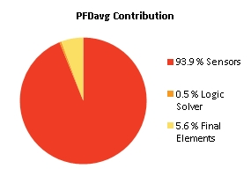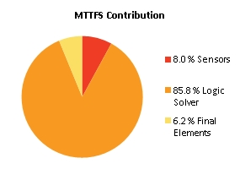
Note: The results shown in this SIL verification Summary are based on detailed calculations. All SIL verification assumptions including used reliability data are documented in the SIL verification Details report.

SIF-002 SIL1 Low differential pressure (254PI330 / 347PI306) Nitrogen system

Project Name |  | Hybrit Pilot Plant | SIF Tag | SIF-002
Unit / Process Area |  |  | SIF Name | SIL1 Low differential pressure (254PI330 / 347PI306) Nitrogen system
Mission Time |  | 15 years
Safety Instrumented Function Performance  Target SIL 1  Target RRF 10  Achieved SIL 2  PFDavg 2.69E-03  SIL (PFDavg) 2  SIL (Arch. Constraints IEC 61511) 2  SIL (Systematic Capability) N/A  Achieved RRF 371.9  MTTFS (years) 17.95 |  |  | PFDavg MTTFS SIL Limit  AC CAP  Sensor Part 2.60E-03 2044.67 2 N/A  Logic Solver Part 7.31E-06 19.43 2 N/A  Final Element Part 8.25E-05 267.4 3 N/A
Remarks | The SIF operates in Low demand mode.
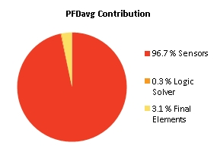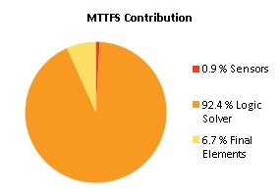
Note: The results shown in this SIL verification Summary are based on detailed calculations. All SIL verification assumptions including used reliability data are documented in the SIL verification Details report.

SIF-003 SIL1 High level (347LZ302) in Absorber (347YM100)

Project Name |  | Hybrit Pilot Plant | SIF Tag | SIF-003
Unit / Process Area |  |  | SIF Name | SIL1 High level (347LZ302) in Absorber (347YM100)
Mission Time |  | 15 years
Safety Instrumented Function Performance  Target SIL 1  Target RRF 10  Achieved SIL 2  PFDavg 2.02E-03  SIL (PFDavg) 2  SIL (Arch. Constraints IEC 61511) 2  SIL (Systematic Capability) N/A  Achieved RRF 494  MTTFS (years) 18.81 |  |  | PFDavg MTTFS SIL Limit  AC CAP  Sensor Part 1.05E-03 263.52 2 N/A  Logic Solver Part 6.90E-06 20.62 2 N/A  Final Element Part 9.68E-04 1162.95 2 N/A
Remarks | The SIF operates in Low demand mode.
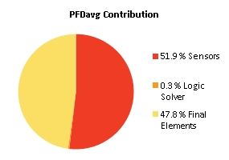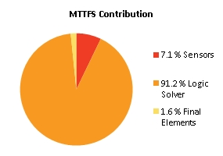
Note: The results shown in this SIL verification Summary are based on detailed calculations. All SIL verification assumptions including used reliability data are documented in the SIL verification Details report.

SIF-004 SIL2 Low level (347LZ300) in Absorber (347YM100)

Project Name |  | Hybrit Pilot Plant | SIF Tag | SIF-004
Unit / Process Area |  |  | SIF Name | SIL2 Low level (347LZ300) in Absorber (347YM100)
Mission Time |  | 15 years
Safety Instrumented Function Performance  Target SIL 2  Target RRF 100  Achieved SIL 2  PFDavg 1.31E-03  SIL (PFDavg) 2  SIL (Arch. Constraints IEC 61511) 2  SIL (Systematic Capability) N/A  Achieved RRF 764.8  MTTFS (years) 18.11 |  |  | PFDavg MTTFS SIL Limit  AC CAP  Sensor Part 1.20E-03 272.43 2 N/A  Logic Solver Part 6.90E-06 20.62 2 N/A  Final Element Part 9.79E-05 329.73 3 N/A
Remarks | The SIF operates in Low demand mode.
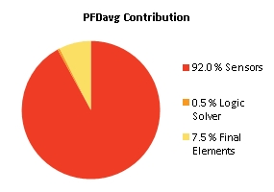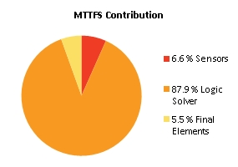
Note: The results shown in this SIL verification Summary are based on detailed calculations. All SIL verification assumptions including used reliability data are documented in the SIL verification Details report.

SIF-005 SIL1 High level (347LS305) filter separator 347SE101 stop 346PU101

Project Name |  | Hybrit Pilot Plant | SIF Tag | SIF-005
Unit / Process Area |  |  | SIF Name | SIL1 High level (347LS305) filter separator 347SE101 stop 346PU101
Mission Time |  | 15 years
Safety Instrumented Function Performance  Target SIL 1  Target RRF 10  Achieved SIL 2  PFDavg 1.29E-03  SIL (PFDavg) 2  SIL (Arch. Constraints IEC 61511) 2  SIL (Systematic Capability) N/A  Achieved RRF 775.8  MTTFS (years) 18.8 |  |  | PFDavg MTTFS SIL Limit  AC CAP  Sensor Part 1.20E-03 272.43 2 N/A  Logic Solver Part 6.90E-06 20.62 2 N/A  Final Element Part 7.93E-05 990.65 2 N/A
Remarks | The SIF operates in Low demand mode.
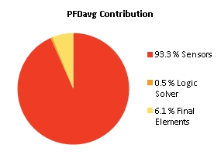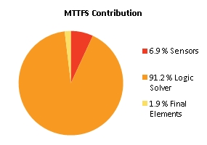
Note: The results shown in this SIL verification Summary are based on detailed calculations. All SIL verification assumptions including used reliability data are documented in the SIL verification Details report.

SIF-006 SIL1 Differential pressure treated gas - sour gas (347XI308)-> 347SV672 close and 347SV673 close

Project Name |  | Hybrit Pilot Plant | SIF Tag | SIF-006
Unit / Process Area |  |  | SIF Name | SIL1 Differential pressure treated gas - sour gas (347XI308)-> 347SV672 close and 347SV673 close
Mission Time |  | 15 years
Safety Instrumented Function Performance  Target SIL 1  Target RRF 10  Achieved SIL 2  PFDavg 2.70E-03  SIL (PFDavg) 2  SIL (Arch. Constraints IEC 61511) 2  SIL (Systematic Capability) N/A  Achieved RRF 369.9  MTTFS (years) 18.18 |  |  | PFDavg MTTFS SIL Limit  AC CAP  Sensor Part 2.60E-03 1976.35 2 N/A  Logic Solver Part 7.31E-06 19.43 2 N/A  Final Element Part 9.79E-05 329.73 3 N/A
Remarks | The SIF operates in Low demand mode.
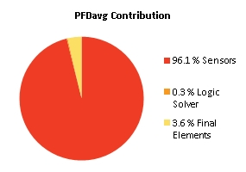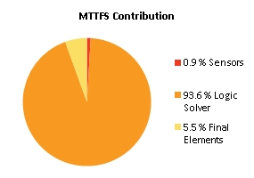
Note: The results shown in this SIL verification Summary are based on detailed calculations. All SIL verification assumptions including used reliability data are documented in the SIL verification Details report.

SIF-007 SIL2 High Temperature (347TI338) after lean MEA cooler close 347SV674 suction side MEA pumps

Project Name |  | Hybrit Pilot Plant | SIF Tag | SIF-007
Unit / Process Area |  |  | SIF Name | SIL2 High Temperature (347TI338) after lean MEA cooler close 347SV674 suction side MEA pumps
Mission Time |  | 15 years
Safety Instrumented Function Performance  Target SIL 2  Target RRF 100  Achieved SIL 2  PFDavg 4.21E-03  SIL (PFDavg) 2  SIL (Arch. Constraints IEC 61511) 2  SIL (Systematic Capability) N/A  Achieved RRF 237.2  MTTFS (years) 18.15 |  |  | PFDavg MTTFS SIL Limit  AC CAP  Sensor Part 3.25E-03 491.58 2 N/A  Logic Solver Part 7.31E-06 19.43 2 N/A  Final Element Part 9.66E-04 626.52 2 N/A
Remarks | The SIF operates in Low demand mode.
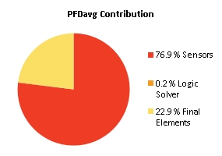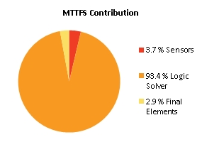
Note: The results shown in this SIL verification Summary are based on detailed calculations. All SIL verification assumptions including used reliability data are documented in the SIL verification Details report.

SIF-008 SIL1 High level (347LZ329 H1) in MEA reboiler (347HE201) close 347RV608

Project Name |  | Hybrit Pilot Plant | SIF Tag | SIF-008
Unit / Process Area |  |  | SIF Name | SIL1 High level (347LZ329 H1) in MEA reboiler (347HE201) close 347RV608
Mission Time |  | 15 years
Safety Instrumented Function Performance  Target SIL 1  Target RRF 10  Achieved SIL 1  PFDavg 2.51E-02  SIL (PFDavg) 1  SIL (Arch. Constraints IEC 61511) 2  SIL (Systematic Capability) N/A  Achieved RRF 39.8  MTTFS (years) 18.79 |  |  | PFDavg MTTFS SIL Limit  AC CAP  Sensor Part 1.05E-03 263.52 2 N/A  Logic Solver Part 6.90E-06 20.61 2 N/A  Final Element Part 2.40E-02 1096.4 2 N/A
Remarks | The SIF operates in Low demand mode.
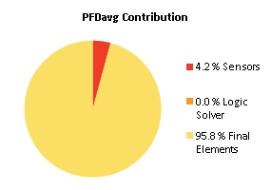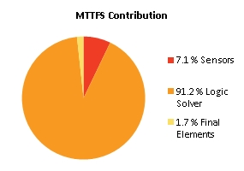
Note: The results shown in this SIL verification Summary are based on detailed calculations. All SIL verification assumptions including used reliability data are documented in the SIL verification Details report.

SIF-009 SIL2 Low differential pressure 347PD339 Pump discharge and absorber (347YM100) close 347SV671 lean MEA to Absorber

Project Name |  | Hybrit Pilot Plant | SIF Tag | SIF-009
Unit / Process Area |  |  | SIF Name | SIL2 Low differential pressure 347PD339 Pump discharge and absorber (347YM100) close 347SV671 lean MEA to Absorber
Mission Time |  | 15 years
Safety Instrumented Function Performance  Target SIL 2  Target RRF 100  Achieved SIL 2  PFDavg 1.54E-03  SIL (PFDavg) 2  SIL (Arch. Constraints IEC 61511) 2  SIL (Systematic Capability) N/A  Achieved RRF 650.5  MTTFS (years) 17.04 |  |  | PFDavg MTTFS SIL Limit  AC CAP  Sensor Part 1.39E-03 208.73 2 N/A  Logic Solver Part 7.31E-06 19.43 2 N/A  Final Element Part 1.40E-04 413.74 3 N/A
Remarks | The SIF operates in Low demand mode.
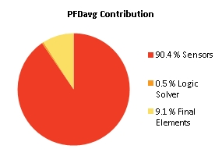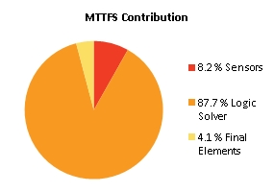
Note: The results shown in this SIL verification Summary are based on detailed calculations. All SIL verification assumptions including used reliability data are documented in the SIL verification Details report.

SIF-011 SIL2 Gastryck toppgas (320PZ320, 320PZ321 & 320PZ322|H2)

Project Name |  | Hybrit Pilot Plant | SIF Tag | SIF-011
Unit / Process Area |  |  | SIF Name | SIL2 Gastryck toppgas (320PZ320, 320PZ321 & 320PZ322|H2)
Mission Time |  | 10 years
Safety Instrumented Function Performance  Target SIL 2  Target RRF 100  Achieved SIL 2  PFDavg 2.67E-03  SIL (PFDavg) 2  SIL (Arch. Constraints IEC 61511) 2  SIL (Systematic Capability) N/A  Achieved RRF 373.9  MTTFS (years) 36.73 |  |  | PFDavg MTTFS SIL Limit  AC CAP  Sensor Part 5.04E-05 3312.46 3 N/A  Logic Solver Part 2.76E-06 37.72 2 N/A  Final Element Part 2.62E-03 2425.2 2 N/A
Remarks | The SIF operates in Low demand mode.
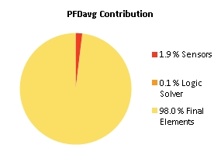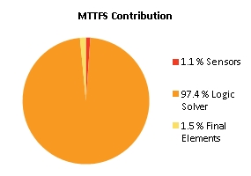
Note: The results shown in this SIL verification Summary are based on detailed calculations. All SIL verification assumptions including used reliability data are documented in the SIL verification Details report.

SIF-011 Beräkning av SIF-011 "open"

Project Name |  | Hybrit Pilot Plant | SIF Tag | SIF-011
Unit / Process Area |  |  | SIF Name | Beräkning av SIF-011 "open"
Mission Time |  | 10 years
Safety Instrumented Function Performance  Target SIL 2  Target RRF 0  Achieved SIL 0  PFDavg 0.00E+00  SIL (PFDavg) 0  SIL (Arch. Constraints IEC 61511) 0  SIL (Systematic Capability) N/A  Achieved RRF 0  MTTFS (years) ∞ |  |  | PFDavg MTTFS SIL Limit  AC CAP  Sensor Part 0.00E+00 ∞ 0 N/A  Logic Solver Part 0.00E+00 ∞ - N/A  Final Element Part 1.25E-03 1131.76 3 N/A
Remarks | The SIF operates in Low demand mode.
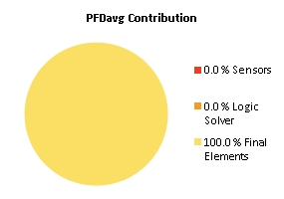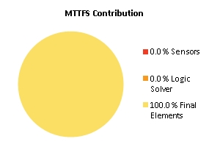
Note: The results shown in this SIL verification Summary are based on detailed calculations. All SIL verification assumptions including used reliability data are documented in the SIL verification Details report.

SIF-011 Beräkning av SIF-011 "close"

Project Name |  | Hybrit Pilot Plant | SIF Tag | SIF-011
Unit / Process Area |  |  | SIF Name | Beräkning av SIF-011 "close"
Mission Time |  | 10 years
Safety Instrumented Function Performance  Target SIL 2  Target RRF 0  Achieved SIL 0  PFDavg 0.00E+00  SIL (PFDavg) 0  SIL (Arch. Constraints IEC 61511) 0  SIL (Systematic Capability) N/A  Achieved RRF 0  MTTFS (years) ∞ |  |  | PFDavg MTTFS SIL Limit  AC CAP  Sensor Part 0.00E+00 ∞ 0 N/A  Logic Solver Part 0.00E+00 ∞ - N/A  Final Element Part 3.27E-03 23908.06 3 N/A
Remarks | The SIF operates in Low demand mode.

Note: The results shown in this SIL verification Summary are based on detailed calculations. All SIL verification assumptions including used reliability data are documented in the SIL verification Details report.

SIF-012 SIL2 Gastryck toppgas (320PZ320, 320PZ321 & 320PZ322|L2)

Project Name |  | Hybrit Pilot Plant | SIF Tag | SIF-012
Unit / Process Area |  |  | SIF Name | SIL2 Gastryck toppgas (320PZ320, 320PZ321 & 320PZ322|L2)
Mission Time |  | 10 years
Safety Instrumented Function Performance  Target SIL 2  Target RRF 100  Achieved SIL 2  PFDavg 6.74E-03  SIL (PFDavg) 2  SIL (Arch. Constraints IEC 61511) 2  SIL (Systematic Capability) N/A  Achieved RRF 148.3  MTTFS (years) 36.62 |  |  | PFDavg MTTFS SIL Limit  AC CAP  Sensor Part 4.31E-05 3341.86 3 N/A  Logic Solver Part 2.46E-06 37.72 2 N/A  Final Element Part 6.69E-03 2004.76 2 N/A
Remarks | The SIF operates in Low demand mode.
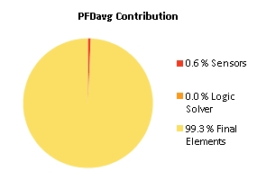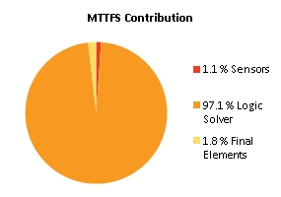
Note: The results shown in this SIL verification Summary are based on detailed calculations. All SIL verification assumptions including used reliability data are documented in the SIL verification Details report.

SIF-013 Gastryck toppgas (320PZ320, 320PZ321 & 320PZ322|H3)

Project Name |  | Hybrit Pilot Plant | SIF Tag | SIF-013
Unit / Process Area |  |  | SIF Name | Gastryck toppgas (320PZ320, 320PZ321 & 320PZ322|H3)
Mission Time |  | 15 years
Safety Instrumented Function Performance  Target SIL 1  Target RRF 10  Achieved SIL 1  PFDavg 1.73E-02  SIL (PFDavg) 1  SIL (Arch. Constraints IEC 61511) 2  SIL (Systematic Capability) N/A  Achieved RRF 57.8  MTTFS (years) 16.73 |  |  | PFDavg MTTFS SIL Limit  AC CAP  Sensor Part 1.05E-04 1698.47 3 N/A  Logic Solver Part 9.49E-06 16.94 2 N/A  Final Element Part 1.72E-02 7069.74 2 N/A
Remarks | The SIF operates in Low demand mode.
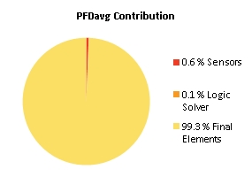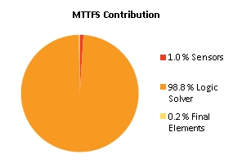
Note: The results shown in this SIL verification Summary are based on detailed calculations. All SIL verification assumptions including used reliability data are documented in the SIL verification Details report.

SIF-015 SIL2 Temp toppgas (320TZ323, 320TZ324 & 320TZ325|H2)

Project Name |  | Hybrit Pilot Plant | SIF Tag | SIF-015
Unit / Process Area |  |  | SIF Name | SIL2 Temp toppgas (320TZ323, 320TZ324 & 320TZ325|H2)
Mission Time |  | 15 years
Safety Instrumented Function Performance  Target SIL 2  Target RRF 100  Achieved SIL 2  PFDavg 5.69E-03  SIL (PFDavg) 2  SIL (Arch. Constraints IEC 61511) 2  SIL (Systematic Capability) N/A  Achieved RRF 175.6  MTTFS (years) 16.71 |  |  | PFDavg MTTFS SIL Limit  AC CAP  Sensor Part 1.31E-04 1693.48 3 N/A  Logic Solver Part 9.40E-06 17.12 2 N/A  Final Element Part 5.55E-03 1170.68 2 N/A
Remarks | The SIF operates in Low demand mode.
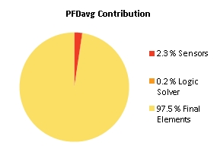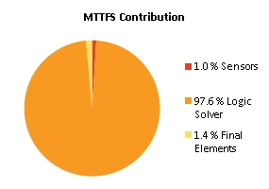
Note: The results shown in this SIL verification Summary are based on detailed calculations. All SIL verification assumptions including used reliability data are documented in the SIL verification Details report.

SIF-016 SIL1 Temp överhettad ånga (271TI552|L2)

Project Name |  | Hybrit Pilot Plant | SIF Tag | SIF-016
Unit / Process Area |  |  | SIF Name | SIL1 Temp överhettad ånga (271TI552|L2)
Mission Time |  | 15 years
Safety Instrumented Function Performance  Target SIL 1  Target RRF 10  Achieved SIL 2  PFDavg 9.38E-03  SIL (PFDavg) 2  SIL (Arch. Constraints IEC 61511) 2  SIL (Systematic Capability) N/A  Achieved RRF 106.6  MTTFS (years) 18.29 |  |  | PFDavg MTTFS SIL Limit  AC CAP  Sensor Part 1.40E-03 554.98 2 N/A  Logic Solver Part 7.31E-06 19.43 2 N/A  Final Element Part 7.98E-03 712.98 2 N/A
Remarks | The SIF operates in Low demand mode.
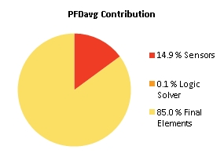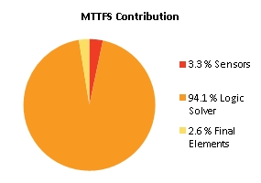
Note: The results shown in this SIL verification Summary are based on detailed calculations. All SIL verification assumptions including used reliability data are documented in the SIL verification Details report.

SIF-017 SIL1 Tryck överhettad ånga (271PI552|L2) Close Avstängningsventil 2 överhettad ånga till PGH (271SV556 SIL2)

Project Name |  | Hybrit Pilot Plant | SIF Tag | SIF-017
Unit / Process Area |  |  | SIF Name | SIL1 Tryck överhettad ånga (271PI552|L2) Close Avstängningsventil 2 överhettad ånga till PGH (271SV556 SIL2)
Mission Time |  | 15 years
Safety Instrumented Function Performance  Target SIL 1  Target RRF 10  Achieved SIL 2  PFDavg 8.77E-03  SIL (PFDavg) 2  SIL (Arch. Constraints IEC 61511) 2  SIL (Systematic Capability) N/A  Achieved RRF 114  MTTFS (years) 17.73 |  |  | PFDavg MTTFS SIL Limit  AC CAP  Sensor Part 7.86E-04 284.42 2 N/A  Logic Solver Part 7.31E-06 19.43 2 N/A  Final Element Part 7.98E-03 712.98 2 N/A
Remarks | The SIF operates in Low demand mode.
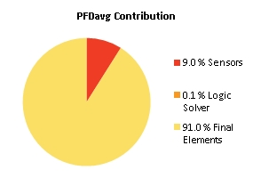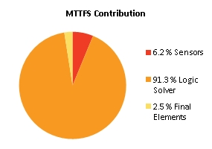
Note: The results shown in this SIL verification Summary are based on detailed calculations. All SIL verification assumptions including used reliability data are documented in the SIL verification Details report.

SIF-018 SIL1 Tryck överhettad ånga friblåsning (271PI320 < (343PZ305/7/8 + 0,1 barg)) Permissive Avstängningsventil 2 överhettad ånga till PGH (271SV556 SIL2)

Project Name |  | Hybrit Pilot Plant | SIF Tag | SIF-018
Unit / Process Area |  |  | SIF Name | SIL1 Tryck överhettad ånga friblåsning (271PI320 < (343PZ305/7/8 + 0,1 barg)) Permissive Avstängningsventil 2 överhettad ånga till PGH (271SV556 SIL2)
Mission Time |  | 15 years
Safety Instrumented Function Performance  Target SIL 1  Target RRF 10  Achieved SIL 2  PFDavg 9.20E-03  SIL (PFDavg) 2  SIL (Arch. Constraints IEC 61511) 2  SIL (Systematic Capability) N/A  Achieved RRF 108.7  MTTFS (years) 18.89 |  |  | PFDavg MTTFS SIL Limit  AC CAP  Sensor Part 1.22E-03 13413.9 2 N/A  Logic Solver Part 7.31E-06 19.43 2 N/A  Final Element Part 7.98E-03 712.98 2 N/A
Remarks | The SIF operates in Low demand mode.
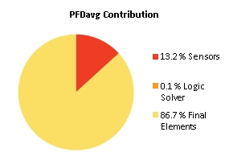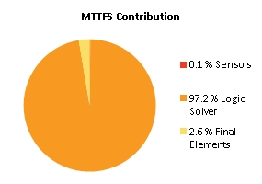
Note: The results shown in this SIL verification Summary are based on detailed calculations. All SIL verification assumptions including used reliability data are documented in the SIL verification Details report.

SIF-019 SIL2 Flöde reduktionsgas till PGH (343XI302|L2)

Project Name |  | Hybrit Pilot Plant | SIF Tag | SIF-019
Unit / Process Area |  |  | SIF Name | SIL2 Flöde reduktionsgas till PGH (343XI302|L2)
Mission Time |  | 15 years
Safety Instrumented Function Performance  Target SIL 2  Target RRF 100  Achieved SIL 2  PFDavg 4.95E-03  SIL (PFDavg) 2  SIL (Arch. Constraints IEC 61511) 2  SIL (Systematic Capability) N/A  Achieved RRF 201.8  MTTFS (years) 36.56 |  |  | PFDavg MTTFS SIL Limit  AC CAP  Sensor Part 1.28E-03 5696.55 2 N/A  Logic Solver Part 3.79E-06 37.91 2 N/A  Final Element Part 3.68E-03 1252.89 3 N/A
Remarks | The SIF operates in Low demand mode.
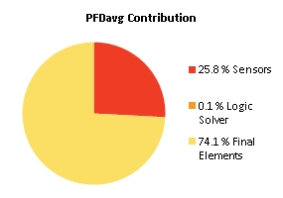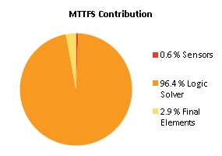
Note: The results shown in this SIL verification Summary are based on detailed calculations. All SIL verification assumptions including used reliability data are documented in the SIL verification Details report.

SIF-020 SIL2 Difftryck O2-transferline (251XI313)

Project Name |  | Hybrit Pilot Plant | SIF Tag | SIF-020
Unit / Process Area |  |  | SIF Name | SIL2 Difftryck O2-transferline (251XI313)
Mission Time |  | 15 years
Safety Instrumented Function Performance  Target SIL 2  Target RRF 100  Achieved SIL 2  PFDavg 2.95E-03  SIL (PFDavg) 2  SIL (Arch. Constraints IEC 61511) 2  SIL (Systematic Capability) N/A  Achieved RRF 339  MTTFS (years) 16.24 |  |  | PFDavg MTTFS SIL Limit  AC CAP  Sensor Part 9.06E-04 1895.34 2 N/A  Logic Solver Part 9.40E-06 17.12 2 N/A  Final Element Part 2.04E-03 378.21 3 N/A
Remarks | The SIF operates in Low demand mode.
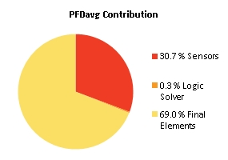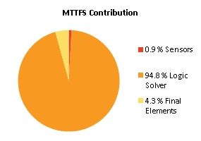
Note: The results shown in this SIL verification Summary are based on detailed calculations. All SIL verification assumptions including used reliability data are documented in the SIL verification Details report.

SIF-021 SIL1 Gastryck transferline (344PZ321|L2)

Project Name |  | Hybrit Pilot Plant | SIF Tag | SIF-021
Unit / Process Area |  |  | SIF Name | SIL1 Gastryck transferline (344PZ321|L2)
Mission Time |  | 15 years
Safety Instrumented Function Performance  Target SIL 1  Target RRF 10  Achieved SIL 2  PFDavg 2.83E-03  SIL (PFDavg) 2  SIL (Arch. Constraints IEC 61511) 2  SIL (Systematic Capability) N/A  Achieved RRF 353.6  MTTFS (years) 17.35 |  |  | PFDavg MTTFS SIL Limit  AC CAP  Sensor Part 7.86E-04 284.42 2 N/A  Logic Solver Part 7.31E-06 19.43 2 N/A  Final Element Part 2.04E-03 378.21 3 N/A
Remarks | The SIF operates in Low demand mode.
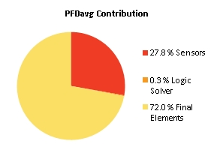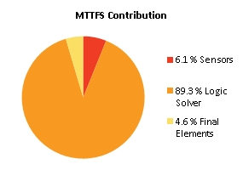
Note: The results shown in this SIL verification Summary are based on detailed calculations. All SIL verification assumptions including used reliability data are documented in the SIL verification Details report.

SIF-022 SIL2 Tryckvakt O2-inj (251XI312 |L2)

Project Name |  | Hybrit Pilot Plant | SIF Tag | SIF-022
Unit / Process Area |  |  | SIF Name | SIL2 Tryckvakt O2-inj (251XI312 |L2)
Mission Time |  | 15 years
Safety Instrumented Function Performance  Target SIL 2  Target RRF 100  Achieved SIL 2  PFDavg 2.17E-03  SIL (PFDavg) 2  SIL (Arch. Constraints IEC 61511) 2  SIL (Systematic Capability) N/A  Achieved RRF 461.7  MTTFS (years) 16.24 |  |  | PFDavg MTTFS SIL Limit  AC CAP  Sensor Part 1.20E-04 1857.58 3 N/A  Logic Solver Part 9.40E-06 17.12 2 N/A  Final Element Part 2.04E-03 378.21 3 N/A
Remarks | The SIF operates in Low demand mode.
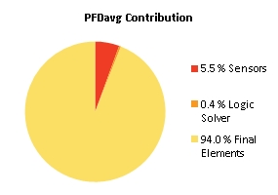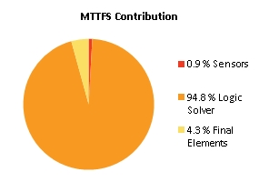
Note: The results shown in this SIL verification Summary are based on detailed calculations. All SIL verification assumptions including used reliability data are documented in the SIL verification Details report.

SIF-023 SIL2 Flödesmätare O2 inj (251XI554|L2)

Project Name |  | Hybrit Pilot Plant | SIF Tag | SIF-023
Unit / Process Area |  |  | SIF Name | SIL2 Flödesmätare O2 inj (251XI554|L2)
Mission Time |  | 15 years
Safety Instrumented Function Performance  Target SIL 2  Target RRF 100  Achieved SIL 2  PFDavg 4.24E-03  SIL (PFDavg) 2  SIL (Arch. Constraints IEC 61511) 2  SIL (Systematic Capability) N/A  Achieved RRF 235.6  MTTFS (years) 16.24 |  |  | PFDavg MTTFS SIL Limit  AC CAP  Sensor Part 2.20E-03 1971.41 2 N/A  Logic Solver Part 9.40E-06 17.12 2 N/A  Final Element Part 2.04E-03 378.21 3 N/A
Remarks | The SIF operates in Low demand mode.
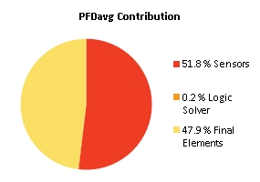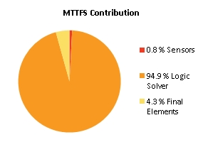
Note: The results shown in this SIL verification Summary are based on detailed calculations. All SIL verification assumptions including used reliability data are documented in the SIL verification Details report.

SIF-024 SIL2 Beräkning difftryck 253XI364|L1 (Skydd mot backflöde processgas till N2 och/eller O2 vid syrgasinjektion) 253XI364 = (2oo3(253PZ362, 253PZ363, 253PZ364) - 344PZ321)

Project Name |  | Hybrit Pilot Plant | SIF Tag | SIF-024
Unit / Process Area |  |  | SIF Name | SIL2 Beräkning difftryck 253XI364|L1 (Skydd mot backflöde processgas till N2 och/eller O2 vid syrgasinjektion) 253XI364 = (2oo3(253PZ362, 253PZ363, 253PZ364) - 344PZ321)
Mission Time |  | 15 years
Safety Instrumented Function Performance  Target SIL 2  Target RRF 100  Achieved SIL 2  PFDavg 2.94E-03  SIL (PFDavg) 2  SIL (Arch. Constraints IEC 61511) 2  SIL (Systematic Capability) N/A  Achieved RRF 340.7  MTTFS (years) 18.3 |  |  | PFDavg MTTFS SIL Limit  AC CAP  Sensor Part 8.94E-04 1886.25 2 N/A  Logic Solver Part 7.31E-06 19.43 2 N/A  Final Element Part 2.04E-03 378.21 3 N/A
Remarks | The SIF operates in Low demand mode.
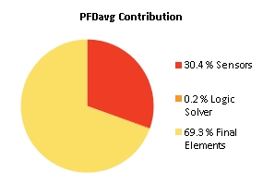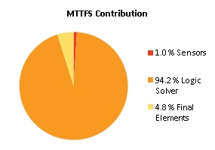
Note: The results shown in this SIL verification Summary are based on detailed calculations. All SIL verification assumptions including used reliability data are documented in the SIL verification Details report.

SIF-025 SIL2 Gastemp transferline (344TZ316, 344TZ317 & 344TZ318|H2)

Project Name |  | Hybrit Pilot Plant | SIF Tag | SIF-025
Unit / Process Area |  |  | SIF Name | SIL2 Gastemp transferline (344TZ316, 344TZ317 & 344TZ318|H2)
Mission Time |  | 15 years
Safety Instrumented Function Performance  Target SIL 2  Target RRF 100  Achieved SIL 2  PFDavg 4.69E-03  SIL (PFDavg) 2  SIL (Arch. Constraints IEC 61511) 2  SIL (Systematic Capability) N/A  Achieved RRF 213.4  MTTFS (years) 19.08 |  |  | PFDavg MTTFS SIL Limit  AC CAP  Sensor Part 7.62E-04 14107.8 3 N/A  Logic Solver Part 7.31E-06 19.43 2 N/A  Final Element Part 3.92E-03 1169.11 2 N/A
Remarks | The SIF operates in Low demand mode.
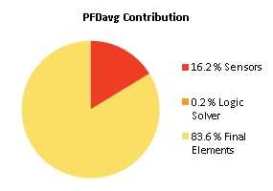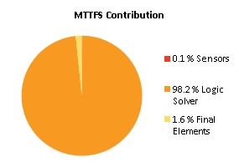
Note: The results shown in this SIL verification Summary are based on detailed calculations. All SIL verification assumptions including used reliability data are documented in the SIL verification Details report.

SIF-026 SIL3 Gastemp transferline (344TZ316, 344TZ317 & 344TZ318|L2)

Project Name |  | Hybrit Pilot Plant | SIF Tag | SIF-026
Unit / Process Area |  |  | SIF Name | SIL3 Gastemp transferline (344TZ316, 344TZ317 & 344TZ318|L2)
Mission Time |  | 10 years
Safety Instrumented Function Performance  Target SIL 3  Target RRF 1000  Achieved SIL 3  PFDavg 8.73E-04  SIL (PFDavg) 3  SIL (Arch. Constraints IEC 61511) 3  SIL (Systematic Capability) N/A  Achieved RRF 1144.8  MTTFS (years) 114.14 |  |  | PFDavg MTTFS SIL Limit  AC CAP  Sensor Part 1.15E-05 3591.84 3 N/A  Logic Solver Part 9.76E-08 140.5 3 N/A  Final Element Part 8.62E-04 732.5 3 N/A
Remarks | The SIF operates in Low demand mode.
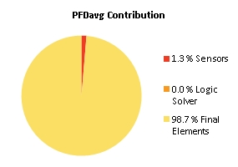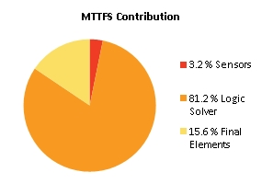
Note: The results shown in this SIL verification Summary are based on detailed calculations. All SIL verification assumptions including used reliability data are documented in the SIL verification Details report.

SIF-027 SIL1 Temperatur konvektionsdel (344TZ303, 344TZ304 & 344TZ305|H2)

Project Name |  | Hybrit Pilot Plant | SIF Tag | SIF-027
Unit / Process Area |  |  | SIF Name | SIL1 Temperatur konvektionsdel (344TZ303, 344TZ304 & 344TZ305|H2)
Mission Time |  | 15 years
Safety Instrumented Function Performance  Target SIL 1  Target RRF 10  Achieved SIL 2  PFDavg 3.92E-03  SIL (PFDavg) 2  SIL (Arch. Constraints IEC 61511) 2  SIL (Systematic Capability) N/A  Achieved RRF 255.3  MTTFS (years) 18.6 |  |  | PFDavg MTTFS SIL Limit  AC CAP  Sensor Part 6.77E-05 1878.24 3 N/A  Logic Solver Part 7.31E-06 19.43 2 N/A  Final Element Part 3.84E-03 566.9 3 N/A
Remarks | The SIF operates in Low demand mode.
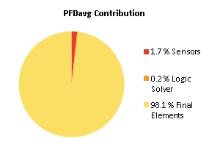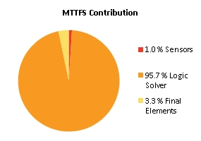
Note: The results shown in this SIL verification Summary are based on detailed calculations. All SIL verification assumptions including used reliability data are documented in the SIL verification Details report.

SIF-028 SIL1 Temperatur konvektionsdel (344TZ303, 344TZ304 & 344TZ305|L2)

Project Name |  | Hybrit Pilot Plant | SIF Tag | SIF-028
Unit / Process Area |  |  | SIF Name | SIL1 Temperatur konvektionsdel (344TZ303, 344TZ304 & 344TZ305|L2)
Mission Time |  | 15 years
Safety Instrumented Function Performance  Target SIL 1  Target RRF 10  Achieved SIL 2  PFDavg 8.06E-03  SIL (PFDavg) 2  SIL (Arch. Constraints IEC 61511) 2  SIL (Systematic Capability) 2  Achieved RRF 124  MTTFS (years) 18.72 |  |  | PFDavg MTTFS SIL Limit  AC CAP  Sensor Part 6.77E-05 1878.24 3 3  Logic Solver Part 7.31E-06 19.43 2 2  Final Element Part 7.98E-03 712.98 2 3
Remarks | The SIF operates in Low demand mode.
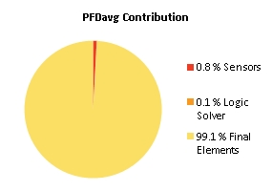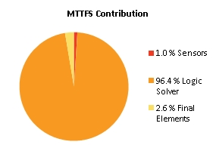
Note: The results shown in this SIL verification Summary are based on detailed calculations. All SIL verification assumptions including used reliability data are documented in the SIL verification Details report.

SIF-029 SIL1 Temperatur strålningssdel (344TZ310, 344TZ311 & 344TZ312|H2)

Project Name |  | Hybrit Pilot Plant | SIF Tag | SIF-029
Unit / Process Area |  |  | SIF Name | SIL1 Temperatur strålningssdel (344TZ310, 344TZ311 & 344TZ312|H2)
Mission Time |  | 15 years
Safety Instrumented Function Performance  Target SIL 1  Target RRF 10  Achieved SIL 2  PFDavg 3.92E-03  SIL (PFDavg) 2  SIL (Arch. Constraints IEC 61511) 2  SIL (Systematic Capability) N/A  Achieved RRF 255.3  MTTFS (years) 18.6 |  |  | PFDavg MTTFS SIL Limit  AC CAP  Sensor Part 6.77E-05 1878.24 3 N/A  Logic Solver Part 7.31E-06 19.43 2 N/A  Final Element Part 3.84E-03 566.9 3 N/A
Remarks | The SIF operates in Low demand mode.

Note: The results shown in this SIL verification Summary are based on detailed calculations. All SIL verification assumptions including used reliability data are documented in the SIL verification Details report.

SIF-031 SIL1 Tryck förbränningskammare (344PZ306, 344PZ307 & 344PZ308|H2)

Project Name |  | Hybrit Pilot Plant | SIF Tag | SIF-031
Unit / Process Area |  |  | SIF Name | SIL1 Tryck förbränningskammare (344PZ306, 344PZ307 & 344PZ308|H2)
Mission Time |  | 15 years
Safety Instrumented Function Performance  Target SIL 1  Target RRF 10  Achieved SIL 2  PFDavg 3.96E-03  SIL (PFDavg) 2  SIL (Arch. Constraints IEC 61511) 2  SIL (Systematic Capability) N/A  Achieved RRF 252.6  MTTFS (years) 16.46 |  |  | PFDavg MTTFS SIL Limit  AC CAP  Sensor Part 1.08E-04 1776.27 3 N/A  Logic Solver Part 9.40E-06 17.12 2 N/A  Final Element Part 3.84E-03 566.9 3 N/A
Remarks | The SIF operates in Low demand mode.
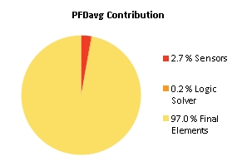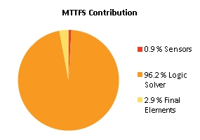
Note: The results shown in this SIL verification Summary are based on detailed calculations. All SIL verification assumptions including used reliability data are documented in the SIL verification Details report.

SIF-032 SIL2 Flamvakt (344YS314|SG1)

Project Name |  | Hybrit Pilot Plant | SIF Tag | SIF-032
Unit / Process Area |  |  | SIF Name | SIL2 Flamvakt (344YS314|SG1)
Mission Time |  | 15 years
Safety Instrumented Function Performance  Target SIL 2  Target RRF 100  Achieved SIL 2  PFDavg 4.15E-03  SIL (PFDavg) 2  SIL (Arch. Constraints IEC 61511) 2  SIL (Systematic Capability) N/A  Achieved RRF 241  MTTFS (years) 21.6 |  |  | PFDavg MTTFS SIL Limit  AC CAP  Sensor Part 3.03E-04 ∞ 2 N/A  Logic Solver Part 5.24E-06 22.45 2 N/A  Final Element Part 3.84E-03 566.9 3 N/A
Remarks | The SIF operates in Low demand mode.
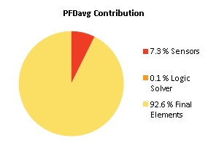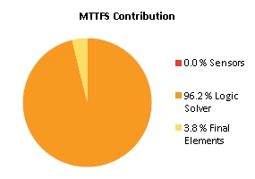
Note: The results shown in this SIL verification Summary are based on detailed calculations. All SIL verification assumptions including used reliability data are documented in the SIL verification Details report.

SIF-033 SIL2 Gastemp transferline efter O2-inj (344TZ322, 344TZ323 & 344TZ324|H2)

Project Name |  | Hybrit Pilot Plant | SIF Tag | SIF-033
Unit / Process Area |  |  | SIF Name | SIL2 Gastemp transferline efter O2-inj (344TZ322, 344TZ323 & 344TZ324|H2)
Mission Time |  | 15 years
Safety Instrumented Function Performance  Target SIL 1  Target RRF 10  Achieved SIL 2  PFDavg 2.17E-03  SIL (PFDavg) 2  SIL (Arch. Constraints IEC 61511) 2  SIL (Systematic Capability) N/A  Achieved RRF 459.7  MTTFS (years) 18.29 |  |  | PFDavg MTTFS SIL Limit  AC CAP  Sensor Part 1.32E-04 1775.15 3 N/A  Logic Solver Part 7.31E-06 19.43 2 N/A  Final Element Part 2.04E-03 378.21 3 N/A
Remarks | The SIF operates in Low demand mode.
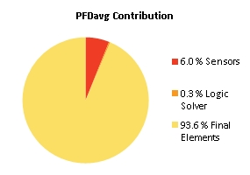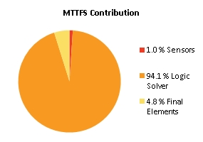
Note: The results shown in this SIL verification Summary are based on detailed calculations. All SIL verification assumptions including used reliability data are documented in the SIL verification Details report.

SIF-034 SIL3 Gastemp transferline efter O2-inj (344TZ322, 344TZ323 & 344TZ324|L2)

Project Name |  | Hybrit Pilot Plant | SIF Tag | SIF-034
Unit / Process Area |  |  | SIF Name | SIL3 Gastemp transferline efter O2-inj (344TZ322, 344TZ323 & 344TZ324|L2)
Mission Time |  | 10 years
Safety Instrumented Function Performance  Target SIL 3  Target RRF 1000  Achieved SIL 3  PFDavg 8.68E-04  SIL (PFDavg) 3  SIL (Arch. Constraints IEC 61511) 3  SIL (Systematic Capability) N/A  Achieved RRF 1151.6  MTTFS (years) 114.14 |  |  | PFDavg MTTFS SIL Limit  AC CAP  Sensor Part 6.41E-06 3591.6 3 N/A  Logic Solver Part 9.76E-08 140.5 3 N/A  Final Element Part 8.62E-04 732.5 3 N/A
Remarks | The SIF operates in Low demand mode.
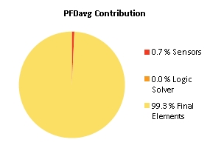
Note: The results shown in this SIL verification Summary are based on detailed calculations. All SIL verification assumptions including used reliability data are documented in the SIL verification Details report.

SIF-035 SIL2 Difftrycksmätning över syreinjektionslans (344XI340_DEV|H2/L2)

Project Name |  | Hybrit Pilot Plant | SIF Tag | SIF-035
Unit / Process Area |  |  | SIF Name | SIL2 Difftrycksmätning över syreinjektionslans (344XI340_DEV|H2/L2)
Mission Time |  | 15 years
Safety Instrumented Function Performance  Target SIL 2  Target RRF 100  Achieved SIL 2  PFDavg 6.58E-03  SIL (PFDavg) 2  SIL (Arch. Constraints IEC 61511) 2  SIL (Systematic Capability) N/A  Achieved RRF 151.9  MTTFS (years) 31.96 |  |  | PFDavg MTTFS SIL Limit  AC CAP  Sensor Part 5.53E-03 745306.04 2 N/A  Logic Solver Part 4.87E-06 33.4 2 N/A  Final Element Part 1.06E-03 738.1 3 N/A
Remarks | The SIF operates in Low demand mode.
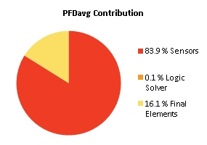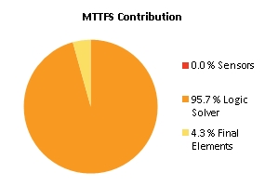
Note: The results shown in this SIL verification Summary are based on detailed calculations. All SIL verification assumptions including used reliability data are documented in the SIL verification Details report.

SIF-036 SIL1 Gastryck N2 (253PZ362, 253PZ363 & 253PZ364|L2)

Project Name |  | Hybrit Pilot Plant | SIF Tag | SIF-036
Unit / Process Area |  |  | SIF Name | SIL1 Gastryck N2 (253PZ362, 253PZ363 & 253PZ364|L2)
Mission Time |  | 15 years
Safety Instrumented Function Performance  Target SIL 1  Target RRF 10  Achieved SIL 2  PFDavg 8.63E-03  SIL (PFDavg) 2  SIL (Arch. Constraints IEC 61511) 2  SIL (Systematic Capability) N/A  Achieved RRF 115.8  MTTFS (years) 18.95 |  |  | PFDavg MTTFS SIL Limit  AC CAP  Sensor Part 4.17E-04 10354.69 3 N/A  Logic Solver Part 7.31E-06 19.43 2 N/A  Final Element Part 8.21E-03 842.93 2 N/A
Remarks | The SIF operates in Low demand mode.
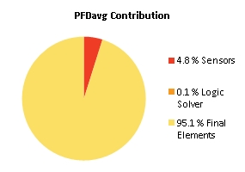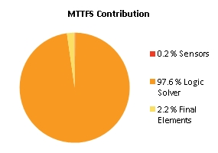
Note: The results shown in this SIL verification Summary are based on detailed calculations. All SIL verification assumptions including used reliability data are documented in the SIL verification Details report.

SIF-037 SIL2 Tryckvakt efter N2 bufferttank 253TA005 (253PZ323, 253PZ324, 253PZ325|L2)

Project Name |  | Hybrit Pilot Plant | SIF Tag | SIF-037
Unit / Process Area |  |  | SIF Name | SIL2 Tryckvakt efter N2 bufferttank 253TA005 (253PZ323, 253PZ324, 253PZ325|L2)
Mission Time |  | 10 years
Safety Instrumented Function Performance  Target SIL 2  Target RRF 100  Achieved SIL 2  PFDavg 8.88E-03  SIL (PFDavg) 2  SIL (Arch. Constraints IEC 61511) 2  SIL (Systematic Capability) N/A  Achieved RRF 112.5  MTTFS (years) 36.75 |  |  | PFDavg MTTFS SIL Limit  AC CAP  Sensor Part 5.76E-05 3622.1 3 N/A  Logic Solver Part 2.76E-06 37.72 2 N/A  Final Element Part 8.82E-03 2390.36 2 N/A
Remarks | The SIF operates in Low demand mode.
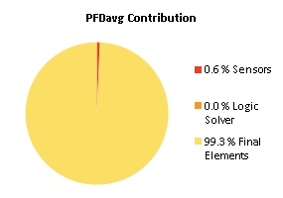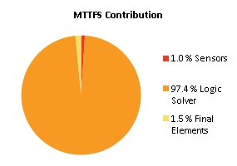
Note: The results shown in this SIL verification Summary are based on detailed calculations. All SIL verification assumptions including used reliability data are documented in the SIL verification Details report.

SIF-038 SIL2 Hög vätskenivå WESP (345LI354/5/6|H2)

Project Name |  | Hybrit Pilot Plant | SIF Tag | SIF-038
Unit / Process Area |  |  | SIF Name | SIL2 Hög vätskenivå WESP (345LI354/5/6|H2)
Mission Time |  | 15 years
Safety Instrumented Function Performance  Target SIL 2  Target RRF 100  Achieved SIL 2  PFDavg 2.53E-03  SIL (PFDavg) 2  SIL (Arch. Constraints IEC 61511) 2  SIL (Systematic Capability) N/A  Achieved RRF 395.8  MTTFS (years) 17.62 |  |  | PFDavg MTTFS SIL Limit  AC CAP  Sensor Part 4.05E-04 228.67 3 N/A  Logic Solver Part 7.31E-06 19.43 2 N/A  Final Element Part 2.12E-03 1095.15 2 N/A
Remarks | The SIF operates in Low demand mode.
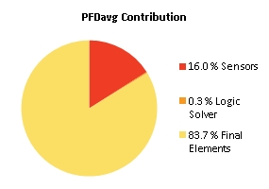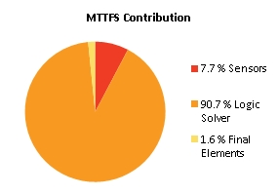
Note: The results shown in this SIL verification Summary are based on detailed calculations. All SIL verification assumptions including used reliability data are documented in the SIL verification Details report.

SIF-039 SIL2 Tryck efter WESP red. gaskrets (345PI361|H2)

Project Name |  | Hybrit Pilot Plant | SIF Tag | SIF-039
Unit / Process Area |  |  | SIF Name | SIL2 Tryck efter WESP red. gaskrets (345PI361|H2)
Mission Time |  | 15 years
Safety Instrumented Function Performance  Target SIL 2  Target RRF 100  Achieved SIL 2  PFDavg 5.32E-03  SIL (PFDavg) 2  SIL (Arch. Constraints IEC 61511) 2  SIL (Systematic Capability) N/A  Achieved RRF 187.9  MTTFS (years) 17.71 |  |  | PFDavg MTTFS SIL Limit  AC CAP  Sensor Part 6.89E-04 273.24 2 N/A  Logic Solver Part 7.31E-06 19.43 2 N/A  Final Element Part 4.63E-03 750.88 2 N/A
Remarks | The SIF operates in Low demand mode.
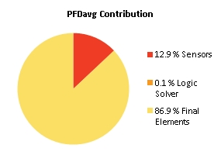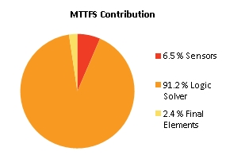
Note: The results shown in this SIL verification Summary are based on detailed calculations. All SIL verification assumptions including used reliability data are documented in the SIL verification Details report.

SIF-040 SIL2 Tryck efter WESP processgaskrets (353PI361|H2)

Project Name |  | Hybrit Pilot Plant | SIF Tag | SIF-040
Unit / Process Area |  |  | SIF Name | SIL2 Tryck efter WESP processgaskrets (353PI361|H2)
Mission Time |  | 15 years
Safety Instrumented Function Performance  Target SIL 2  Target RRF 100  Achieved SIL 2  PFDavg 5.32E-03  SIL (PFDavg) 2  SIL (Arch. Constraints IEC 61511) 2  SIL (Systematic Capability) N/A  Achieved RRF 187.9  MTTFS (years) 17.71 |  |  | PFDavg MTTFS SIL Limit  AC CAP  Sensor Part 6.89E-04 273.24 2 N/A  Logic Solver Part 7.31E-06 19.43 2 N/A  Final Element Part 4.63E-03 750.88 2 N/A
Remarks | The SIF operates in Low demand mode.

Note: The results shown in this SIL verification Summary are based on detailed calculations. All SIL verification assumptions including used reliability data are documented in the SIL verification Details report.

SIF-041 SIL1 Temp kondensor reduktionsgas (345TI301|H2)

Project Name |  | Hybrit Pilot Plant | SIF Tag | SIF-041
Unit / Process Area |  |  | SIF Name | SIL1 Temp kondensor reduktionsgas (345TI301|H2)
Mission Time |  | 15 years
Safety Instrumented Function Performance  Target SIL 1  Target RRF 10  Achieved SIL 1  PFDavg 1.15E-02  SIL (PFDavg) 1  SIL (Arch. Constraints IEC 61511) 2  SIL (Systematic Capability) N/A  Achieved RRF 86.6  MTTFS (years) 16.24 |  |  | PFDavg MTTFS SIL Limit  AC CAP  Sensor Part 1.40E-03 554.98 2 N/A  Logic Solver Part 9.49E-06 16.94 2 N/A  Final Element Part 1.02E-02 1344.25 2 N/A
Remarks | The SIF operates in Low demand mode.
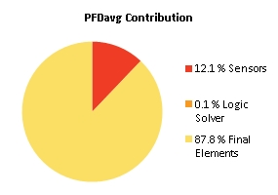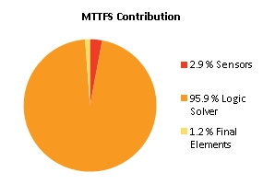
Note: The results shown in this SIL verification Summary are based on detailed calculations. All SIL verification assumptions including used reliability data are documented in the SIL verification Details report.

SIF-042 SIL1 Temp kondensor processgas (353TI301|H2)

Project Name |  | Hybrit Pilot Plant | SIF Tag | SIF-042
Unit / Process Area |  |  | SIF Name | SIL1 Temp kondensor processgas (353TI301|H2)
Mission Time |  | 15 years
Safety Instrumented Function Performance  Target SIL 1  Target RRF 10  Achieved SIL 2  PFDavg 5.00E-03  SIL (PFDavg) 2  SIL (Arch. Constraints IEC 61511) 2  SIL (Systematic Capability) N/A  Achieved RRF 199.8  MTTFS (years) 16.23 |  |  | PFDavg MTTFS SIL Limit  AC CAP  Sensor Part 1.40E-03 554.98 2 N/A  Logic Solver Part 9.49E-06 16.94 2 N/A  Final Element Part 3.60E-03 1286.95 2 N/A
Remarks | The SIF operates in Low demand mode.
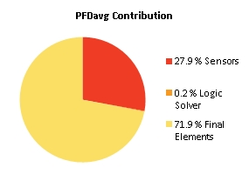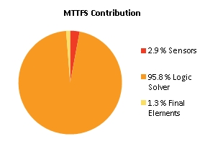
Note: The results shown in this SIL verification Summary are based on detailed calculations. All SIL verification assumptions including used reliability data are documented in the SIL verification Details report.

SIF-043 SIL2 Skintemp förquench reduktionsgas (345TI307|H2)

Project Name |  | Hybrit Pilot Plant | SIF Tag | SIF-043
Unit / Process Area |  |  | SIF Name | SIL2 Skintemp förquench reduktionsgas (345TI307|H2)
Mission Time |  | 15 years
Safety Instrumented Function Performance  Target SIL 2  Target RRF 100  Achieved SIL 2  PFDavg 5.94E-03  SIL (PFDavg) 2  SIL (Arch. Constraints IEC 61511) 2  SIL (Systematic Capability) N/A  Achieved RRF 168.3  MTTFS (years) 28.2 |  |  | PFDavg MTTFS SIL Limit  AC CAP  Sensor Part 7.20E-04 1082.88 2 N/A  Logic Solver Part 6.05E-06 29.3 2 N/A  Final Element Part 5.22E-03 2498.19 2 N/A
Remarks | The SIF operates in Low demand mode.
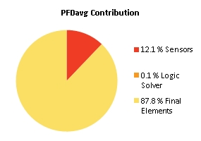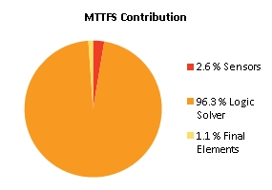
Note: The results shown in this SIL verification Summary are based on detailed calculations. All SIL verification assumptions including used reliability data are documented in the SIL verification Details report.

SIF-044 SIL2 Skintemp quench reduktionsgas (345TI308|H2)

Project Name |  | Hybrit Pilot Plant | SIF Tag | SIF-044
Unit / Process Area |  |  | SIF Name | SIL2 Skintemp quench reduktionsgas (345TI308|H2)
Mission Time |  | 15 years
Safety Instrumented Function Performance  Target SIL 2  Target RRF 100  Achieved SIL 2  PFDavg 5.94E-03  SIL (PFDavg) 2  SIL (Arch. Constraints IEC 61511) 2  SIL (Systematic Capability) N/A  Achieved RRF 168.3  MTTFS (years) 28.2 |  |  | PFDavg MTTFS SIL Limit  AC CAP  Sensor Part 7.20E-04 1082.88 2 N/A  Logic Solver Part 6.05E-06 29.3 2 N/A  Final Element Part 5.22E-03 2498.19 2 N/A
Remarks | The SIF operates in Low demand mode.

Note: The results shown in this SIL verification Summary are based on detailed calculations. All SIL verification assumptions including used reliability data are documented in the SIL verification Details report.

SIF-045 SIL2 Skintemp förquench processgas (353TI307|H2)

Project Name |  | Hybrit Pilot Plant | SIF Tag | SIF-045
Unit / Process Area |  |  | SIF Name | SIL2 Skintemp förquench processgas (353TI307|H2)
Mission Time |  | 15 years
Safety Instrumented Function Performance  Target SIL 2  Target RRF 100  Achieved SIL 2  PFDavg 6.49E-03  SIL (PFDavg) 2  SIL (Arch. Constraints IEC 61511) 2  SIL (Systematic Capability) N/A  Achieved RRF 154.1  MTTFS (years) 25.47 |  |  | PFDavg MTTFS SIL Limit  AC CAP  Sensor Part 7.20E-04 1082.88 2 N/A  Logic Solver Part 7.21E-06 26.31 2 N/A  Final Element Part 5.77E-03 2975.01 2 N/A
Remarks | The SIF operates in Low demand mode.
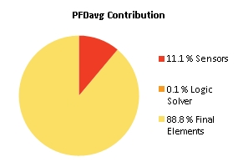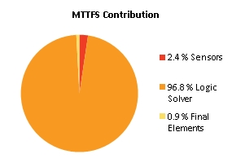
Note: The results shown in this SIL verification Summary are based on detailed calculations. All SIL verification assumptions including used reliability data are documented in the SIL verification Details report.

SIF-046 SIL2 Skintemp quench processgas (353TI308|H2)

Project Name |  | Hybrit Pilot Plant | SIF Tag | SIF-046
Unit / Process Area |  |  | SIF Name | SIL2 Skintemp quench processgas (353TI308|H2)
Mission Time |  | 15 years
Safety Instrumented Function Performance  Target SIL 2  Target RRF 100  Achieved SIL 2  PFDavg 5.02E-03  SIL (PFDavg) 2  SIL (Arch. Constraints IEC 61511) 2  SIL (Systematic Capability) N/A  Achieved RRF 199  MTTFS (years) 20.6 |  |  | PFDavg MTTFS SIL Limit  AC CAP  Sensor Part 1.40E-03 119.15 2 N/A  Logic Solver Part 3.11E-06 27.05 2 N/A  Final Element Part 3.63E-03 314.84 2 N/A
Remarks | The SIF operates in Low demand mode.
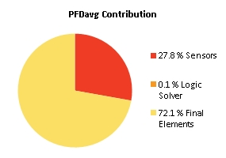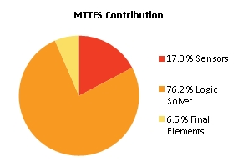
Note: The results shown in this SIL verification Summary are based on detailed calculations. All SIL verification assumptions including used reliability data are documented in the SIL verification Details report.

SIF-047 SIL1 Flödesmätare till förquench reduktionsgaskrets (345FI305|L2)

Project Name |  | Hybrit Pilot Plant | SIF Tag | SIF-047
Unit / Process Area |  |  | SIF Name | SIL1 Flödesmätare till förquench reduktionsgaskrets (345FI305|L2)
Mission Time |  | 15 years
Safety Instrumented Function Performance  Target SIL 1  Target RRF 10  Achieved SIL 1  PFDavg 1.11E-02  SIL (PFDavg) 1  SIL (Arch. Constraints IEC 61511) 2  SIL (Systematic Capability) N/A  Achieved RRF 90.3  MTTFS (years) 12.18 |  |  | PFDavg MTTFS SIL Limit  AC CAP  Sensor Part 1.01E-03 33.51 2 N/A  Logic Solver Part 7.31E-06 19.43 2 N/A  Final Element Part 1.01E-02 1280.3 2 N/A
Remarks | The SIF operates in Low demand mode.
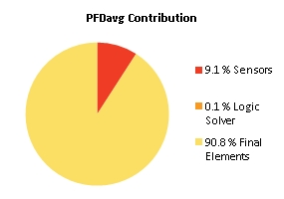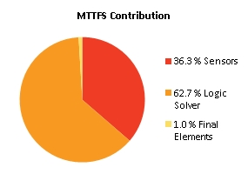
Note: The results shown in this SIL verification Summary are based on detailed calculations. All SIL verification assumptions including used reliability data are documented in the SIL verification Details report.

SIF-048 SIL1 Flödesmätare till förquench processgaskrets (353FI305|L2)

Project Name |  | Hybrit Pilot Plant | SIF Tag | SIF-048
Unit / Process Area |  |  | SIF Name | SIL1 Flödesmätare till förquench processgaskrets (353FI305|L2)
Mission Time |  | 15 years
Safety Instrumented Function Performance  Target SIL 1  Target RRF 10  Achieved SIL 1  PFDavg 4.63E-03  SIL (PFDavg) 2  SIL (Arch. Constraints IEC 61508) 1  SIL (Systematic Capability) 2  Achieved RRF 215.7  MTTFS (years) 13.06 |  |  | PFDavg MTTFS SIL Limit  AC CAP  Sensor Part 1.01E-03 27.45 2 2  Logic Solver Part 3.11E-06 27.05 2 2  Final Element Part 3.63E-03 314.84 1 3
Remarks | The SIF operates in Low demand mode.
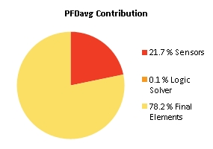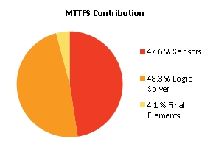
Note: The results shown in this SIL verification Summary are based on detailed calculations. All SIL verification assumptions including used reliability data are documented in the SIL verification Details report.

SIF-049 SIL1 Hög Nivå kondesseparator inlopp red.gaskompressor (346LI300|H2) =>Trip red.gaskompressor (346PU101 SIL2)

Project Name |  | Hybrit Pilot Plant | SIF Tag | SIF-049
Unit / Process Area |  |  | SIF Name | SIL1 Hög Nivå kondesseparator inlopp red.gaskompressor (346LI300|H2) =>Trip red.gaskompressor (346PU101 SIL2)
Mission Time |  | 15 years
Safety Instrumented Function Performance  Target SIL 1  Target RRF 10  Achieved SIL 2  PFDavg 2.24E-03  SIL (PFDavg) 2  SIL (Arch. Constraints IEC 61511) 2  SIL (Systematic Capability) N/A  Achieved RRF 445.7  MTTFS (years) 17.74 |  |  | PFDavg MTTFS SIL Limit  AC CAP  Sensor Part 2.08E-03 257.02 2 N/A  Logic Solver Part 7.31E-06 19.43 2 N/A  Final Element Part 1.53E-04 990.72 2 N/A
Remarks | The SIF operates in Low demand mode.
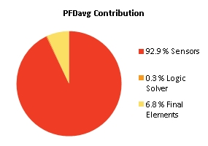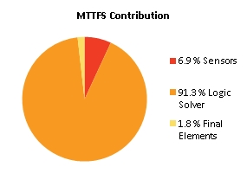
Note: The results shown in this SIL verification Summary are based on detailed calculations. All SIL verification assumptions including used reliability data are documented in the SIL verification Details report.

SIF-050 SIL2 Gastryck inlopp red.gaskompressor (346PI304|L2) =>Trip red.gaskompressor (346PU101 SIL2)

Project Name |  | Hybrit Pilot Plant | SIF Tag | SIF-050
Unit / Process Area |  |  | SIF Name | SIL2 Gastryck inlopp red.gaskompressor (346PI304|L2) =>Trip red.gaskompressor (346PU101 SIL2)
Mission Time |  | 15 years
Safety Instrumented Function Performance  Target SIL 2  Target RRF 100  Achieved SIL 2  PFDavg 1.36E-03  SIL (PFDavg) 2  SIL (Arch. Constraints IEC 61511) 2  SIL (Systematic Capability) N/A  Achieved RRF 736.8  MTTFS (years) 17.54 |  |  | PFDavg MTTFS SIL Limit  AC CAP  Sensor Part 1.27E-03 220.37 2 N/A  Logic Solver Part 7.31E-06 19.43 2 N/A  Final Element Part 7.93E-05 990.65 2 N/A
Remarks | The SIF operates in Low demand mode.
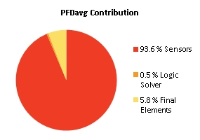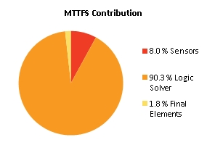
Note: The results shown in this SIL verification Summary are based on detailed calculations. All SIL verification assumptions including used reliability data are documented in the SIL verification Details report.

SIF-051 SIL2 Gastemp eft. kylare red.gaskompressor (oberoende) (346TI410|H2) =>Trip red.gaskompressor (346PU101 SIL2)

Project Name |  | Hybrit Pilot Plant | SIF Tag | SIF-051
Unit / Process Area |  |  | SIF Name | SIL2 Gastemp eft. kylare red.gaskompressor (oberoende) (346TI410|H2) =>Trip red.gaskompressor (346PU101 SIL2)
Mission Time |  | 15 years
Safety Instrumented Function Performance  Target SIL 2  Target RRF 100  Achieved SIL 2  PFDavg 1.02E-03  SIL (PFDavg) 2  SIL (Arch. Constraints IEC 61511) 2  SIL (Systematic Capability) N/A  Achieved RRF 981.2  MTTFS (years) 17.87 |  |  | PFDavg MTTFS SIL Limit  AC CAP  Sensor Part 8.59E-04 287.37 2 N/A  Logic Solver Part 7.31E-06 19.43 2 N/A  Final Element Part 1.53E-04 990.72 2 N/A
Remarks | The SIF operates in Low demand mode.
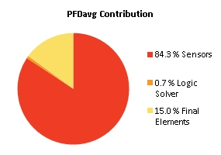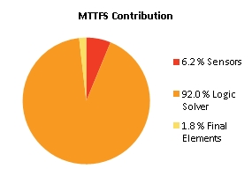
Note: The results shown in this SIL verification Summary are based on detailed calculations. All SIL verification assumptions including used reliability data are documented in the SIL verification Details report.

SIF-052 SIL1 Hög Nivå kondensseparator utlopp red.gaskompressor (346LI311|H2) =>Trip red.gaskompressor (346PU101 SIL2)

Project Name |  | Hybrit Pilot Plant | SIF Tag | SIF-052
Unit / Process Area |  |  | SIF Name | SIL1 Hög Nivå kondensseparator utlopp red.gaskompressor (346LI311|H2) =>Trip red.gaskompressor (346PU101 SIL2)
Mission Time |  | 15 years
Safety Instrumented Function Performance  Target SIL 1  Target RRF 10  Achieved SIL 2  PFDavg 2.24E-03  SIL (PFDavg) 2  SIL (Arch. Constraints IEC 61511) 2  SIL (Systematic Capability) N/A  Achieved RRF 445.7  MTTFS (years) 17.74 |  |  | PFDavg MTTFS SIL Limit  AC CAP  Sensor Part 2.08E-03 257.02 2 N/A  Logic Solver Part 7.31E-06 19.43 2 N/A  Final Element Part 1.53E-04 990.72 2 N/A
Remarks | The SIF operates in Low demand mode.

Note: The results shown in this SIL verification Summary are based on detailed calculations. All SIL verification assumptions including used reliability data are documented in the SIL verification Details report.

SIF-053 SIL2 Lågt oljetryck red.gaskompressor (346PI334|L2) =>Trip red.gaskompressor (346PU101 SIL2)

Project Name |  | Hybrit Pilot Plant | SIF Tag | SIF-053
Unit / Process Area |  |  | SIF Name | SIL2 Lågt oljetryck red.gaskompressor (346PI334|L2) =>Trip red.gaskompressor (346PU101 SIL2)
Mission Time |  | 15 years
Safety Instrumented Function Performance  Target SIL 2  Target RRF 100  Achieved SIL 2  PFDavg 1.34E-03  SIL (PFDavg) 2  SIL (Arch. Constraints IEC 61511) 2  SIL (Systematic Capability) N/A  Achieved RRF 743.8  MTTFS (years) 17.46 |  |  | PFDavg MTTFS SIL Limit  AC CAP  Sensor Part 1.18E-03 208.68 2 N/A  Logic Solver Part 7.31E-06 19.43 2 N/A  Final Element Part 1.53E-04 990.72 2 N/A
Remarks | The SIF operates in Low demand mode.
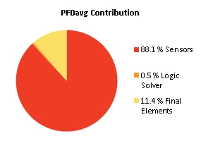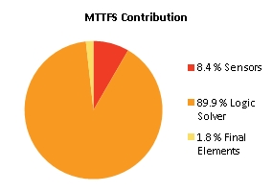
Note: The results shown in this SIL verification Summary are based on detailed calculations. All SIL verification assumptions including used reliability data are documented in the SIL verification Details report.

SIF-054 SIL1 Hög Nivå kondensseparator inlopp proc.gaskompressor (354LI300|H2) =>Trip proc.gaskompressor (354PU101 SIL2)

Project Name |  | Hybrit Pilot Plant | SIF Tag | SIF-054
Unit / Process Area |  |  | SIF Name | SIL1 Hög Nivå kondensseparator inlopp proc.gaskompressor (354LI300|H2) =>Trip proc.gaskompressor (354PU101 SIL2)
Mission Time |  | 15 years
Safety Instrumented Function Performance  Target SIL 1  Target RRF 10  Achieved SIL 2  PFDavg 2.24E-03  SIL (PFDavg) 2  SIL (Arch. Constraints IEC 61511) 2  SIL (Systematic Capability) N/A  Achieved RRF 445.7  MTTFS (years) 17.74 |  |  | PFDavg MTTFS SIL Limit  AC CAP  Sensor Part 2.08E-03 257.02 2 N/A  Logic Solver Part 7.31E-06 19.43 2 N/A  Final Element Part 1.53E-04 990.72 2 N/A
Remarks | The SIF operates in Low demand mode.

Note: The results shown in this SIL verification Summary are based on detailed calculations. All SIL verification assumptions including used reliability data are documented in the SIL verification Details report.

SIF-055 SIL2 Gastryck inlopp proc.gaskompressor (354PI304|L2) =>Trip proc.gaskompressor (354PU101 SIL2)

Project Name |  | Hybrit Pilot Plant | SIF Tag | SIF-055
Unit / Process Area |  |  | SIF Name | SIL2 Gastryck inlopp proc.gaskompressor (354PI304|L2) =>Trip proc.gaskompressor (354PU101 SIL2)
Mission Time |  | 15 years
Safety Instrumented Function Performance  Target SIL 2  Target RRF 100  Achieved SIL 2  PFDavg 1.43E-03  SIL (PFDavg) 2  SIL (Arch. Constraints IEC 61511) 2  SIL (Systematic Capability) N/A  Achieved RRF 699  MTTFS (years) 17.54 |  |  | PFDavg MTTFS SIL Limit  AC CAP  Sensor Part 1.27E-03 220.37 2 N/A  Logic Solver Part 7.31E-06 19.43 2 N/A  Final Element Part 1.53E-04 990.72 2 N/A
Remarks | The SIF operates in Low demand mode.
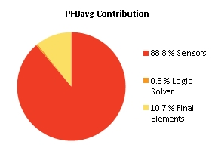
Note: The results shown in this SIL verification Summary are based on detailed calculations. All SIL verification assumptions including used reliability data are documented in the SIL verification Details report.

SIF-056 SIL1 Hög Nivå kondensseparator utlopp proc.gaskompressor (354LI311|H2) =>Trip proc.gaskompressor (354PU101 SIL2)

Project Name |  | Hybrit Pilot Plant | SIF Tag | SIF-056
Unit / Process Area |  |  | SIF Name | SIL1 Hög Nivå kondensseparator utlopp proc.gaskompressor (354LI311|H2) =>Trip proc.gaskompressor (354PU101 SIL2)
Mission Time |  | 15 years
Safety Instrumented Function Performance  Target SIL 1  Target RRF 10  Achieved SIL 2  PFDavg 2.24E-03  SIL (PFDavg) 2  SIL (Arch. Constraints IEC 61511) 2  SIL (Systematic Capability) N/A  Achieved RRF 445.7  MTTFS (years) 17.74 |  |  | PFDavg MTTFS SIL Limit  AC CAP  Sensor Part 2.08E-03 257.02 2 N/A  Logic Solver Part 7.31E-06 19.43 2 N/A  Final Element Part 1.53E-04 990.72 2 N/A
Remarks | The SIF operates in Low demand mode.

Note: The results shown in this SIL verification Summary are based on detailed calculations. All SIL verification assumptions including used reliability data are documented in the SIL verification Details report.

SIF-057 SIL2 Lågt oljetryck proc.gaskompressor (354PI354|L2) =>Trip proc.gaskompressor (354PU101 SIL2)

Project Name |  | Hybrit Pilot Plant | SIF Tag | SIF-057
Unit / Process Area |  |  | SIF Name | SIL2 Lågt oljetryck proc.gaskompressor (354PI354|L2) =>Trip proc.gaskompressor (354PU101 SIL2)
Mission Time |  | 15 years
Safety Instrumented Function Performance  Target SIL 2  Target RRF 100  Achieved SIL 2  PFDavg 1.34E-03  SIL (PFDavg) 2  SIL (Arch. Constraints IEC 61511) 2  SIL (Systematic Capability) N/A  Achieved RRF 743.8  MTTFS (years) 17.46 |  |  | PFDavg MTTFS SIL Limit  AC CAP  Sensor Part 1.18E-03 208.68 2 N/A  Logic Solver Part 7.31E-06 19.43 2 N/A  Final Element Part 1.53E-04 990.72 2 N/A
Remarks | The SIF operates in Low demand mode.

Note: The results shown in this SIL verification Summary are based on detailed calculations. All SIL verification assumptions including used reliability data are documented in the SIL verification Details report.

SIF-058 SIL1 Syrehalt gasväg (345AZ362|H2) => Trip Högspänningsenhet (345EC015)

Project Name |  | Hybrit Pilot Plant | SIF Tag | SIF-058
Unit / Process Area |  |  | SIF Name | SIL1 Syrehalt gasväg (345AZ362|H2) => Trip Högspänningsenhet (345EC015)
Mission Time |  | 15 years
Safety Instrumented Function Performance  Target SIL 1  Target RRF 10  Achieved SIL 1  PFDavg 1.66E-02  SIL (PFDavg) 1  SIL (Arch. Constraints IEC 61511) 2  SIL (Systematic Capability) N/A  Achieved RRF 60.1  MTTFS (years) 14.4 |  |  | PFDavg MTTFS SIL Limit  AC CAP  Sensor Part 1.30E-02 151.42 2 N/A  Logic Solver Part 7.31E-06 19.43 2 N/A  Final Element Part 3.64E-03 87.84 2 N/A
Remarks | The SIF operates in Low demand mode.
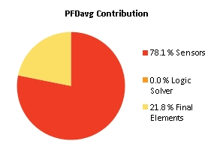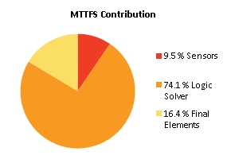
Note: The results shown in this SIL verification Summary are based on detailed calculations. All SIL verification assumptions including used reliability data are documented in the SIL verification Details report.

SIF-059 SIL2 Vätsketryck nedströms pump (345PI326 < (320PZ320/1/2 + 0,5 bar)) => Close Avblödning slamvatten(345SV566)

Project Name |  | Hybrit Pilot Plant | SIF Tag | SIF-059
Unit / Process Area |  |  | SIF Name | SIL2 Vätsketryck nedströms pump (345PI326 < (320PZ320/1/2 + 0,5 bar)) => Close Avblödning slamvatten(345SV566)
Mission Time |  | 15 years
Safety Instrumented Function Performance  Target SIL 2  Target RRF 100  Achieved SIL 2  PFDavg 8.08E-03  SIL (PFDavg) 2  SIL (Arch. Constraints IEC 61511) 2  SIL (Systematic Capability) N/A  Achieved RRF 123.7  MTTFS (years) 37.14 |  |  | PFDavg MTTFS SIL Limit  AC CAP  Sensor Part 4.16E-04 20212.05 2 N/A  Logic Solver Part 3.79E-06 37.91 2 N/A  Final Element Part 7.67E-03 2031.38 2 N/A
Remarks | The SIF operates in Low demand mode.
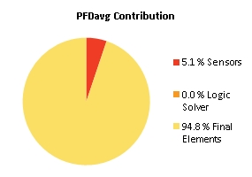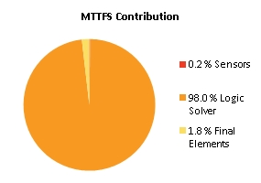
Note: The results shown in this SIL verification Summary are based on detailed calculations. All SIL verification assumptions including used reliability data are documented in the SIL verification Details report.

SIF-060 SIL2 Vätskenivå sludge tank (345LS310|H2) => Close Avstängning tillopp spolvatten (345SV634)

Project Name |  | Hybrit Pilot Plant | SIF Tag | SIF-060
Unit / Process Area |  |  | SIF Name | SIL2 Vätskenivå sludge tank (345LS310|H2) => Close Avstängning tillopp spolvatten (345SV634)
Mission Time |  | 15 years
Safety Instrumented Function Performance  Target SIL 2  Target RRF 100  Achieved SIL 2  PFDavg 7.90E-03  SIL (PFDavg) 2  SIL (Arch. Constraints IEC 61511) 2  SIL (Systematic Capability) N/A  Achieved RRF 126.5  MTTFS (years) 18.31 |  |  | PFDavg MTTFS SIL Limit  AC CAP  Sensor Part 6.69E-04 576.96 2 N/A  Logic Solver Part 7.31E-06 19.43 2 N/A  Final Element Part 7.23E-03 709.66 2 N/A
Remarks | The SIF operates in Low demand mode.
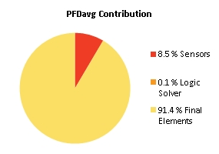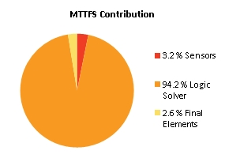
Note: The results shown in this SIL verification Summary are based on detailed calculations. All SIL verification assumptions including used reliability data are documented in the SIL verification Details report.

SIF-061 SIL2 Vätskenivå sludge tank (345LS312|L2) => Close Avblödning slamvatten (345SV566 )

Project Name |  | Hybrit Pilot Plant | SIF Tag | SIF-061
Unit / Process Area |  |  | SIF Name | SIL2 Vätskenivå sludge tank (345LS312|L2) => Close Avblödning slamvatten (345SV566 )
Mission Time |  | 15 years
Safety Instrumented Function Performance  Target SIL 2  Target RRF 100  Achieved SIL 2  PFDavg 8.09E-03  SIL (PFDavg) 2  SIL (Arch. Constraints IEC 61511) 2  SIL (Systematic Capability) N/A  Achieved RRF 123.6  MTTFS (years) 31.67 |  |  | PFDavg MTTFS SIL Limit  AC CAP  Sensor Part 4.23E-04 1212.32 2 N/A  Logic Solver Part 4.91E-06 33.05 2 N/A  Final Element Part 7.67E-03 2031.38 2 N/A
Remarks | The SIF operates in Low demand mode.
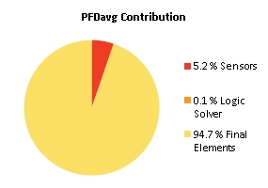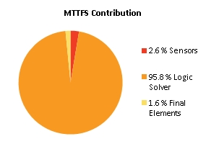
Note: The results shown in this SIL verification Summary are based on detailed calculations. All SIL verification assumptions including used reliability data are documented in the SIL verification Details report.

SIF-062 SIL2 Hög vätskenivå WESP (345LI354/5/6|H2) => Close Avstängning tillopp spolvatten (345SV634)

Project Name |  | Hybrit Pilot Plant | SIF Tag | SIF-062
Unit / Process Area |  |  | SIF Name | SIL2 Hög vätskenivå WESP (345LI354/5/6|H2) => Close Avstängning tillopp spolvatten (345SV634)
Mission Time |  | 15 years
Safety Instrumented Function Performance  Target SIL 2  Target RRF 100  Achieved SIL 2  PFDavg 7.64E-03  SIL (PFDavg) 2  SIL (Arch. Constraints IEC 61511) 2  SIL (Systematic Capability) N/A  Achieved RRF 130.9  MTTFS (years) 15.58 |  |  | PFDavg MTTFS SIL Limit  AC CAP  Sensor Part 4.05E-04 228.67 3 N/A  Logic Solver Part 9.40E-06 17.12 2 N/A  Final Element Part 7.23E-03 709.66 2 N/A
Remarks | The SIF operates in Low demand mode.
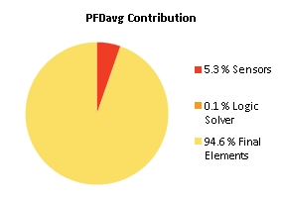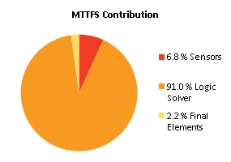
Note: The results shown in this SIL verification Summary are based on detailed calculations. All SIL verification assumptions including used reliability data are documented in the SIL verification Details report.

SIF-063 SIL2 Position avstängning venturihals (345SV520 & 345SV521) => Open avstängning venturihals(345SV522)

Project Name |  | Hybrit Pilot Plant | SIF Tag | SIF-063
Unit / Process Area |  |  | SIF Name | SIL2 Position avstängning venturihals (345SV520 & 345SV521) => Open avstängning venturihals(345SV522)
Mission Time |  | 15 years
Safety Instrumented Function Performance  Target SIL 2  Target RRF 100  Achieved SIL 2  PFDavg 6.50E-03  SIL (PFDavg) 2  SIL (Arch. Constraints IEC 61511) 2  SIL (Systematic Capability) N/A  Achieved RRF 153.8  MTTFS (years) 19.53 |  |  | PFDavg MTTFS SIL Limit  AC CAP  Sensor Part 2.02E-04 40131.7 2 N/A  Logic Solver Part 6.90E-06 20.62 2 N/A  Final Element Part 6.29E-03 372.95 2 N/A
Remarks | The SIF operates in Low demand mode.
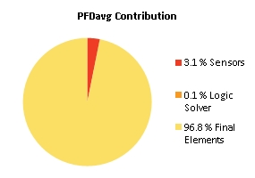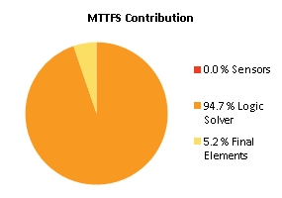
Note: The results shown in this SIL verification Summary are based on detailed calculations. All SIL verification assumptions including used reliability data are documented in the SIL verification Details report.

SIF-064 SIL2 Position avstängning venturihals (345SV520 & 345SV522) => Open avstängning venturihals(345SV521)

Project Name |  | Hybrit Pilot Plant | SIF Tag | SIF-064
Unit / Process Area |  |  | SIF Name | SIL2 Position avstängning venturihals (345SV520 & 345SV522) => Open avstängning venturihals(345SV521)
Mission Time |  | 15 years
Safety Instrumented Function Performance  Target SIL 2  Target RRF 100  Achieved SIL 2  PFDavg 5.44E-03  SIL (PFDavg) 2  SIL (Arch. Constraints IEC 61511) 2  SIL (Systematic Capability) N/A  Achieved RRF 183.8  MTTFS (years) 20.02 |  |  | PFDavg MTTFS SIL Limit  AC CAP  Sensor Part 2.02E-04 40131.7 2 N/A  Logic Solver Part 6.90E-06 20.62 2 N/A  Final Element Part 5.23E-03 708.23 2 N/A
Remarks | The SIF operates in Low demand mode.
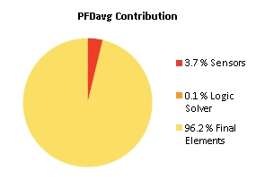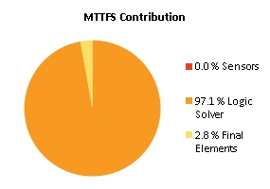
Note: The results shown in this SIL verification Summary are based on detailed calculations. All SIL verification assumptions including used reliability data are documented in the SIL verification Details report.

SIF-065 SIL2 Position avstängning venturihals (345SV521 & 345SV522) => Open avstängning venturihals(345SV520)

Project Name |  | Hybrit Pilot Plant | SIF Tag | SIF-065
Unit / Process Area |  |  | SIF Name | SIL2 Position avstängning venturihals (345SV521 & 345SV522) => Open avstängning venturihals(345SV520)
Mission Time |  | 15 years
Safety Instrumented Function Performance  Target SIL 2  Target RRF 100  Achieved SIL 2  PFDavg 5.44E-03  SIL (PFDavg) 2  SIL (Arch. Constraints IEC 61511) 2  SIL (Systematic Capability) N/A  Achieved RRF 183.8  MTTFS (years) 20.02 |  |  | PFDavg MTTFS SIL Limit  AC CAP  Sensor Part 2.02E-04 40131.7 2 N/A  Logic Solver Part 6.90E-06 20.62 2 N/A  Final Element Part 5.23E-03 708.23 2 N/A
Remarks | The SIF operates in Low demand mode.

Note: The results shown in this SIL verification Summary are based on detailed calculations. All SIL verification assumptions including used reliability data are documented in the SIL verification Details report.

SIF-066 SIL2 Tryckmätare hydrofor ((345PI420/1 )< (320PZ320/1/2 + 0,5 bar)) =>

Close Avstängning tillopp spolvatten (345SV634)

Project Name |  | Hybrit Pilot Plant | SIF Tag | SIF-066
Unit / Process Area |  |  | SIF Name | SIL2 Tryckmätare hydrofor ((345PI420/1 )< (320PZ320/1/2 + 0,5 bar)) =>  Close Avstängning tillopp spolvatten (345SV634)
Mission Time |  | 15 years
Safety Instrumented Function Performance  Target SIL 2  Target RRF 100  Achieved SIL 2  PFDavg 3.84E-03  SIL (PFDavg) 2  SIL (Arch. Constraints IEC 61511) 2  SIL (Systematic Capability) N/A  Achieved RRF 260.3  MTTFS (years) 36.51 |  |  | PFDavg MTTFS SIL Limit  AC CAP  Sensor Part 9.18E-05 3481.2 3 N/A  Logic Solver Part 3.79E-06 37.91 2 N/A  Final Element Part 3.75E-03 1384.78 2 N/A
Remarks | The SIF operates in Low demand mode.
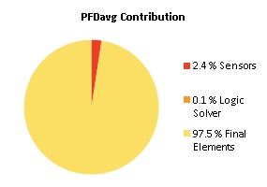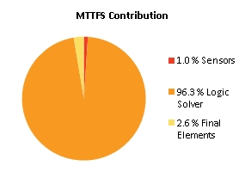
Note: The results shown in this SIL verification Summary are based on detailed calculations. All SIL verification assumptions including used reliability data are documented in the SIL verification Details report.

SIF-067 SIL1 Syrehalt gasväg (353AZ362|H2) => Trip Högspänningsenhet (353EC015)

Project Name |  | Hybrit Pilot Plant | SIF Tag | SIF-067
Unit / Process Area |  |  | SIF Name | SIL1 Syrehalt gasväg (353AZ362|H2) => Trip Högspänningsenhet (353EC015)
Mission Time |  | 15 years
Safety Instrumented Function Performance  Target SIL 1  Target RRF 10  Achieved SIL 1  PFDavg 1.72E-02  SIL (PFDavg) 1  SIL (Arch. Constraints IEC 61511) 2  SIL (Systematic Capability) N/A  Achieved RRF 58.1  MTTFS (years) 14.4 |  |  | PFDavg MTTFS SIL Limit  AC CAP  Sensor Part 1.30E-02 151.42 2 N/A  Logic Solver Part 7.31E-06 19.43 2 N/A  Final Element Part 4.22E-03 87.89 2 N/A
Remarks | The SIF operates in Low demand mode.
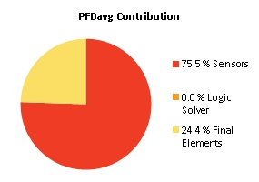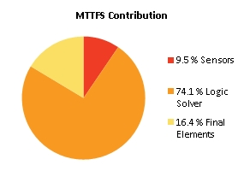
Note: The results shown in this SIL verification Summary are based on detailed calculations. All SIL verification assumptions including used reliability data are documented in the SIL verification Details report.

SIF-068 SIL2 Vätsketryck nedströms pump (353PI326 < (320PZ320/1/2 + 0,5 bar)) => Close Avblödning slamvatten(353SV566 )

Project Name |  | Hybrit Pilot Plant | SIF Tag | SIF-068
Unit / Process Area |  |  | SIF Name | SIL2 Vätsketryck nedströms pump (353PI326 < (320PZ320/1/2 + 0,5 bar)) => Close Avblödning slamvatten(353SV566 )
Mission Time |  | 10 years
Safety Instrumented Function Performance  Target SIL 2  Target RRF 100  Achieved SIL 2  PFDavg 7.47E-03  SIL (PFDavg) 2  SIL (Arch. Constraints IEC 61511) 2  SIL (Systematic Capability) N/A  Achieved RRF 133.8  MTTFS (years) 18.87 |  |  | PFDavg MTTFS SIL Limit  AC CAP  Sensor Part 7.65E-04 10364.55 2 N/A  Logic Solver Part 5.42E-06 19.43 2 N/A  Final Element Part 6.71E-03 709.28 2 N/A
Remarks | The SIF operates in Low demand mode.
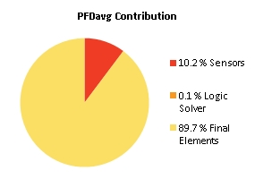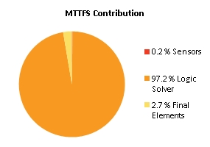
Note: The results shown in this SIL verification Summary are based on detailed calculations. All SIL verification assumptions including used reliability data are documented in the SIL verification Details report.

SIF-069 SIL2 Vätskenivå sludge tank (353LS310|H2) => Close Avstängning tillopp spolvatten (345SV635)

Project Name |  | Hybrit Pilot Plant | SIF Tag | SIF-069
Unit / Process Area |  |  | SIF Name | SIL2 Vätskenivå sludge tank (353LS310|H2) => Close Avstängning tillopp spolvatten (345SV635)
Mission Time |  | 15 years
Safety Instrumented Function Performance  Target SIL 2  Target RRF 0  Achieved SIL 2  PFDavg 7.90E-03  SIL (PFDavg) 2  SIL (Arch. Constraints IEC 61511) 2  SIL (Systematic Capability) N/A  Achieved RRF 126.5  MTTFS (years) 18.31 |  |  | PFDavg MTTFS SIL Limit  AC CAP  Sensor Part 6.69E-04 576.96 2 N/A  Logic Solver Part 7.31E-06 19.43 2 N/A  Final Element Part 7.23E-03 709.66 2 N/A
Remarks | The SIF operates in Low demand mode.

Note: The results shown in this SIL verification Summary are based on detailed calculations. All SIL verification assumptions including used reliability data are documented in the SIL verification Details report.

SIF-070 SIL2 Vätskenivå sludge tank (353LS312|L2) => Close Avblödning slamvatten (353SV566 )

Project Name |  | Hybrit Pilot Plant | SIF Tag | SIF-070
Unit / Process Area |  |  | SIF Name | SIL2 Vätskenivå sludge tank (353LS312|L2) => Close Avblödning slamvatten (353SV566 )
Mission Time |  | 15 years
Safety Instrumented Function Performance  Target SIL 2  Target RRF 0  Achieved SIL 2  PFDavg 8.05E-03  SIL (PFDavg) 2  SIL (Arch. Constraints IEC 61511) 2  SIL (Systematic Capability) N/A  Achieved RRF 124.2  MTTFS (years) 18.35 |  |  | PFDavg MTTFS SIL Limit  AC CAP  Sensor Part 8.22E-04 621.33 2 N/A  Logic Solver Part 7.31E-06 19.43 2 N/A  Final Element Part 7.23E-03 709.66 2 N/A
Remarks | The SIF operates in Low demand mode.
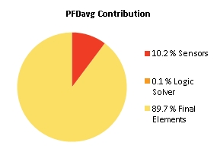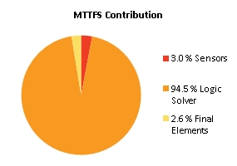
Note: The results shown in this SIL verification Summary are based on detailed calculations. All SIL verification assumptions including used reliability data are documented in the SIL verification Details report.

SIF-071 SIL2 Hög vätskenivå WESP (353LI354/5/6|H2) => Close Avstängning tillopp spolvatten (345SV635)

Project Name |  | Hybrit Pilot Plant | SIF Tag | SIF-071
Unit / Process Area |  |  | SIF Name | SIL2 Hög vätskenivå WESP (353LI354/5/6|H2) => Close Avstängning tillopp spolvatten (345SV635)
Mission Time |  | 15 years
Safety Instrumented Function Performance  Target SIL 2  Target RRF 0  Achieved SIL 2  PFDavg 7.64E-03  SIL (PFDavg) 2  SIL (Arch. Constraints IEC 61511) 2  SIL (Systematic Capability) N/A  Achieved RRF 130.9  MTTFS (years) 15.58 |  |  | PFDavg MTTFS SIL Limit  AC CAP  Sensor Part 4.05E-04 228.67 3 N/A  Logic Solver Part 9.40E-06 17.12 2 N/A  Final Element Part 7.23E-03 709.66 2 N/A
Remarks | The SIF operates in Low demand mode.

Note: The results shown in this SIL verification Summary are based on detailed calculations. All SIL verification assumptions including used reliability data are documented in the SIL verification Details report.

SIF-072 SIL2 Position avstängning venturihals (353SV520 & 353SV521) => Open avstängning venturihals(353SV522)

Project Name |  | Hybrit Pilot Plant | SIF Tag | SIF-072
Unit / Process Area |  |  | SIF Name | SIL2 Position avstängning venturihals (353SV520 & 353SV521) => Open avstängning venturihals(353SV522)
Mission Time |  | 15 years
Safety Instrumented Function Performance  Target SIL 2  Target RRF 0  Achieved SIL 2  PFDavg 6.50E-03  SIL (PFDavg) 2  SIL (Arch. Constraints IEC 61511) 2  SIL (Systematic Capability) N/A  Achieved RRF 153.8  MTTFS (years) 19.53 |  |  | PFDavg MTTFS SIL Limit  AC CAP  Sensor Part 2.02E-04 40131.7 2 N/A  Logic Solver Part 6.90E-06 20.62 2 N/A  Final Element Part 6.29E-03 372.95 2 N/A
Remarks | The SIF operates in Low demand mode.

Note: The results shown in this SIL verification Summary are based on detailed calculations. All SIL verification assumptions including used reliability data are documented in the SIL verification Details report.

SIF-073 SIL2 Position avstängning venturihals (353SV520 & 353SV522) => Open avstängning venturihals(353SV521)

Project Name |  | Hybrit Pilot Plant | SIF Tag | SIF-073
Unit / Process Area |  |  | SIF Name | SIL2 Position avstängning venturihals (353SV520 & 353SV522) => Open avstängning venturihals(353SV521)
Mission Time |  | 15 years
Safety Instrumented Function Performance  Target SIL 2  Target RRF 0  Achieved SIL 2  PFDavg 5.44E-03  SIL (PFDavg) 2  SIL (Arch. Constraints IEC 61511) 2  SIL (Systematic Capability) N/A  Achieved RRF 183.8  MTTFS (years) 20.02 |  |  | PFDavg MTTFS SIL Limit  AC CAP  Sensor Part 2.02E-04 40131.7 2 N/A  Logic Solver Part 6.90E-06 20.62 2 N/A  Final Element Part 5.23E-03 708.23 2 N/A
Remarks | The SIF operates in Low demand mode.

Note: The results shown in this SIL verification Summary are based on detailed calculations. All SIL verification assumptions including used reliability data are documented in the SIL verification Details report.

SIF-074 SIL2 Position avstängning venturihals (353SV521 & 353SV522) => Open avstängning venturihals(353SV520)

Project Name |  | Hybrit Pilot Plant | SIF Tag | SIF-074
Unit / Process Area |  |  | SIF Name | SIL2 Position avstängning venturihals (353SV521 & 353SV522) => Open avstängning venturihals(353SV520)
Mission Time |  | 15 years
Safety Instrumented Function Performance  Target SIL 2  Target RRF 0  Achieved SIL 2  PFDavg 5.44E-03  SIL (PFDavg) 2  SIL (Arch. Constraints IEC 61511) 2  SIL (Systematic Capability) N/A  Achieved RRF 183.8  MTTFS (years) 20.02 |  |  | PFDavg MTTFS SIL Limit  AC CAP  Sensor Part 2.02E-04 40131.7 2 N/A  Logic Solver Part 6.90E-06 20.62 2 N/A  Final Element Part 5.23E-03 708.23 2 N/A
Remarks | The SIF operates in Low demand mode.

Note: The results shown in this SIL verification Summary are based on detailed calculations. All SIL verification assumptions including used reliability data are documented in the SIL verification Details report.

SIF-075 SIL2 Tryckvakt efter N2 bufferttank 253TA005-reduktionsgastryck ((253PZ323, 253PZ324, 253PZ325) - (343PZ305, 343PZ307, 343PZ308) < 0,5) => Close N2 till reduktionskrets (254SV582)

Project Name |  | Hybrit Pilot Plant | SIF Tag | SIF-075
Unit / Process Area |  |  | SIF Name | SIL2 Tryckvakt efter N2 bufferttank 253TA005-reduktionsgastryck ((253PZ323, 253PZ324, 253PZ325) - (343PZ305, 343PZ307, 343PZ308) < 0,5) => Close N2 till reduktionskrets (254SV582)
Mission Time |  | 15 years
Safety Instrumented Function Performance  Target SIL 2  Target RRF 100  Achieved SIL 2  PFDavg 7.36E-03  SIL (PFDavg) 2  SIL (Arch. Constraints IEC 61511) 2  SIL (Systematic Capability) N/A  Achieved RRF 135.8  MTTFS (years) 18.88 |  |  | PFDavg MTTFS SIL Limit  AC CAP  Sensor Part 5.37E-04 10637.24 3 N/A  Logic Solver Part 7.31E-06 19.43 2 N/A  Final Element Part 6.82E-03 712.14 2 N/A
Remarks | The SIF operates in Low demand mode.
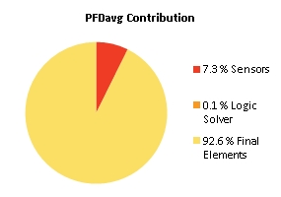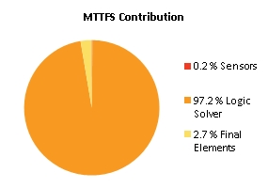
Note: The results shown in this SIL verification Summary are based on detailed calculations. All SIL verification assumptions including used reliability data are documented in the SIL verification Details report.

SIF-076 SIL2 Hög nivå i ångpanna 271AG001 (271LZ316|H2) =>

Close Avstängningsventil 2 överhettad ånga till PGH (271SV556)

Project Name |  | Hybrit Pilot Plant | SIF Tag | SIF-076
Unit / Process Area |  |  | SIF Name | SIL2 Hög nivå i ångpanna 271AG001 (271LZ316|H2) =>  Close Avstängningsventil 2 överhettad ånga till PGH (271SV556)
Mission Time |  | 15 years
Safety Instrumented Function Performance  Target SIL 2  Target RRF 100  Achieved SIL 2  PFDavg 8.15E-03  SIL (PFDavg) 2  SIL (Arch. Constraints IEC 61511) 2  SIL (Systematic Capability) N/A  Achieved RRF 122.7  MTTFS (years) 21.61 |  |  | PFDavg MTTFS SIL Limit  AC CAP  Sensor Part 1.58E-04 3060.49 2 N/A  Logic Solver Part 5.24E-06 22.45 2 N/A  Final Element Part 7.98E-03 712.98 2 N/A
Remarks | The SIF operates in Low demand mode.
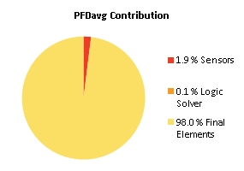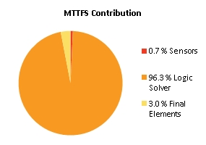
Note: The results shown in this SIL verification Summary are based on detailed calculations. All SIL verification assumptions including used reliability data are documented in the SIL verification Details report.

SIF-077 Temp efter O2-förångare vid tankparken (251TI300 |L2) =>

Close Avstängningsventil O2 efter tankpark (251SV520)

Project Name |  | Hybrit Pilot Plant | SIF Tag | SIF-077
Unit / Process Area |  |  | SIF Name | Temp efter O2-förångare vid tankparken (251TI300 |L2) =>  Close Avstängningsventil O2 efter tankpark (251SV520)
Mission Time |  | 15 years
Safety Instrumented Function Performance  Target SIL 2  Target RRF 100  Achieved SIL 2  PFDavg 9.19E-03  SIL (PFDavg) 2  SIL (Arch. Constraints IEC 61511) 2  SIL (Systematic Capability) N/A  Achieved RRF 108.8  MTTFS (years) 18.24 |  |  | PFDavg MTTFS SIL Limit  AC CAP  Sensor Part 1.21E-03 513.5 2 N/A  Logic Solver Part 7.31E-06 19.43 2 N/A  Final Element Part 7.98E-03 712.98 2 N/A
Remarks | The SIF operates in Low demand mode.
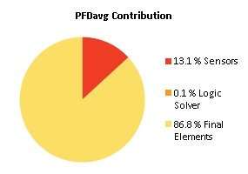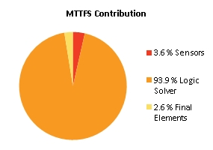
Note: The results shown in this SIL verification Summary are based on detailed calculations. All SIL verification assumptions including used reliability data are documented in the SIL verification Details report.

SIF-078 SIL2 253PZ352 (TRYCKMÄTNING 320YM005) => Close 253SV631

Project Name |  | Hybrit Pilot Plant | SIF Tag | SIF-078
Unit / Process Area |  |  | SIF Name | SIL2 253PZ352 (TRYCKMÄTNING 320YM005) => Close 253SV631
Mission Time |  | 15 years
Safety Instrumented Function Performance  Target SIL TBD  Target RRF 0  Achieved SIL 0  PFDavg 0.00E+00  SIL (PFDavg) 0  SIL (Arch. Constraints IEC 61508) 0  SIL (Systematic Capability) 0  Achieved RRF 0  MTTFS (years) ∞ |  |  | PFDavg MTTFS SIL Limit  AC CAP  Sensor Part 3.85E-04 93.33 2 2  Logic Solver Part 3.11E-06 27.05 2 2  Final Element Part 0.00E+00 ∞ 0 0
Remarks | The SIF operates in Low demand mode.
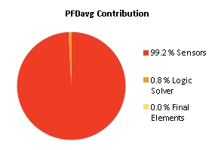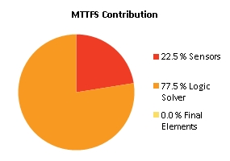
Note: The results shown in this SIL verification Summary are based on detailed calculations. All SIL verification assumptions including used reliability data are documented in the SIL verification Details report.

SIF-079 SIL2 341PZ401 (H2/L2) => close H2

Project Name |  | Hybrit Pilot Plant | SIF Tag | SIF-079
Unit / Process Area |  |  | SIF Name | SIL2 341PZ401 (H2/L2) => close H2
Mission Time |  | 15 years
Safety Instrumented Function Performance  Target SIL 2  Target RRF 100  Achieved SIL 2  PFDavg 6.59E-03  SIL (PFDavg) 2  SIL (Arch. Constraints IEC 61511) 2  SIL (Systematic Capability) N/A  Achieved RRF 151.6  MTTFS (years) 27.36 |  |  | PFDavg MTTFS SIL Limit  AC CAP  Sensor Part 3.58E-04 533.14 2 N/A  Logic Solver Part 6.05E-06 29.3 2 N/A  Final Element Part 6.24E-03 1825.59 2 N/A
Remarks | The SIF operates in Low demand mode.
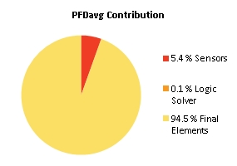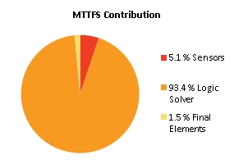
Note: The results shown in this SIL verification Summary are based on detailed calculations. All SIL verification assumptions including used reliability data are documented in the SIL verification Details report.

SIF-080 SIL1 271XI323 Ånga ej tillräckligt överhettad => close 271SV556

Project Name |  | Hybrit Pilot Plant | SIF Tag | SIF-080
Unit / Process Area |  |  | SIF Name | SIL1 271XI323 Ånga ej tillräckligt överhettad => close 271SV556
Mission Time |  | 15 years
Safety Instrumented Function Performance  Target SIL 1  Target RRF 10  Achieved SIL 1  PFDavg 1.46E-02  SIL (PFDavg) 1  SIL (Arch. Constraints IEC 61511) 2  SIL (Systematic Capability) N/A  Achieved RRF 68.6  MTTFS (years) 18.9 |  |  | PFDavg MTTFS SIL Limit  AC CAP  Sensor Part 6.63E-03 50602.91 2 N/A  Logic Solver Part 7.31E-06 19.43 2 N/A  Final Element Part 7.98E-03 712.98 2 N/A
Remarks | The SIF operates in Low demand mode.
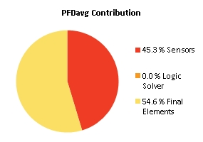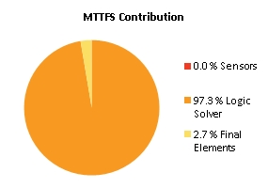
Note: The results shown in this SIL verification Summary are based on detailed calculations. All SIL verification assumptions including used reliability data are documented in the SIL verification Details report.

SIF-081 SIL2 Mätvärde på tillsatt flöde naturgas 252XI565*K

Project Name |  | Hybrit Pilot Plant | SIF Tag | SIF-081
Unit / Process Area |  |  | SIF Name | SIL2 Mätvärde på tillsatt flöde naturgas 252XI565*K
Mission Time |  | 15 years
Safety Instrumented Function Performance  Target SIL 2  Target RRF 100  Achieved SIL 2  PFDavg 3.93E-03  SIL (PFDavg) 2  SIL (Arch. Constraints IEC 61511) 2  SIL (Systematic Capability) N/A  Achieved RRF 254.5  MTTFS (years) 16.33 |  |  | PFDavg MTTFS SIL Limit  AC CAP  Sensor Part 1.89E-03 5138.39 2 N/A  Logic Solver Part 9.40E-06 17.12 2 N/A  Final Element Part 2.04E-03 378.21 3 N/A
Remarks | The SIF operates in Low demand mode.
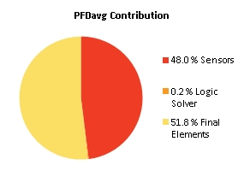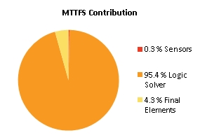
Note: The results shown in this SIL verification Summary are based on detailed calculations. All SIL verification assumptions including used reliability data are documented in the SIL verification Details report.

SIF-082 SIL2 252PZ337 (H2/L2) => close NG

Project Name |  | Hybrit Pilot Plant | SIF Tag | SIF-082
Unit / Process Area |  |  | SIF Name | SIL2 252PZ337 (H2/L2) => close NG
Mission Time |  | 15 years
Safety Instrumented Function Performance  Target SIL 2  Target RRF 100  Achieved SIL 2  PFDavg 1.78E-03  SIL (PFDavg) 2  SIL (Arch. Constraints IEC 61511) 2  SIL (Systematic Capability) N/A  Achieved RRF 560.9  MTTFS (years) 33.78 |  |  | PFDavg MTTFS SIL Limit  AC CAP  Sensor Part 3.58E-04 533.14 2 N/A  Logic Solver Part 3.79E-06 37.91 2 N/A  Final Element Part 1.42E-03 741.34 3 N/A
Remarks | The SIF operates in Low demand mode.
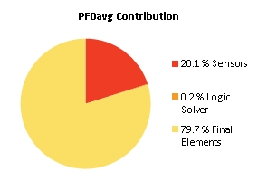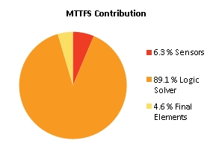
Note: The results shown in this SIL verification Summary are based on detailed calculations. All SIL verification assumptions including used reliability data are documented in the SIL verification Details report.

SIF-083 Beräkning difftryck 253XI364|L2 (Skydd mot backflöde processgas till N2 och/eller O2 vid syrgasinjektion) 253XI364 = (2oo3(253PZ362, 253PZ363, 253PZ364) - 344PZ321)

Project Name |  | Hybrit Pilot Plant | SIF Tag | SIF-083
Unit / Process Area |  |  | SIF Name | Beräkning difftryck 253XI364|L2 (Skydd mot backflöde processgas till N2 och/eller O2 vid syrgasinjektion) 253XI364 = (2oo3(253PZ362, 253PZ363, 253PZ364) - 344PZ321)
Mission Time |  | 15 years
Safety Instrumented Function Performance  Target SIL 0  Target RRF 1  Achieved SIL 2  PFDavg 2.71E-03  SIL (PFDavg) 2  SIL (Arch. Constraints IEC 61511) 2  SIL (Systematic Capability) N/A  Achieved RRF 369.2  MTTFS (years) 18.3 |  |  | PFDavg MTTFS SIL Limit  AC CAP  Sensor Part 8.94E-04 1886.25 2 N/A  Logic Solver Part 7.31E-06 19.43 2 N/A  Final Element Part 1.81E-03 377.66 3 N/A
Remarks | The SIF operates in Low demand mode.
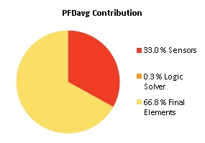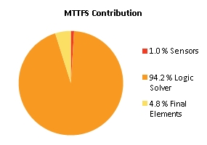
Note: The results shown in this SIL verification Summary are based on detailed calculations. All SIL verification assumptions including used reliability data are documented in the SIL verification Details report.

SIF-084 SIL2 Hög vätskenivå WESP (353XI354) (353LI354/5/6|H2)

Project Name |  | Hybrit Pilot Plant | SIF Tag | SIF-084
Unit / Process Area |  |  | SIF Name | SIL2 Hög vätskenivå WESP (353XI354) (353LI354/5/6|H2)
Mission Time |  | 15 years
Safety Instrumented Function Performance  Target SIL 2  Target RRF 100  Achieved SIL 2  PFDavg 3.23E-03  SIL (PFDavg) 2  SIL (Arch. Constraints IEC 61511) 2  SIL (Systematic Capability) N/A  Achieved RRF 309.4  MTTFS (years) 17.62 |  |  | PFDavg MTTFS SIL Limit  AC CAP  Sensor Part 4.05E-04 228.67 3 N/A  Logic Solver Part 7.31E-06 19.43 2 N/A  Final Element Part 2.82E-03 1095.95 2 N/A
Remarks | The SIF operates in Low demand mode.
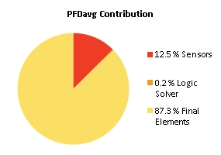
Note: The results shown in this SIL verification Summary are based on detailed calculations. All SIL verification assumptions including used reliability data are documented in the SIL verification Details report.

SIF-085 SIL2 Reduktionsgasvärmare trip/ej i drift (344MA001_RUN_N)

Project Name |  | Hybrit Pilot Plant | SIF Tag | SIF-085
Unit / Process Area |  |  | SIF Name | SIL2 Reduktionsgasvärmare trip/ej i drift (344MA001_RUN_N)
Mission Time |  | 10 years
Safety Instrumented Function Performance  Target SIL 2  Target RRF 100  Achieved SIL 2  PFDavg 8.98E-03  SIL (PFDavg) 2  SIL (Arch. Constraints IEC 61511) 2  SIL (Systematic Capability) N/A  Achieved RRF 111.3  MTTFS (years) 33.87 |  |  | PFDavg MTTFS SIL Limit  AC CAP  Sensor Part 4.15E-03 31371.67 2 N/A  Logic Solver Part 3.45E-06 34.63 2 N/A  Final Element Part 4.87E-03 1638.37 2 N/A
Remarks | The SIF operates in Low demand mode.
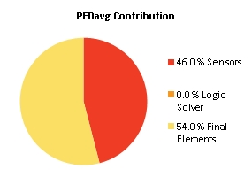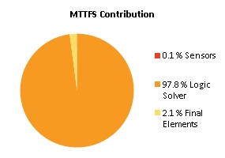
Note: The results shown in this SIL verification Summary are based on detailed calculations. All SIL verification assumptions including used reliability data are documented in the SIL verification Details report.

SIF-086 SIL1 | Lye Temperature H2 A (341TZ300 TZA HH) => Stop electrolyzer A

Project Name |  | Hybrit Pilot Plant | SIF Tag | SIF-086
Unit / Process Area |  |  | SIF Name | SIL1 | Lye Temperature H2 A (341TZ300 TZA HH) => Stop electrolyzer A
Mission Time |  | 15 years
Safety Instrumented Function Performance  Target SIL 1  Target RRF 10  Achieved SIL 2  PFDavg 6.85E-03  SIL (PFDavg) 2  SIL (Arch. Constraints IEC 61511) 2  SIL (Systematic Capability) N/A  Achieved RRF 145.9  MTTFS (years) 17.7 |  |  | PFDavg MTTFS SIL Limit  AC CAP  Sensor Part 1.21E-03 117.1 2 N/A  Logic Solver Part 3.11E-06 27.05 2 N/A  Final Element Part 5.64E-03 90.96 2 N/A
Remarks | The SIF operates in Low demand mode.
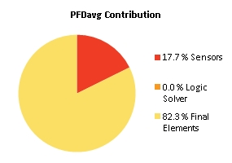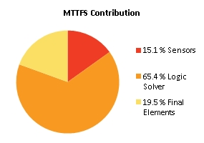
Note: The results shown in this SIL verification Summary are based on detailed calculations. All SIL verification assumptions including used reliability data are documented in the SIL verification Details report.

SIF-087 SIL1 | Lye Temperature O2 A (341TZ303 TZA HH) => Stop electrolyzer A

Project Name |  | Hybrit Pilot Plant | SIF Tag | SIF-087
Unit / Process Area |  |  | SIF Name | SIL1 | Lye Temperature O2 A (341TZ303 TZA HH) => Stop electrolyzer A
Mission Time |  | 15 years
Safety Instrumented Function Performance  Target SIL 1  Target RRF 10  Achieved SIL 2  PFDavg 6.85E-03  SIL (PFDavg) 2  SIL (Arch. Constraints IEC 61511) 2  SIL (Systematic Capability) N/A  Achieved RRF 145.9  MTTFS (years) 17.7 |  |  | PFDavg MTTFS SIL Limit  AC CAP  Sensor Part 1.21E-03 117.1 2 N/A  Logic Solver Part 3.11E-06 27.05 2 N/A  Final Element Part 5.64E-03 90.96 2 N/A
Remarks | The SIF operates in Low demand mode.

Note: The results shown in this SIL verification Summary are based on detailed calculations. All SIL verification assumptions including used reliability data are documented in the SIL verification Details report.

SIF-088 SIL1 | Lye Temperature H2 B (341TZ320 TZA HH) => Stop electrolyzer B

Project Name |  | Hybrit Pilot Plant | SIF Tag | SIF-088
Unit / Process Area |  |  | SIF Name | SIL1 | Lye Temperature H2 B (341TZ320 TZA HH) => Stop electrolyzer B
Mission Time |  | 15 years
Safety Instrumented Function Performance  Target SIL 1  Target RRF 10  Achieved SIL 2  PFDavg 6.85E-03  SIL (PFDavg) 2  SIL (Arch. Constraints IEC 61511) 2  SIL (Systematic Capability) N/A  Achieved RRF 145.9  MTTFS (years) 17.7 |  |  | PFDavg MTTFS SIL Limit  AC CAP  Sensor Part 1.21E-03 117.1 2 N/A  Logic Solver Part 3.11E-06 27.05 2 N/A  Final Element Part 5.64E-03 90.96 2 N/A
Remarks | The SIF operates in Low demand mode.

Note: The results shown in this SIL verification Summary are based on detailed calculations. All SIL verification assumptions including used reliability data are documented in the SIL verification Details report.

SIF-089 SIL1 | Lye Temperature O2 B (341TZ323 TZA HH) => Stop electrolyzer B

Project Name |  | Hybrit Pilot Plant | SIF Tag | SIF-089
Unit / Process Area |  |  | SIF Name | SIL1 | Lye Temperature O2 B (341TZ323 TZA HH) => Stop electrolyzer B
Mission Time |  | 15 years
Safety Instrumented Function Performance  Target SIL 1  Target RRF 10  Achieved SIL 2  PFDavg 6.85E-03  SIL (PFDavg) 2  SIL (Arch. Constraints IEC 61511) 2  SIL (Systematic Capability) N/A  Achieved RRF 145.9  MTTFS (years) 17.7 |  |  | PFDavg MTTFS SIL Limit  AC CAP  Sensor Part 1.21E-03 117.1 2 N/A  Logic Solver Part 3.11E-06 27.05 2 N/A  Final Element Part 5.64E-03 90.96 2 N/A
Remarks | The SIF operates in Low demand mode.

Note: The results shown in this SIL verification Summary are based on detailed calculations. All SIL verification assumptions including used reliability data are documented in the SIL verification Details report.

SIF-090 SIL2 | O2 Separator A Level Transmitter 2 (341LZ306 LZA LLL) => Stop electrolyzer A

Project Name |  | Hybrit Pilot Plant | SIF Tag | SIF-090
Unit / Process Area |  |  | SIF Name | SIL2 | O2 Separator A Level Transmitter 2 (341LZ306 LZA LLL) => Stop electrolyzer A
Mission Time |  | 15 years
Safety Instrumented Function Performance  Target SIL 2  Target RRF 100  Achieved SIL 2  PFDavg 5.98E-03  SIL (PFDavg) 2  SIL (Arch. Constraints IEC 61511) 2  SIL (Systematic Capability) N/A  Achieved RRF 167.1  MTTFS (years) 17.48 |  |  | PFDavg MTTFS SIL Limit  AC CAP  Sensor Part 3.37E-04 108.08 2 N/A  Logic Solver Part 3.11E-06 27.05 2 N/A  Final Element Part 5.64E-03 90.96 2 N/A
Remarks | The SIF operates in Low demand mode.
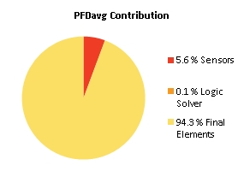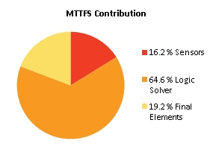
Note: The results shown in this SIL verification Summary are based on detailed calculations. All SIL verification assumptions including used reliability data are documented in the SIL verification Details report.

SIF-091 SIL2 | O2 Separator B Level Transmitter 2 (341LZ326 LZA LLL) => Stop electrolyzer B

Project Name |  | Hybrit Pilot Plant | SIF Tag | SIF-091
Unit / Process Area |  |  | SIF Name | SIL2 | O2 Separator B Level Transmitter 2 (341LZ326 LZA LLL) => Stop electrolyzer B
Mission Time |  | 15 years
Safety Instrumented Function Performance  Target SIL 2  Target RRF 100  Achieved SIL 2  PFDavg 5.98E-03  SIL (PFDavg) 2  SIL (Arch. Constraints IEC 61511) 2  SIL (Systematic Capability) N/A  Achieved RRF 167.1  MTTFS (years) 17.48 |  |  | PFDavg MTTFS SIL Limit  AC CAP  Sensor Part 3.37E-04 108.08 2 N/A  Logic Solver Part 3.11E-06 27.05 2 N/A  Final Element Part 5.64E-03 90.96 2 N/A
Remarks | The SIF operates in Low demand mode.

Note: The results shown in this SIL verification Summary are based on detailed calculations. All SIL verification assumptions including used reliability data are documented in the SIL verification Details report.

SIF-092 SIL1 | O2 in H2 A Analyzer (341QZ319 QA HH) => Stop electrolyzer A and successfull nitrogen purging

Project Name |  | Hybrit Pilot Plant | SIF Tag | SIF-092
Unit / Process Area |  |  | SIF Name | SIL1 | O2 in H2 A Analyzer (341QZ319 QA HH) => Stop electrolyzer A and successfull nitrogen purging
Mission Time |  | 15 years
Safety Instrumented Function Performance  Target SIL 1  Target RRF 10  Achieved SIL 1  PFDavg 3.22E-02  SIL (PFDavg) 1  SIL (Arch. Constraints IEC 61511) 2  SIL (Systematic Capability) N/A  Achieved RRF 31  MTTFS (years) 24.53 |  |  | PFDavg MTTFS SIL Limit  AC CAP  Sensor Part 4.90E-03 306.91 2 N/A  Logic Solver Part 3.11E-06 27.05 2 N/A  Final Element Part 2.74E-02 1843.7 2 N/A
Remarks | The SIF operates in Low demand mode.
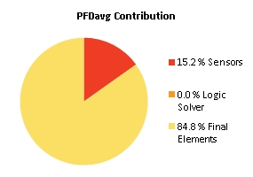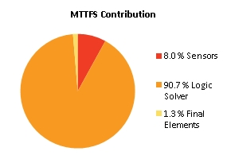
Note: The results shown in this SIL verification Summary are based on detailed calculations. All SIL verification assumptions including used reliability data are documented in the SIL verification Details report.

SIF-093 SIL1 | O2 in H2 B Analyzer (341QZ339 QA HH) => Stop electrolyzer B and successfull nitrogen purging

Project Name |  | Hybrit Pilot Plant | SIF Tag | SIF-093
Unit / Process Area |  |  | SIF Name | SIL1 | O2 in H2 B Analyzer (341QZ339 QA HH) => Stop electrolyzer B and successfull nitrogen purging
Mission Time |  | 15 years
Safety Instrumented Function Performance  Target SIL 1  Target RRF 10  Achieved SIL 1  PFDavg 3.22E-02  SIL (PFDavg) 1  SIL (Arch. Constraints IEC 61511) 2  SIL (Systematic Capability) N/A  Achieved RRF 31  MTTFS (years) 24.53 |  |  | PFDavg MTTFS SIL Limit  AC CAP  Sensor Part 4.90E-03 306.91 2 N/A  Logic Solver Part 3.11E-06 27.05 2 N/A  Final Element Part 2.74E-02 1843.7 2 N/A
Remarks | The SIF operates in Low demand mode.

Note: The results shown in this SIL verification Summary are based on detailed calculations. All SIL verification assumptions including used reliability data are documented in the SIL verification Details report.

SIF-094 SIL1 | Lye Flow A (341FZ538 FZA LL) => Stop electrolyzer A

Project Name |  | Hybrit Pilot Plant | SIF Tag | SIF-094
Unit / Process Area |  |  | SIF Name | SIL1 | Lye Flow A (341FZ538 FZA LL) => Stop electrolyzer A
Mission Time |  | 15 years
Safety Instrumented Function Performance  Target SIL 1  Target RRF 10  Achieved SIL 2  PFDavg 6.57E-03  SIL (PFDavg) 2  SIL (Arch. Constraints IEC 61511) 2  SIL (Systematic Capability) N/A  Achieved RRF 152.2  MTTFS (years) 18.9 |  |  | PFDavg MTTFS SIL Limit  AC CAP  Sensor Part 9.26E-04 202.31 2 N/A  Logic Solver Part 3.11E-06 27.05 2 N/A  Final Element Part 5.64E-03 90.96 2 N/A
Remarks | The SIF operates in Low demand mode.
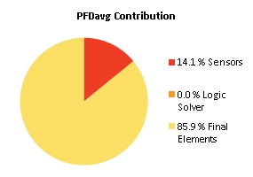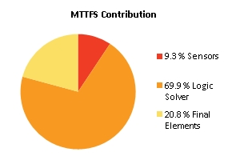
Note: The results shown in this SIL verification Summary are based on detailed calculations. All SIL verification assumptions including used reliability data are documented in the SIL verification Details report.

SIF-095 SIL1 | Lye Flow B (341FZ578 FZA LL) => Stop electrolyzer B

Project Name |  | Hybrit Pilot Plant | SIF Tag | SIF-095
Unit / Process Area |  |  | SIF Name | SIL1 | Lye Flow B (341FZ578 FZA LL) => Stop electrolyzer B
Mission Time |  | 15 years
Safety Instrumented Function Performance  Target SIL 1  Target RRF 10  Achieved SIL 2  PFDavg 6.57E-03  SIL (PFDavg) 2  SIL (Arch. Constraints IEC 61511) 2  SIL (Systematic Capability) N/A  Achieved RRF 152.3  MTTFS (years) 18.9 |  |  | PFDavg MTTFS SIL Limit  AC CAP  Sensor Part 9.25E-04 202.31 2 N/A  Logic Solver Part 3.11E-06 27.05 2 N/A  Final Element Part 5.64E-03 90.96 2 N/A
Remarks | The SIF operates in Low demand mode.
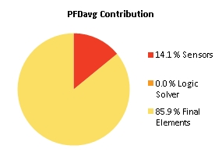
Note: The results shown in this SIL verification Summary are based on detailed calculations. All SIL verification assumptions including used reliability data are documented in the SIL verification Details report.

SIF-096 SIL1 | H2 Gasholder waterseal (341LZ365 LZA LL) => Stop electrolyzer A+B+341PU132+341PU133

Project Name |  | Hybrit Pilot Plant | SIF Tag | SIF-096
Unit / Process Area |  |  | SIF Name | SIL1 | H2 Gasholder waterseal (341LZ365 LZA LL) => Stop electrolyzer A+B+341PU132+341PU133
Mission Time |  | 15 years
Safety Instrumented Function Performance  Target SIL 1  Target RRF 10  Achieved SIL 1  PFDavg 1.19E-02  SIL (PFDavg) 1  SIL (Arch. Constraints IEC 61511) 2  SIL (Systematic Capability) N/A  Achieved RRF 83.7  MTTFS (years) 19.78 |  |  | PFDavg MTTFS SIL Limit  AC CAP  Sensor Part 3.85E-04 93.33 2 N/A  Logic Solver Part 3.11E-06 27.05 2 N/A  Final Element Part 1.16E-02 349.46 2 N/A
Remarks | The SIF operates in Low demand mode.
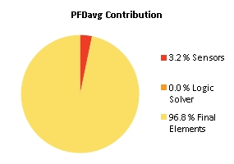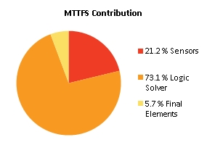
Note: The results shown in this SIL verification Summary are based on detailed calculations. All SIL verification assumptions including used reliability data are documented in the SIL verification Details report.

SIF-097 SIL1 | Compressor Waterseal Level (341LZ366 LZA LL) => Stop electrolyzer A+B+341PU132+341PU133

Project Name |  | Hybrit Pilot Plant | SIF Tag | SIF-097
Unit / Process Area |  |  | SIF Name | SIL1 | Compressor Waterseal Level (341LZ366 LZA LL) => Stop electrolyzer A+B+341PU132+341PU133
Mission Time |  | 15 years
Safety Instrumented Function Performance  Target SIL 1  Target RRF 10  Achieved SIL 1  PFDavg 1.19E-02  SIL (PFDavg) 1  SIL (Arch. Constraints IEC 61511) 2  SIL (Systematic Capability) N/A  Achieved RRF 83.7  MTTFS (years) 19.78 |  |  | PFDavg MTTFS SIL Limit  AC CAP  Sensor Part 3.85E-04 93.33 2 N/A  Logic Solver Part 3.11E-06 27.05 2 N/A  Final Element Part 1.16E-02 349.46 2 N/A
Remarks | The SIF operates in Low demand mode.

Note: The results shown in this SIL verification Summary are based on detailed calculations. All SIL verification assumptions including used reliability data are documented in the SIL verification Details report.

SIF-098 SIL1 | Comp. A Separator 1 level switch H (341LS428 LZA H) => Stop Comp. A motor 341PU132

Project Name |  | Hybrit Pilot Plant | SIF Tag | SIF-098
Unit / Process Area |  |  | SIF Name | SIL1 | Comp. A Separator 1 level switch H (341LS428 LZA H) => Stop Comp. A motor 341PU132
Mission Time |  | 15 years
Safety Instrumented Function Performance  Target SIL 1  Target RRF 10  Achieved SIL 2  PFDavg 8.31E-04  SIL (PFDavg) 3  SIL (Arch. Constraints IEC 61511) 2  SIL (Systematic Capability) N/A  Achieved RRF 1203.7  MTTFS (years) 20.05 |  |  | PFDavg MTTFS SIL Limit  AC CAP  Sensor Part 6.71E-04 120.06 2 N/A  Logic Solver Part 3.11E-06 27.05 2 N/A  Final Element Part 1.57E-04 218.29 2 N/A
Remarks | The SIF operates in Low demand mode.
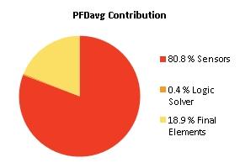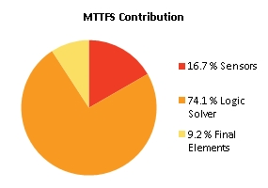
Note: The results shown in this SIL verification Summary are based on detailed calculations. All SIL verification assumptions including used reliability data are documented in the SIL verification Details report.

SIF-099 SIL1 | Comp. A Separator 2 level switch H (341LS438 LZA H) => Stop Comp. A motor 341PU132

Project Name |  | Hybrit Pilot Plant | SIF Tag | SIF-099
Unit / Process Area |  |  | SIF Name | SIL1 | Comp. A Separator 2 level switch H (341LS438 LZA H) => Stop Comp. A motor 341PU132
Mission Time |  | 15 years
Safety Instrumented Function Performance  Target SIL 1  Target RRF 10  Achieved SIL 2  PFDavg 8.31E-04  SIL (PFDavg) 3  SIL (Arch. Constraints IEC 61511) 2  SIL (Systematic Capability) N/A  Achieved RRF 1203.7  MTTFS (years) 20.05 |  |  | PFDavg MTTFS SIL Limit  AC CAP  Sensor Part 6.71E-04 120.06 2 N/A  Logic Solver Part 3.11E-06 27.05 2 N/A  Final Element Part 1.57E-04 218.29 2 N/A
Remarks | The SIF operates in Low demand mode.

Note: The results shown in this SIL verification Summary are based on detailed calculations. All SIL verification assumptions including used reliability data are documented in the SIL verification Details report.

SIF-100 SIL2 | Comp. A Condensate level switch LL (341LS449 LZA LL ) => Close 341SV926

Project Name |  | Hybrit Pilot Plant | SIF Tag | SIF-100
Unit / Process Area |  |  | SIF Name | SIL2 | Comp. A Condensate level switch LL (341LS449 LZA LL ) => Close 341SV926
Mission Time |  | 15 years
Safety Instrumented Function Performance  Target SIL 2  Target RRF 100  Achieved SIL 2  PFDavg 8.91E-03  SIL (PFDavg) 2  SIL (Arch. Constraints IEC 61511) 2  SIL (Systematic Capability) N/A  Achieved RRF 112.1  MTTFS (years) 19.95 |  |  | PFDavg MTTFS SIL Limit  AC CAP  Sensor Part 8.24E-04 121.88 2 N/A  Logic Solver Part 3.11E-06 27.05 2 N/A  Final Element Part 8.09E-03 202.2 2 N/A
Remarks | The SIF operates in Low demand mode.
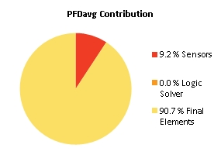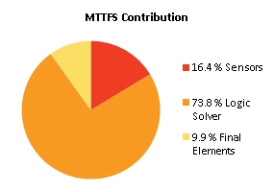
Note: The results shown in this SIL verification Summary are based on detailed calculations. All SIL verification assumptions including used reliability data are documented in the SIL verification Details report.

SIF-101 SIL1 | Comp. A Outlet pressure transmitter (341PS442 PZA HH) => Stop Comp. A motor 341PU132

Project Name |  | Hybrit Pilot Plant | SIF Tag | SIF-101
Unit / Process Area |  |  | SIF Name | SIL1 | Comp. A Outlet pressure transmitter (341PS442 PZA HH) => Stop Comp. A motor 341PU132
Mission Time |  | 15 years
Safety Instrumented Function Performance  Target SIL 1  Target RRF 10  Achieved SIL 2  PFDavg 1.91E-03  SIL (PFDavg) 2  SIL (Arch. Constraints IEC 61511) 2  SIL (Systematic Capability) N/A  Achieved RRF 522.9  MTTFS (years) 20.04 |  |  | PFDavg MTTFS SIL Limit  AC CAP  Sensor Part 1.75E-03 119.82 2 N/A  Logic Solver Part 3.11E-06 27.05 2 N/A  Final Element Part 1.57E-04 218.29 2 N/A
Remarks | The SIF operates in Low demand mode.
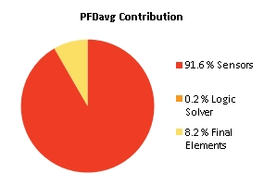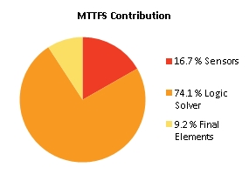
Note: The results shown in this SIL verification Summary are based on detailed calculations. All SIL verification assumptions including used reliability data are documented in the SIL verification Details report.

SIF-102 SIL2 | Comp. A Inlet pressure transmitter (341PS420 PZA LL) => Stop Comp. A motor 341PU132

Project Name |  | Hybrit Pilot Plant | SIF Tag | SIF-102
Unit / Process Area |  |  | SIF Name | SIL2 | Comp. A Inlet pressure transmitter (341PS420 PZA LL) => Stop Comp. A motor 341PU132
Mission Time |  | 15 years
Safety Instrumented Function Performance  Target SIL 2  Target RRF 100  Achieved SIL 2  PFDavg 1.91E-03  SIL (PFDavg) 2  SIL (Arch. Constraints IEC 61511) 2  SIL (Systematic Capability) N/A  Achieved RRF 522.9  MTTFS (years) 20.04 |  |  | PFDavg MTTFS SIL Limit  AC CAP  Sensor Part 1.75E-03 119.82 2 N/A  Logic Solver Part 3.11E-06 27.05 2 N/A  Final Element Part 1.57E-04 218.29 2 N/A
Remarks | The SIF operates in Low demand mode.

Note: The results shown in this SIL verification Summary are based on detailed calculations. All SIL verification assumptions including used reliability data are documented in the SIL verification Details report.

SIF-104 SIL1 | Comp. B Separator 1 level switch H (341LS468 LZA H) => Stop Comp. B motor 341PU133

Project Name |  | Hybrit Pilot Plant | SIF Tag | SIF-104
Unit / Process Area |  |  | SIF Name | SIL1 | Comp. B Separator 1 level switch H (341LS468 LZA H) => Stop Comp. B motor 341PU133
Mission Time |  | 15 years
Safety Instrumented Function Performance  Target SIL 1  Target RRF 10  Achieved SIL 2  PFDavg 8.31E-04  SIL (PFDavg) 3  SIL (Arch. Constraints IEC 61511) 2  SIL (Systematic Capability) N/A  Achieved RRF 1203.7  MTTFS (years) 20.05 |  |  | PFDavg MTTFS SIL Limit  AC CAP  Sensor Part 6.71E-04 120.06 2 N/A  Logic Solver Part 3.11E-06 27.05 2 N/A  Final Element Part 1.57E-04 218.29 2 N/A
Remarks | The SIF operates in Low demand mode.

Note: The results shown in this SIL verification Summary are based on detailed calculations. All SIL verification assumptions including used reliability data are documented in the SIL verification Details report.

SIF-105 SIL1 | Comp. B Separator 2 level switch H (341LS478 LZA H) => Stop Comp. B motor 341PU133

Project Name |  | Hybrit Pilot Plant | SIF Tag | SIF-105
Unit / Process Area |  |  | SIF Name | SIL1 | Comp. B Separator 2 level switch H (341LS478 LZA H) => Stop Comp. B motor 341PU133
Mission Time |  | 15 years
Safety Instrumented Function Performance  Target SIL 1  Target RRF 10  Achieved SIL 2  PFDavg 8.31E-04  SIL (PFDavg) 3  SIL (Arch. Constraints IEC 61511) 2  SIL (Systematic Capability) N/A  Achieved RRF 1203.7  MTTFS (years) 20.05 |  |  | PFDavg MTTFS SIL Limit  AC CAP  Sensor Part 6.71E-04 120.06 2 N/A  Logic Solver Part 3.11E-06 27.05 2 N/A  Final Element Part 1.57E-04 218.29 2 N/A
Remarks | The SIF operates in Low demand mode.

Note: The results shown in this SIL verification Summary are based on detailed calculations. All SIL verification assumptions including used reliability data are documented in the SIL verification Details report.

SIF-106 SIL2 | Comp. B Condensate level switch LL (341LS489 LZA LL) => Close 341SV966

Project Name |  | Hybrit Pilot Plant | SIF Tag | SIF-106
Unit / Process Area |  |  | SIF Name | SIL2 | Comp. B Condensate level switch LL (341LS489 LZA LL) => Close 341SV966
Mission Time |  | 15 years
Safety Instrumented Function Performance  Target SIL 2  Target RRF 100  Achieved SIL 2  PFDavg 8.91E-03  SIL (PFDavg) 2  SIL (Arch. Constraints IEC 61511) 2  SIL (Systematic Capability) N/A  Achieved RRF 112.1  MTTFS (years) 19.95 |  |  | PFDavg MTTFS SIL Limit  AC CAP  Sensor Part 8.24E-04 121.88 2 N/A  Logic Solver Part 3.11E-06 27.05 2 N/A  Final Element Part 8.09E-03 202.2 2 N/A
Remarks | The SIF operates in Low demand mode.

Note: The results shown in this SIL verification Summary are based on detailed calculations. All SIL verification assumptions including used reliability data are documented in the SIL verification Details report.

SIF-107 SIL1 | Comp. B Outlet pressure transmitter (341PS482 PZA HH) => Stop Comp. B motor 341PU133

Project Name |  | Hybrit Pilot Plant | SIF Tag | SIF-107
Unit / Process Area |  |  | SIF Name | SIL1 | Comp. B Outlet pressure transmitter (341PS482 PZA HH) => Stop Comp. B motor 341PU133
Mission Time |  | 15 years
Safety Instrumented Function Performance  Target SIL 1  Target RRF 10  Achieved SIL 2  PFDavg 1.91E-03  SIL (PFDavg) 2  SIL (Arch. Constraints IEC 61511) 2  SIL (Systematic Capability) N/A  Achieved RRF 522.9  MTTFS (years) 20.04 |  |  | PFDavg MTTFS SIL Limit  AC CAP  Sensor Part 1.75E-03 119.82 2 N/A  Logic Solver Part 3.11E-06 27.05 2 N/A  Final Element Part 1.57E-04 218.29 2 N/A
Remarks | The SIF operates in Low demand mode.

Note: The results shown in this SIL verification Summary are based on detailed calculations. All SIL verification assumptions including used reliability data are documented in the SIL verification Details report.

SIF-108 SIL2 | Comp. B Inlet pressure transmitter (341PS460 PZA LL) => Stop Comp. B motor 341PU133

Project Name |  | Hybrit Pilot Plant | SIF Tag | SIF-108
Unit / Process Area |  |  | SIF Name | SIL2 | Comp. B Inlet pressure transmitter (341PS460 PZA LL) => Stop Comp. B motor 341PU133
Mission Time |  | 15 years
Safety Instrumented Function Performance  Target SIL 2  Target RRF 100  Achieved SIL 2  PFDavg 1.91E-03  SIL (PFDavg) 2  SIL (Arch. Constraints IEC 61511) 2  SIL (Systematic Capability) N/A  Achieved RRF 522.9  MTTFS (years) 20.04 |  |  | PFDavg MTTFS SIL Limit  AC CAP  Sensor Part 1.75E-03 119.82 2 N/A  Logic Solver Part 3.11E-06 27.05 2 N/A  Final Element Part 1.57E-04 218.29 2 N/A
Remarks | The SIF operates in Low demand mode.

Note: The results shown in this SIL verification Summary are based on detailed calculations. All SIL verification assumptions including used reliability data are documented in the SIL verification Details report.

SIF-110 SIL2 | Dryer drain level switch (341LZ499 LZA LL) => Close 341SV999

Project Name |  | Hybrit Pilot Plant | SIF Tag | SIF-110
Unit / Process Area |  |  | SIF Name | SIL2 | Dryer drain level switch (341LZ499 LZA LL) => Close 341SV999
Mission Time |  | 15 years
Safety Instrumented Function Performance  Target SIL 2  Target RRF 100  Achieved SIL 2  PFDavg 8.91E-03  SIL (PFDavg) 2  SIL (Arch. Constraints IEC 61511) 2  SIL (Systematic Capability) N/A  Achieved RRF 112.1  MTTFS (years) 19.95 |  |  | PFDavg MTTFS SIL Limit  AC CAP  Sensor Part 8.24E-04 121.88 2 N/A  Logic Solver Part 3.11E-06 27.05 2 N/A  Final Element Part 8.09E-03 202.2 2 N/A
Remarks | The SIF operates in Low demand mode.

Note: The results shown in this SIL verification Summary are based on detailed calculations. All SIL verification assumptions including used reliability data are documented in the SIL verification Details report.

SIF-111 SIL2 | Comp. A Inlet filter level switch H (341LS423 LZA H) => Stop Comp. A motor 341PU132

Project Name |  | Hybrit Pilot Plant | SIF Tag | SIF-111
Unit / Process Area |  |  | SIF Name | SIL2 | Comp. A Inlet filter level switch H (341LS423 LZA H) => Stop Comp. A motor 341PU132
Mission Time |  | 15 years
Safety Instrumented Function Performance  Target SIL 2  Target RRF 100  Achieved SIL 2  PFDavg 7.65E-04  SIL (PFDavg) 3  SIL (Arch. Constraints IEC 61511) 2  SIL (Systematic Capability) N/A  Achieved RRF 1306.5  MTTFS (years) 20.05 |  |  | PFDavg MTTFS SIL Limit  AC CAP  Sensor Part 6.71E-04 120.06 2 N/A  Logic Solver Part 3.11E-06 27.05 2 N/A  Final Element Part 9.14E-05 218.28 2 N/A
Remarks | The SIF operates in Low demand mode.
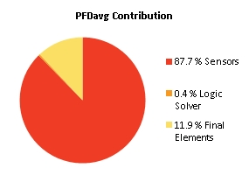
Note: The results shown in this SIL verification Summary are based on detailed calculations. All SIL verification assumptions including used reliability data are documented in the SIL verification Details report.

SIF-112 SIL2 | Comp. B Inlet filter level switch H (341LS463 LZA H ) => Stop Comp. B motor 341PU133

Project Name |  | Hybrit Pilot Plant | SIF Tag | SIF-112
Unit / Process Area |  |  | SIF Name | SIL2 | Comp. B Inlet filter level switch H (341LS463 LZA H ) => Stop Comp. B motor 341PU133
Mission Time |  | 15 years
Safety Instrumented Function Performance  Target SIL 2  Target RRF 100  Achieved SIL 2  PFDavg 7.65E-04  SIL (PFDavg) 3  SIL (Arch. Constraints IEC 61511) 2  SIL (Systematic Capability) N/A  Achieved RRF 1306.5  MTTFS (years) 20.05 |  |  | PFDavg MTTFS SIL Limit  AC CAP  Sensor Part 6.71E-04 120.06 2 N/A  Logic Solver Part 3.11E-06 27.05 2 N/A  Final Element Part 9.14E-05 218.28 2 N/A
Remarks | The SIF operates in Low demand mode.

Note: The results shown in this SIL verification Summary are based on detailed calculations. All SIL verification assumptions including used reliability data are documented in the SIL verification Details report.

SIF-113 SIL2 | Pressure after dryer (341PZ371 not H (6 times) during Nitrogen flushing sequence) => Stop electrolyzer A+B (prevent start)

SIL2 | Pressure after dryer (341PZ371 L2) => Stop electrolyzer A+B (prevent start)

Project Name |  | Hybrit Pilot Plant | SIF Tag | SIF-113
Unit / Process Area |  |  | SIF Name | SIL2 | Pressure after dryer (341PZ371 not H (6 times) during Nitrogen flushing sequence) => Stop electrolyzer A+B (prevent start)  SIL2 | Pressure after dryer (341PZ371 L2) => Stop electrolyzer A+B (prevent start)
Mission Time |  | 15 years
Safety Instrumented Function Performance  Target SIL 2  Target RRF 100  Achieved SIL 2  PFDavg 8.50E-03  SIL (PFDavg) 2  SIL (Arch. Constraints IEC 61511) 2  SIL (Systematic Capability) N/A  Achieved RRF 117.5  MTTFS (years) 22.17 |  |  | PFDavg MTTFS SIL Limit  AC CAP  Sensor Part 2.35E-04 1254.3 2 N/A  Logic Solver Part 3.11E-06 27.05 2 N/A  Final Element Part 8.27E-03 136.23 2 N/A
Remarks | The SIF operates in Low demand mode.
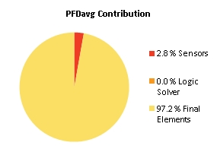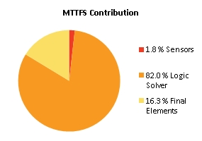
Note: The results shown in this SIL verification Summary are based on detailed calculations. All SIL verification assumptions including used reliability data are documented in the SIL verification Details report.

SIF-114 SIL1 | High temperature Kanthal 354TI442 => stop heater 354HE240

Project Name |  | Hybrit Pilot Plant | SIF Tag | SIF-114
Unit / Process Area |  |  | SIF Name | SIL1 | High temperature Kanthal 354TI442 => stop heater 354HE240
Mission Time |  | 15 years
Safety Instrumented Function Performance  Target SIL 1  Target RRF 10  Achieved SIL 1  PFDavg 1.32E-02  SIL (PFDavg) 1  SIL (Arch. Constraints IEC 61511) 2  SIL (Systematic Capability) N/A  Achieved RRF 75.7  MTTFS (years) 16.07 |  |  | PFDavg MTTFS SIL Limit  AC CAP  Sensor Part 8.72E-04 152.59 2 N/A  Logic Solver Part 3.11E-06 27.05 2 N/A  Final Element Part 1.23E-02 53.46 2 N/A
Remarks | The SIF operates in Low demand mode.
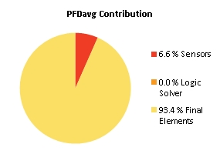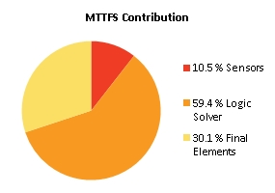
Note: The results shown in this SIL verification Summary are based on detailed calculations. All SIL verification assumptions including used reliability data are documented in the SIL verification Details report.

SIF-115 SIL1 | High temperature Kanthal 354TI443 => stop heater 354HE240

Project Name |  | Hybrit Pilot Plant | SIF Tag | SIF-115
Unit / Process Area |  |  | SIF Name | SIL1 | High temperature Kanthal 354TI443 => stop heater 354HE240
Mission Time |  | 15 years
Safety Instrumented Function Performance  Target SIL 1  Target RRF 10  Achieved SIL 1  PFDavg 1.32E-02  SIL (PFDavg) 1  SIL (Arch. Constraints IEC 61511) 2  SIL (Systematic Capability) N/A  Achieved RRF 75.7  MTTFS (years) 16.07 |  |  | PFDavg MTTFS SIL Limit  AC CAP  Sensor Part 8.72E-04 152.59 2 N/A  Logic Solver Part 3.11E-06 27.05 2 N/A  Final Element Part 1.23E-02 53.46 2 N/A
Remarks | The SIF operates in Low demand mode.

Note: The results shown in this SIL verification Summary are based on detailed calculations. All SIL verification assumptions including used reliability data are documented in the SIL verification Details report.

SIF-116 SIL1 | High temperature Kanthal 354TI444 => stop heater 354HE240

Project Name |  | Hybrit Pilot Plant | SIF Tag | SIF-116
Unit / Process Area |  |  | SIF Name | SIL1 | High temperature Kanthal 354TI444 => stop heater 354HE240
Mission Time |  | 15 years
Safety Instrumented Function Performance  Target SIL 1  Target RRF 10  Achieved SIL 1  PFDavg 1.32E-02  SIL (PFDavg) 1  SIL (Arch. Constraints IEC 61511) 2  SIL (Systematic Capability) N/A  Achieved RRF 75.7  MTTFS (years) 16.07 |  |  | PFDavg MTTFS SIL Limit  AC CAP  Sensor Part 8.72E-04 152.59 2 N/A  Logic Solver Part 3.11E-06 27.05 2 N/A  Final Element Part 1.23E-02 53.46 2 N/A
Remarks | The SIF operates in Low demand mode.

Note: The results shown in this SIL verification Summary are based on detailed calculations. All SIL verification assumptions including used reliability data are documented in the SIL verification Details report.

SIF-117 SIL1 | Temp kondensor processgas (321XI319|H2)

Project Name |  | Hybrit Pilot Plant | SIF Tag | SIF-117
Unit / Process Area |  |  | SIF Name | SIL1 | Temp kondensor processgas (321XI319|H2)
Mission Time |  | 15 years
Safety Instrumented Function Performance  Target SIL 1  Target RRF 10  Achieved SIL 1  PFDavg 1.13E-02  SIL (PFDavg) 1  SIL (Arch. Constraints IEC 61511) 2  SIL (Systematic Capability) N/A  Achieved RRF 88.4  MTTFS (years) 24.25 |  |  | PFDavg MTTFS SIL Limit  AC CAP  Sensor Part 1.32E-04 585.39 3 N/A  Logic Solver Part 3.11E-06 27.05 2 N/A  Final Element Part 1.12E-02 391.09 2 N/A
Remarks | The SIF operates in Low demand mode.
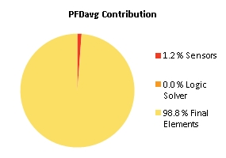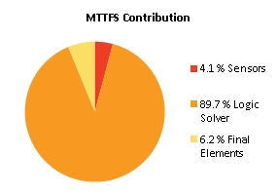
Note: The results shown in this SIL verification Summary are based on detailed calculations. All SIL verification assumptions including used reliability data are documented in the SIL verification Details report.

SIF-118 SIL1 | High temperature Chromalox 354TI331 and 354TI332 (1oo2) => stop heater 354HE230

Project Name |  | Hybrit Pilot Plant | SIF Tag | SIF-118
Unit / Process Area |  |  | SIF Name | SIL1 | High temperature Chromalox 354TI331 and 354TI332 (1oo2) => stop heater 354HE230
Mission Time |  | 15 years
Safety Instrumented Function Performance  Target SIL 1  Target RRF 10  Achieved SIL 1  PFDavg 1.27E-02  SIL (PFDavg) 1  SIL (Arch. Constraints IEC 61511) 2  SIL (Systematic Capability) N/A  Achieved RRF 78.6  MTTFS (years) 13.62 |  |  | PFDavg MTTFS SIL Limit  AC CAP  Sensor Part 3.86E-04 56.31 3 N/A  Logic Solver Part 3.11E-06 27.05 2 N/A  Final Element Part 1.23E-02 53.46 2 N/A
Remarks | The SIF operates in Low demand mode.
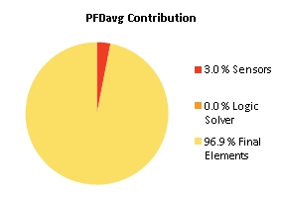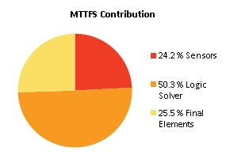
Note: The results shown in this SIL verification Summary are based on detailed calculations. All SIL verification assumptions including used reliability data are documented in the SIL verification Details report.

SIF-119 SIL1 | High temperature Chromalox 354TI335 and 354TI336 (1oo2) => stop heater 354HE230

Project Name |  | Hybrit Pilot Plant | SIF Tag | SIF-119
Unit / Process Area |  |  | SIF Name | SIL1 | High temperature Chromalox 354TI335 and 354TI336 (1oo2) => stop heater 354HE230
Mission Time |  | 15 years
Safety Instrumented Function Performance  Target SIL 1  Target RRF 10  Achieved SIL 1  PFDavg 1.27E-02  SIL (PFDavg) 1  SIL (Arch. Constraints IEC 61511) 2  SIL (Systematic Capability) N/A  Achieved RRF 78.6  MTTFS (years) 13.62 |  |  | PFDavg MTTFS SIL Limit  AC CAP  Sensor Part 3.86E-04 56.31 3 N/A  Logic Solver Part 3.11E-06 27.05 2 N/A  Final Element Part 1.23E-02 53.46 2 N/A
Remarks | The SIF operates in Low demand mode.

Note: The results shown in this SIL verification Summary are based on detailed calculations. All SIL verification assumptions including used reliability data are documented in the SIL verification Details report.

SIF-120 SIL1 | High temperature Chromalox 354TI339 and 354TI340 (1oo2) => stop heater 354HE230

Project Name |  | Hybrit Pilot Plant | SIF Tag | SIF-120
Unit / Process Area |  |  | SIF Name | SIL1 | High temperature Chromalox 354TI339 and 354TI340 (1oo2) => stop heater 354HE230
Mission Time |  | 15 years
Safety Instrumented Function Performance  Target SIL 1  Target RRF 10  Achieved SIL 1  PFDavg 1.27E-02  SIL (PFDavg) 1  SIL (Arch. Constraints IEC 61511) 2  SIL (Systematic Capability) N/A  Achieved RRF 78.6  MTTFS (years) 13.62 |  |  | PFDavg MTTFS SIL Limit  AC CAP  Sensor Part 3.86E-04 56.31 3 N/A  Logic Solver Part 3.11E-06 27.05 2 N/A  Final Element Part 1.23E-02 53.46 2 N/A
Remarks | The SIF operates in Low demand mode.

Note: The results shown in this SIL verification Summary are based on detailed calculations. All SIL verification assumptions including used reliability data are documented in the SIL verification Details report.

SIF-121 SIL2 Gastryck nedre krets (321PI315, 321PI316 & 321PI317|H2)

Project Name |  | Hybrit Pilot Plant | SIF Tag | SIF-121
Unit / Process Area |  |  | SIF Name | SIL2 Gastryck nedre krets (321PI315, 321PI316 & 321PI317|H2)
Mission Time |  | 15 years
Safety Instrumented Function Performance  Target SIL TBD  Target RRF 1  Achieved SIL 2  PFDavg 7.56E-03  SIL (PFDavg) 2  SIL (Arch. Constraints IEC 61511) 2  SIL (Systematic Capability) N/A  Achieved RRF 132.1  MTTFS (years) 23.94 |  |  | PFDavg MTTFS SIL Limit  AC CAP  Sensor Part 6.17E-05 2036.08 3 N/A  Logic Solver Part 3.11E-06 27.05 2 N/A  Final Element Part 7.50E-03 231.72 2 N/A
Remarks | The SIF operates in Low demand mode.
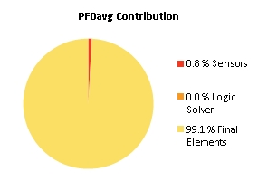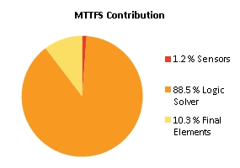
Note: The results shown in this SIL verification Summary are based on detailed calculations. All SIL verification assumptions including used reliability data are documented in the SIL verification Details report.

SIF-122 SIL2 Gastryck nedre krets (321PI315, 321PI316 & 321PI317|L2)

Project Name |  | Hybrit Pilot Plant | SIF Tag | SIF-122
Unit / Process Area |  |  | SIF Name | SIL2 Gastryck nedre krets (321PI315, 321PI316 & 321PI317|L2)
Mission Time |  | 15 years
Safety Instrumented Function Performance  Target SIL TBD  Target RRF 1  Achieved SIL 2  PFDavg 7.64E-03  SIL (PFDavg) 2  SIL (Arch. Constraints IEC 61511) 2  SIL (Systematic Capability) N/A  Achieved RRF 130.9  MTTFS (years) 24.01 |  |  | PFDavg MTTFS SIL Limit  AC CAP  Sensor Part 6.17E-05 2036.08 3 N/A  Logic Solver Part 3.11E-06 27.05 2 N/A  Final Element Part 7.57E-03 238.57 2 N/A
Remarks | The SIF operates in Low demand mode.
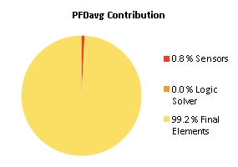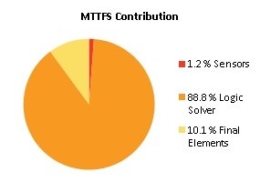
Note: The results shown in this SIL verification Summary are based on detailed calculations. All SIL verification assumptions including used reliability data are documented in the SIL verification Details report.

SIF-123 SIL2 Gastryck nedre krets (321PI315, 321PI316 & 321PI317|H3)

Project Name |  | Hybrit Pilot Plant | SIF Tag | SIF-123
Unit / Process Area |  |  | SIF Name | SIL2 Gastryck nedre krets (321PI315, 321PI316 & 321PI317|H3)
Mission Time |  | 15 years
Safety Instrumented Function Performance  Target SIL TBD  Target RRF 1  Achieved SIL 2  PFDavg 8.89E-03  SIL (PFDavg) 2  SIL (Arch. Constraints IEC 61511) 2  SIL (Systematic Capability) N/A  Achieved RRF 112.5  MTTFS (years) 51.4 |  |  | PFDavg MTTFS SIL Limit  AC CAP  Sensor Part 3.20E-05 3972.77 3 N/A  Logic Solver Part 1.62E-06 52.78 2 N/A  Final Element Part 8.85E-03 3915.32 2 N/A
Remarks | The SIF operates in Low demand mode.
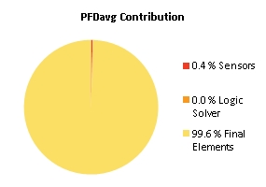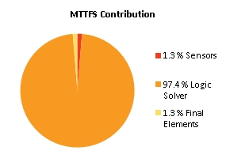
Note: The results shown in this SIL verification Summary are based on detailed calculations. All SIL verification assumptions including used reliability data are documented in the SIL verification Details report.

SIF-124 SIL1 | Low flow to O2 in H2 A Analyzer (341FS315 FZA LL) => Stop electrolyzer A and successfull nitrogen purging

Project Name |  | Hybrit Pilot Plant | SIF Tag | SIF-124
Unit / Process Area |  |  | SIF Name | SIL1 | Low flow to O2 in H2 A Analyzer (341FS315 FZA LL) => Stop electrolyzer A and successfull nitrogen purging
Mission Time |  | 15 years
Safety Instrumented Function Performance  Target SIL 1  Target RRF 10  Achieved SIL 1  PFDavg 2.86E-02  SIL (PFDavg) 1  SIL (Arch. Constraints IEC 61511) 2  SIL (Systematic Capability) N/A  Achieved RRF 34.9  MTTFS (years) 23.76 |  |  | PFDavg MTTFS SIL Limit  AC CAP  Sensor Part 1.18E-03 219.04 2 N/A  Logic Solver Part 3.11E-06 27.05 2 N/A  Final Element Part 2.74E-02 1843.7 2 N/A
Remarks | The SIF operates in Low demand mode.
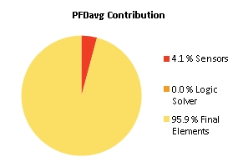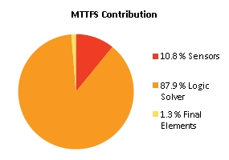
Note: The results shown in this SIL verification Summary are based on detailed calculations. All SIL verification assumptions including used reliability data are documented in the SIL verification Details report.

SIF-125 SIL1 | Low flow to O2 in H2 B Analyzer (341FS335 FZA LL) => Stop electrolyzer B and successfull nitrogen purging

Project Name |  | Hybrit Pilot Plant | SIF Tag | SIF-125
Unit / Process Area |  |  | SIF Name | SIL1 | Low flow to O2 in H2 B Analyzer (341FS335 FZA LL) => Stop electrolyzer B and successfull nitrogen purging
Mission Time |  | 15 years
Safety Instrumented Function Performance  Target SIL 1  Target RRF 10  Achieved SIL 1  PFDavg 2.86E-02  SIL (PFDavg) 1  SIL (Arch. Constraints IEC 61511) 2  SIL (Systematic Capability) N/A  Achieved RRF 34.9  MTTFS (years) 23.76 |  |  | PFDavg MTTFS SIL Limit  AC CAP  Sensor Part 1.18E-03 219.04 2 N/A  Logic Solver Part 3.11E-06 27.05 2 N/A  Final Element Part 2.74E-02 1843.7 2 N/A
Remarks | The SIF operates in Low demand mode.

Note: The results shown in this SIL verification Summary are based on detailed calculations. All SIL verification assumptions including used reliability data are documented in the SIL verification Details report.

SIF-126 SIL1 | Dryer heater outlet temperature transmitter (341TI341 TZA HH) => Stop heater 341HE266

Project Name |  | Hybrit Pilot Plant | SIF Tag | SIF-126
Unit / Process Area |  |  | SIF Name | SIL1 | Dryer heater outlet temperature transmitter (341TI341 TZA HH) => Stop heater 341HE266
Mission Time |  | 15 years
Safety Instrumented Function Performance  Target SIL 1  Target RRF 10  Achieved SIL 2  PFDavg 4.48E-03  SIL (PFDavg) 2  SIL (Arch. Constraints IEC 61511) 2  SIL (Systematic Capability) N/A  Achieved RRF 223.4  MTTFS (years) 19.45 |  |  | PFDavg MTTFS SIL Limit  AC CAP  Sensor Part 3.30E-04 292.22 2 N/A  Logic Solver Part 3.11E-06 27.05 2 N/A  Final Element Part 4.14E-03 90.82 2 N/A
Remarks | The SIF operates in Low demand mode.
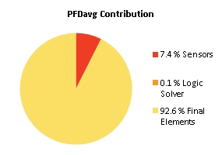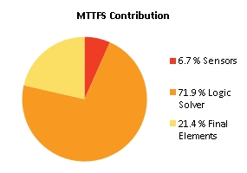
Note: The results shown in this SIL verification Summary are based on detailed calculations. All SIL verification assumptions including used reliability data are documented in the SIL verification Details report.

SIF-127 SIL2 Tryckmätare hydrofor (345PI420/1 )< (321PI315/6/7 + 1,0 bar)

Project Name |  | Hybrit Pilot Plant | SIF Tag | SIF-127
Unit / Process Area |  |  | SIF Name | SIL2 Tryckmätare hydrofor (345PI420/1 )< (321PI315/6/7 + 1,0 bar)
Mission Time |  | 15 years
Safety Instrumented Function Performance  Target SIL 2  Target RRF 100  Achieved SIL 2  PFDavg 7.41E-03  SIL (PFDavg) 2  SIL (Arch. Constraints IEC 61511) 2  SIL (Systematic Capability) N/A  Achieved RRF 134.9  MTTFS (years) 16.56 |  |  | PFDavg MTTFS SIL Limit  AC CAP  Sensor Part 1.77E-04 1785.73 3 N/A  Logic Solver Part 9.40E-06 17.12 2 N/A  Final Element Part 7.22E-03 709.66 2 N/A
Remarks | The SIF operates in Low demand mode.
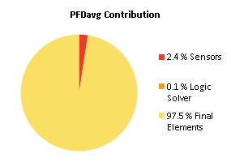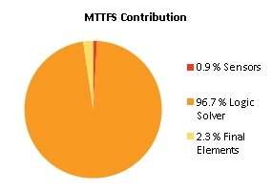
Note: The results shown in this SIL verification Summary are based on detailed calculations. All SIL verification assumptions including used reliability data are documented in the SIL verification Details report.

SIF-128 SIL1 | Difftryck, H2 – Processgas 354XI327|L2 (341PI882 - 354PI326)

Project Name |  | Hybrit Pilot Plant | SIF Tag | SIF-128
Unit / Process Area |  |  | SIF Name | SIL1 | Difftryck, H2 – Processgas 354XI327|L2 (341PI882 - 354PI326)
Mission Time |  | 15 years
Safety Instrumented Function Performance  Target SIL 1  Target RRF 10  Achieved SIL 1  PFDavg 1.48E-02  SIL (PFDavg) 1  SIL (Arch. Constraints IEC 61511) 2  SIL (Systematic Capability) N/A  Achieved RRF 67.5  MTTFS (years) 18.91 |  |  | PFDavg MTTFS SIL Limit  AC CAP  Sensor Part 8.03E-03 268851.38 2 N/A  Logic Solver Part 7.31E-06 19.43 2 N/A  Final Element Part 6.82E-03 712.14 2 N/A
Remarks | The SIF operates in Low demand mode.
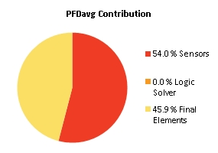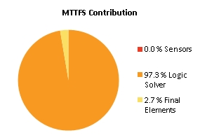
Note: The results shown in this SIL verification Summary are based on detailed calculations. All SIL verification assumptions including used reliability data are documented in the SIL verification Details report.

SIF-129 SIL1 | Difftryck, CO – Processgas 354XI328|L2 (356PI311 - 354PI326)

Project Name |  | Hybrit Pilot Plant | SIF Tag | SIF-129
Unit / Process Area |  |  | SIF Name | SIL1 | Difftryck, CO – Processgas 354XI328|L2 (356PI311 - 354PI326)
Mission Time |  | 15 years
Safety Instrumented Function Performance  Target SIL 1  Target RRF 10  Achieved SIL 1  PFDavg 1.14E-02  SIL (PFDavg) 1  SIL (Arch. Constraints IEC 61511) 2  SIL (Systematic Capability) N/A  Achieved RRF 88  MTTFS (years) 18.89 |  |  | PFDavg MTTFS SIL Limit  AC CAP  Sensor Part 3.40E-03 19570.98 2 N/A  Logic Solver Part 7.31E-06 19.43 2 N/A  Final Element Part 7.98E-03 712.98 2 N/A
Remarks | The SIF operates in Low demand mode.
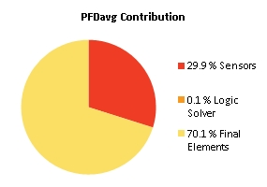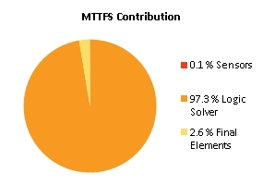
Note: The results shown in this SIL verification Summary are based on detailed calculations. All SIL verification assumptions including used reliability data are documented in the SIL verification Details report.

SIF-130 SIL1 | Difftryck H2-linje till red.krets 343XI308|L2 (341PI675<(343PZ305/7/8+0,5))

Project Name |  | Hybrit Pilot Plant | SIF Tag | SIF-130
Unit / Process Area |  |  | SIF Name | SIL1 | Difftryck H2-linje till red.krets 343XI308|L2 (341PI675<(343PZ305/7/8+0,5))
Mission Time |  | 15 years
Safety Instrumented Function Performance  Target SIL 1  Target RRF 10  Achieved SIL 2  PFDavg 9.79E-03  SIL (PFDavg) 2  SIL (Arch. Constraints IEC 61511) 2  SIL (Systematic Capability) N/A  Achieved RRF 102.1  MTTFS (years) 18.89 |  |  | PFDavg MTTFS SIL Limit  AC CAP  Sensor Part 2.98E-03 13531.06 2 N/A  Logic Solver Part 7.31E-06 19.43 2 N/A  Final Element Part 6.82E-03 712.14 2 N/A
Remarks | The SIF operates in Low demand mode.
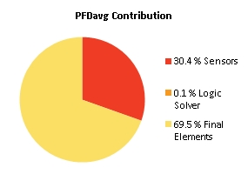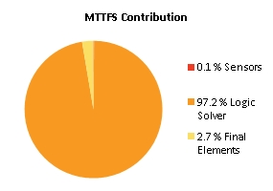
Note: The results shown in this SIL verification Summary are based on detailed calculations. All SIL verification assumptions including used reliability data are documented in the SIL verification Details report.

SIF-131 SIL1 | Difftryck NG-linje till red.krets 343XI307|L2 (252PI565<(343PZ305/7/8+0,5))

Project Name |  | Hybrit Pilot Plant | SIF Tag | SIF-131
Unit / Process Area |  |  | SIF Name | SIL1 | Difftryck NG-linje till red.krets 343XI307|L2 (252PI565<(343PZ305/7/8+0,5))
Mission Time |  | 15 years
Safety Instrumented Function Performance  Target SIL 1  Target RRF 10  Achieved SIL 2  PFDavg 5.09E-03  SIL (PFDavg) 2  SIL (Arch. Constraints IEC 61511) 2  SIL (Systematic Capability) N/A  Achieved RRF 196.5  MTTFS (years) 36.85 |  |  | PFDavg MTTFS SIL Limit  AC CAP  Sensor Part 1.56E-03 26399.15 2 N/A  Logic Solver Part 3.79E-06 37.91 2 N/A  Final Element Part 3.54E-03 1389.63 2 N/A
Remarks | The SIF operates in Low demand mode.
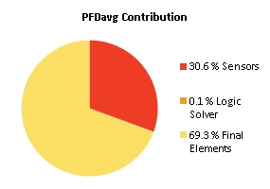
Note: The results shown in this SIL verification Summary are based on detailed calculations. All SIL verification assumptions including used reliability data are documented in the SIL verification Details report.

SIF-132 SIL3 | High pressure downstream of 356RV558 => close 356SV563 & 356SV564 (1oo2)

Project Name |  | Hybrit Pilot Plant | SIF Tag | SIF-132
Unit / Process Area |  |  | SIF Name | SIL3 | High pressure downstream of 356RV558 => close 356SV563 & 356SV564 (1oo2)
Mission Time |  | 10 years
Safety Instrumented Function Performance  Target SIL 3  Target RRF 1000  Achieved SIL 3  PFDavg 8.87E-04  SIL (PFDavg) 3  SIL (Arch. Constraints IEC 61511) 3  SIL (Systematic Capability) N/A  Achieved RRF 1127.6  MTTFS (years) 48.9 |  |  | PFDavg MTTFS SIL Limit  AC CAP  Sensor Part 3.40E-05 151.73 3 N/A  Logic Solver Part 2.25E-08 144 3 N/A  Final Element Part 8.53E-04 144.66 3 N/A
Remarks | The SIF operates in Low demand mode.
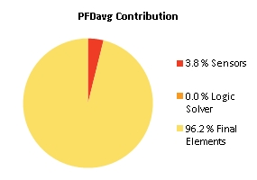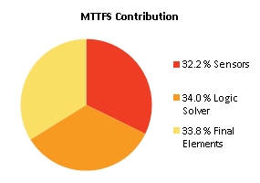
Note: The results shown in this SIL verification Summary are based on detailed calculations. All SIL verification assumptions including used reliability data are documented in the SIL verification Details report.

SIF-133 SIL1 High level (347LZ302) in Absorber (347YM100)

Project Name |  | Hybrit Pilot Plant | SIF Tag | SIF-133
Unit / Process Area |  |  | SIF Name | SIL1 High level (347LZ302) in Absorber (347YM100)
Mission Time |  | 15 years
Safety Instrumented Function Performance  Target SIL 1  Target RRF 10  Achieved SIL 2  PFDavg 2.02E-03  SIL (PFDavg) 2  SIL (Arch. Constraints IEC 61511) 2  SIL (Systematic Capability) N/A  Achieved RRF 494  MTTFS (years) 18.81 |  |  | PFDavg MTTFS SIL Limit  AC CAP  Sensor Part 1.05E-03 263.52 2 N/A  Logic Solver Part 6.90E-06 20.62 2 N/A  Final Element Part 9.68E-04 1162.95 2 N/A
Remarks | The SIF operates in Low demand mode.

Note: The results shown in this SIL verification Summary are based on detailed calculations. All SIL verification assumptions including used reliability data are documented in the SIL verification Details report.

SIF-134 SIL2 Gastemp eft. kylare proc.gaskompressor (oberoende) (354TI410|H2) =>Trip proc.gaskompressor (354PU101 SIL2)

Project Name |  | Hybrit Pilot Plant | SIF Tag | SIF-134
Unit / Process Area |  |  | SIF Name | SIL2 Gastemp eft. kylare proc.gaskompressor (oberoende) (354TI410|H2) =>Trip proc.gaskompressor (354PU101 SIL2)
Mission Time |  | 15 years
Safety Instrumented Function Performance  Target SIL 2  Target RRF 100  Achieved SIL 2  PFDavg 1.56E-03  SIL (PFDavg) 2  SIL (Arch. Constraints IEC 61511) 2  SIL (Systematic Capability) N/A  Achieved RRF 642.4  MTTFS (years) 18.42 |  |  | PFDavg MTTFS SIL Limit  AC CAP  Sensor Part 1.40E-03 554.98 2 N/A  Logic Solver Part 7.31E-06 19.43 2 N/A  Final Element Part 1.53E-04 990.72 2 N/A
Remarks | The SIF operates in Low demand mode.
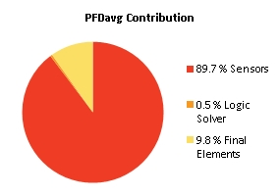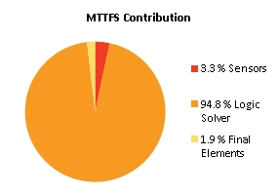
Note: The results shown in this SIL verification Summary are based on detailed calculations. All SIL verification assumptions including used reliability data are documented in the SIL verification Details report.

SIF-135 SIL1 High level (347LS305) filter separator 347SE101

Project Name |  | Hybrit Pilot Plant | SIF Tag | SIF-135
Unit / Process Area |  |  | SIF Name | SIL1 High level (347LS305) filter separator 347SE101
Mission Time |  | 15 years
Safety Instrumented Function Performance  Target SIL 1  Target RRF 10  Achieved SIL 2  PFDavg 1.36E-03  SIL (PFDavg) 2  SIL (Arch. Constraints IEC 61511) 2  SIL (Systematic Capability) N/A  Achieved RRF 734.1  MTTFS (years) 18.8 |  |  | PFDavg MTTFS SIL Limit  AC CAP  Sensor Part 1.20E-03 272.43 2 N/A  Logic Solver Part 6.90E-06 20.62 2 N/A  Final Element Part 1.53E-04 990.72 2 N/A
Remarks | The SIF operates in Low demand mode.
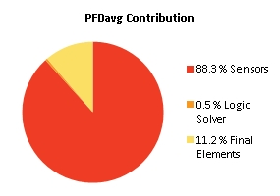
Note: The results shown in this SIL verification Summary are based on detailed calculations. All SIL verification assumptions including used reliability data are documented in the SIL verification Details report.

SIF-136 SIL1 | High temperature Kanthal 344TI340 => stop heater 344HE002

Project Name |  | Hybrit Pilot Plant | SIF Tag | SIF-136
Unit / Process Area |  |  | SIF Name | SIL1 | High temperature Kanthal 344TI340 => stop heater 344HE002
Mission Time |  | 15 years
Safety Instrumented Function Performance  Target SIL 1  Target RRF 10  Achieved SIL 2  PFDavg 6.51E-03  SIL (PFDavg) 2  SIL (Arch. Constraints IEC 61511) 2  SIL (Systematic Capability) N/A  Achieved RRF 153.5  MTTFS (years) 18.34 |  |  | PFDavg MTTFS SIL Limit  AC CAP  Sensor Part 8.72E-04 152.59 2 N/A  Logic Solver Part 3.11E-06 27.05 2 N/A  Final Element Part 5.64E-03 90.96 2 N/A
Remarks | The SIF operates in Low demand mode.
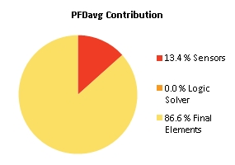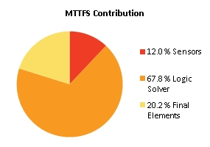
Note: The results shown in this SIL verification Summary are based on detailed calculations. All SIL verification assumptions including used reliability data are documented in the SIL verification Details report.

SIF-137 SIL1 | High temperature Kanthal 344TI341 => stop heater 344HE002

Project Name |  | Hybrit Pilot Plant | SIF Tag | SIF-137
Unit / Process Area |  |  | SIF Name | SIL1 | High temperature Kanthal 344TI341 => stop heater 344HE002
Mission Time |  | 15 years
Safety Instrumented Function Performance  Target SIL 1  Target RRF 10  Achieved SIL 2  PFDavg 6.51E-03  SIL (PFDavg) 2  SIL (Arch. Constraints IEC 61511) 2  SIL (Systematic Capability) N/A  Achieved RRF 153.5  MTTFS (years) 18.34 |  |  | PFDavg MTTFS SIL Limit  AC CAP  Sensor Part 8.72E-04 152.59 2 N/A  Logic Solver Part 3.11E-06 27.05 2 N/A  Final Element Part 5.64E-03 90.96 2 N/A
Remarks | The SIF operates in Low demand mode.

Note: The results shown in this SIL verification Summary are based on detailed calculations. All SIL verification assumptions including used reliability data are documented in the SIL verification Details report.

SIF-138 SIL1 | High temperature Kanthal 344TI342 => stop heater 344HE002

Project Name |  | Hybrit Pilot Plant | SIF Tag | SIF-138
Unit / Process Area |  |  | SIF Name | SIL1 | High temperature Kanthal 344TI342 => stop heater 344HE002
Mission Time |  | 15 years
Safety Instrumented Function Performance  Target SIL 1  Target RRF 10  Achieved SIL 2  PFDavg 6.51E-03  SIL (PFDavg) 2  SIL (Arch. Constraints IEC 61511) 2  SIL (Systematic Capability) N/A  Achieved RRF 153.5  MTTFS (years) 18.34 |  |  | PFDavg MTTFS SIL Limit  AC CAP  Sensor Part 8.72E-04 152.59 2 N/A  Logic Solver Part 3.11E-06 27.05 2 N/A  Final Element Part 5.64E-03 90.96 2 N/A
Remarks | The SIF operates in Low demand mode.

Note: The results shown in this SIL verification Summary are based on detailed calculations. All SIL verification assumptions including used reliability data are documented in the SIL verification Details report.

SIF-139 SIL1 | High temperature Kanthal 344TI343 => stop heater 344HE002

Project Name |  | Hybrit Pilot Plant | SIF Tag | SIF-139
Unit / Process Area |  |  | SIF Name | SIL1 | High temperature Kanthal 344TI343 => stop heater 344HE002
Mission Time |  | 15 years
Safety Instrumented Function Performance  Target SIL 1  Target RRF 10  Achieved SIL 2  PFDavg 6.51E-03  SIL (PFDavg) 2  SIL (Arch. Constraints IEC 61511) 2  SIL (Systematic Capability) N/A  Achieved RRF 153.5  MTTFS (years) 18.34 |  |  | PFDavg MTTFS SIL Limit  AC CAP  Sensor Part 8.72E-04 152.59 2 N/A  Logic Solver Part 3.11E-06 27.05 2 N/A  Final Element Part 5.64E-03 90.96 2 N/A
Remarks | The SIF operates in Low demand mode.

Note: The results shown in this SIL verification Summary are based on detailed calculations. All SIL verification assumptions including used reliability data are documented in the SIL verification Details report.

SIF-140 SIL1 | High temperature Kanthal 344TI344 => stop heater 344HE002

Project Name |  | Hybrit Pilot Plant | SIF Tag | SIF-140
Unit / Process Area |  |  | SIF Name | SIL1 | High temperature Kanthal 344TI344 => stop heater 344HE002
Mission Time |  | 15 years
Safety Instrumented Function Performance  Target SIL 1  Target RRF 10  Achieved SIL 2  PFDavg 6.51E-03  SIL (PFDavg) 2  SIL (Arch. Constraints IEC 61511) 2  SIL (Systematic Capability) N/A  Achieved RRF 153.5  MTTFS (years) 18.34 |  |  | PFDavg MTTFS SIL Limit  AC CAP  Sensor Part 8.72E-04 152.59 2 N/A  Logic Solver Part 3.11E-06 27.05 2 N/A  Final Element Part 5.64E-03 90.96 2 N/A
Remarks | The SIF operates in Low demand mode.

Note: The results shown in this SIL verification Summary are based on detailed calculations. All SIL verification assumptions including used reliability data are documented in the SIL verification Details report.

SIF-141 SIL1 | High temperature Kanthal 344TI345 => stop heater 344HE002

Project Name |  | Hybrit Pilot Plant | SIF Tag | SIF-141
Unit / Process Area |  |  | SIF Name | SIL1 | High temperature Kanthal 344TI345 => stop heater 344HE002
Mission Time |  | 15 years
Safety Instrumented Function Performance  Target SIL 1  Target RRF 10  Achieved SIL 2  PFDavg 6.51E-03  SIL (PFDavg) 2  SIL (Arch. Constraints IEC 61511) 2  SIL (Systematic Capability) N/A  Achieved RRF 153.5  MTTFS (years) 18.34 |  |  | PFDavg MTTFS SIL Limit  AC CAP  Sensor Part 8.72E-04 152.59 2 N/A  Logic Solver Part 3.11E-06 27.05 2 N/A  Final Element Part 5.64E-03 90.96 2 N/A
Remarks | The SIF operates in Low demand mode.

Note: The results shown in this SIL verification Summary are based on detailed calculations. All SIL verification assumptions including used reliability data are documented in the SIL verification Details report.

SIF-143 SIL1 | 343HV500_Ej GSO och / eller 343HV501_Ej GSS => Trip fired heater

Project Name |  | Hybrit Pilot Plant | SIF Tag | SIF-143
Unit / Process Area |  |  | SIF Name | SIL1 | 343HV500_Ej GSO och / eller 343HV501_Ej GSS => Trip fired heater
Mission Time |  | 15 years
Safety Instrumented Function Performance  Target SIL 2  Target RRF 100  Achieved SIL 2  PFDavg 7.11E-03  SIL (PFDavg) 2  SIL (Arch. Constraints IEC 61511) 2  SIL (Systematic Capability) N/A  Achieved RRF 140.7  MTTFS (years) 19.81 |  |  | PFDavg MTTFS SIL Limit  AC CAP  Sensor Part 6.34E-06 2409.2 3 N/A  Logic Solver Part 6.90E-06 20.62 2 N/A  Final Element Part 7.09E-03 642.01 3 N/A
Remarks | The SIF operates in Low demand mode.
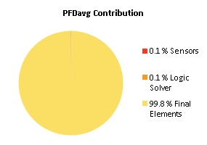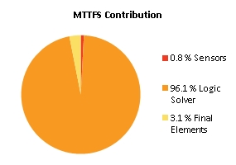
Note: The results shown in this SIL verification Summary are based on detailed calculations. All SIL verification assumptions including used reliability data are documented in the SIL verification Details report.

SIF-144 SIL1| High tempertature in (356TI308) => trip 356HE200

Project Name |  | Hybrit Pilot Plant | SIF Tag | SIF-144
Unit / Process Area |  |  | SIF Name | SIL1| High tempertature in (356TI308) => trip 356HE200
Mission Time |  | 15 years
Safety Instrumented Function Performance  Target SIL TBD  Target RRF 1  Achieved SIL 2  PFDavg 4.76E-03  SIL (PFDavg) 2  SIL (Arch. Constraints IEC 61511) 2  SIL (Systematic Capability) N/A  Achieved RRF 210.1  MTTFS (years) 17.68 |  |  | PFDavg MTTFS SIL Limit  AC CAP  Sensor Part 6.15E-04 116.43 2 N/A  Logic Solver Part 3.11E-06 27.05 2 N/A  Final Element Part 4.14E-03 90.82 2 N/A
Remarks | The SIF operates in Low demand mode.
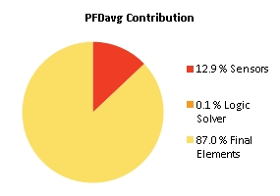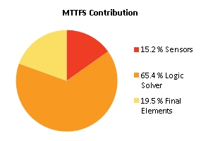
Note: The results shown in this SIL verification Summary are based on detailed calculations. All SIL verification assumptions including used reliability data are documented in the SIL verification Details report.

SIF-301 SIL1|Temperature stage 1 (423TI301) HH => Stop Compressor (423PU001)

Project Name |  | Hybrit Pilot Plant | SIF Tag | SIF-301
Unit / Process Area |  |  | SIF Name | SIL1|Temperature stage 1 (423TI301) HH => Stop Compressor (423PU001)
Mission Time |  | 15 years
Safety Instrumented Function Performance  Target SIL 1  Target RRF 10  Achieved SIL 2  PFDavg 1.38E-03  SIL (PFDavg) 2  SIL (Arch. Constraints IEC 61511) 2  SIL (Systematic Capability) N/A  Achieved RRF 724.9  MTTFS (years) 19.96 |  |  | PFDavg MTTFS SIL Limit  AC CAP  Sensor Part 1.21E-03 117.1 2 N/A  Logic Solver Part 3.11E-06 27.05 2 N/A  Final Element Part 1.66E-04 218.3 2 N/A
Remarks | The SIF operates in Low demand mode.
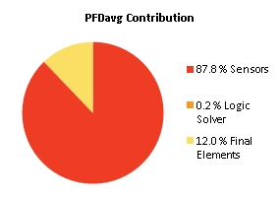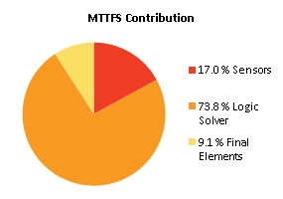
Note: The results shown in this SIL verification Summary are based on detailed calculations. All SIL verification assumptions including used reliability data are documented in the SIL verification Details report.

SIF-302 SIL1|Temperature stage 2 (423TI302) HH => Stop Compressor (423PU001)

Project Name |  | Hybrit Pilot Plant | SIF Tag | SIF-302
Unit / Process Area |  |  | SIF Name | SIL1|Temperature stage 2 (423TI302) HH => Stop Compressor (423PU001)
Mission Time |  | 15 years
Safety Instrumented Function Performance  Target SIL 1  Target RRF 10  Achieved SIL 2  PFDavg 1.38E-03  SIL (PFDavg) 2  SIL (Arch. Constraints IEC 61511) 2  SIL (Systematic Capability) N/A  Achieved RRF 724.9  MTTFS (years) 19.96 |  |  | PFDavg MTTFS SIL Limit  AC CAP  Sensor Part 1.21E-03 117.1 2 N/A  Logic Solver Part 3.11E-06 27.05 2 N/A  Final Element Part 1.66E-04 218.3 2 N/A
Remarks | The SIF operates in Low demand mode.

Note: The results shown in this SIL verification Summary are based on detailed calculations. All SIL verification assumptions including used reliability data are documented in the SIL verification Details report.

SIF-303 SIL1|Temperature stage 3 (423TI303) HH => Stop Compressor (423PU001)

Project Name |  | Hybrit Pilot Plant | SIF Tag | SIF-303
Unit / Process Area |  |  | SIF Name | SIL1|Temperature stage 3 (423TI303) HH => Stop Compressor (423PU001)
Mission Time |  | 15 years
Safety Instrumented Function Performance  Target SIL 1  Target RRF 10  Achieved SIL 2  PFDavg 1.38E-03  SIL (PFDavg) 2  SIL (Arch. Constraints IEC 61511) 2  SIL (Systematic Capability) N/A  Achieved RRF 724.9  MTTFS (years) 19.96 |  |  | PFDavg MTTFS SIL Limit  AC CAP  Sensor Part 1.21E-03 117.1 2 N/A  Logic Solver Part 3.11E-06 27.05 2 N/A  Final Element Part 1.66E-04 218.3 2 N/A
Remarks | The SIF operates in Low demand mode.

Note: The results shown in this SIL verification Summary are based on detailed calculations. All SIL verification assumptions including used reliability data are documented in the SIL verification Details report.

SIF-304 SIL1|High Pressure compressor (423PI304) HH => Stop Compressor (423PU001)

Project Name |  | Hybrit Pilot Plant | SIF Tag | SIF-304
Unit / Process Area |  |  | SIF Name | SIL1|High Pressure compressor (423PI304) HH => Stop Compressor (423PU001)
Mission Time |  | 15 years
Safety Instrumented Function Performance  Target SIL 1  Target RRF 10  Achieved SIL 2  PFDavg 5.54E-04  SIL (PFDavg) 3  SIL (Arch. Constraints IEC 61511) 2  SIL (Systematic Capability) N/A  Achieved RRF 1806.2  MTTFS (years) 19.13 |  |  | PFDavg MTTFS SIL Limit  AC CAP  Sensor Part 3.85E-04 93.33 2 N/A  Logic Solver Part 3.11E-06 27.05 2 N/A  Final Element Part 1.66E-04 218.3 2 N/A
Remarks | The SIF operates in Low demand mode.
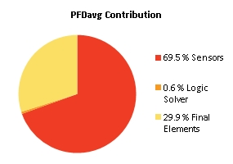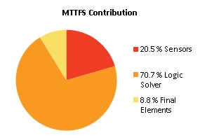
Note: The results shown in this SIL verification Summary are based on detailed calculations. All SIL verification assumptions including used reliability data are documented in the SIL verification Details report.

SIF-305 SIL1|341TI390 HH => Stop 341HE269

Project Name |  | Hybrit Pilot Plant | SIF Tag | SIF-305
Unit / Process Area |  |  | SIF Name | SIL1|341TI390 HH => Stop 341HE269
Mission Time |  | 15 years
Safety Instrumented Function Performance  Target SIL 1  Target RRF 10  Achieved SIL 2  PFDavg 8.15E-03  SIL (PFDavg) 2  SIL (Arch. Constraints IEC 61511) 2  SIL (Systematic Capability) N/A  Achieved RRF 122.6  MTTFS (years) 18.91 |  |  | PFDavg MTTFS SIL Limit  AC CAP  Sensor Part 2.52E-03 203 2 N/A  Logic Solver Part 3.11E-06 27.05 2 N/A  Final Element Part 5.64E-03 90.96 2 N/A
Remarks | The SIF operates in Low demand mode.
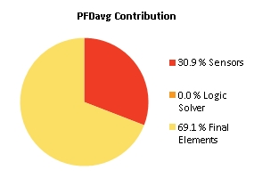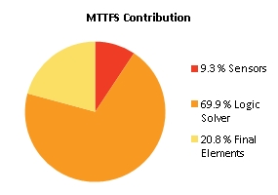
Note: The results shown in this SIL verification Summary are based on detailed calculations. All SIL verification assumptions including used reliability data are documented in the SIL verification Details report.

SIF-306 SIL1| Leakage detection 341XI687

Project Name |  | Hybrit Pilot Plant | SIF Tag | SIF-306
Unit / Process Area |  |  | SIF Name | SIL1| Leakage detection 341XI687
Mission Time |  | 15 years
Safety Instrumented Function Performance  Target SIL TBD  Target RRF 1  Achieved SIL 1  PFDavg 3.30E-02  SIL (PFDavg) 1  SIL (Arch. Constraints IEC 61511) 2  SIL (Systematic Capability) N/A  Achieved RRF 30.3  MTTFS (years) 26.21 |  |  | PFDavg MTTFS SIL Limit  AC CAP  Sensor Part 4.22E-03 1179.31 2 N/A  Logic Solver Part 3.11E-06 27.05 2 N/A  Final Element Part 2.89E-02 3025.17 2 N/A
Remarks | The SIF operates in Low demand mode.
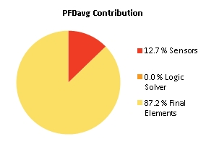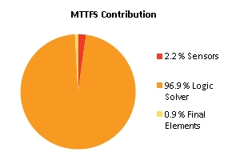
Note: The results shown in this SIL verification Summary are based on detailed calculations. All SIL verification assumptions including used reliability data are documented in the SIL verification Details report.

SIF-308 SIL1|421PI305 LL => close 421SV501

Project Name |  | Hybrit Pilot Plant | SIF Tag | SIF-308
Unit / Process Area |  |  | SIF Name | SIL1|421PI305 LL => close 421SV501
Mission Time |  | 15 years
Safety Instrumented Function Performance  Target SIL TBD  Target RRF 1  Achieved SIL 2  PFDavg 8.47E-03  SIL (PFDavg) 2  SIL (Arch. Constraints IEC 61511) 2  SIL (Systematic Capability) N/A  Achieved RRF 118.1  MTTFS (years) 19.09 |  |  | PFDavg MTTFS SIL Limit  AC CAP  Sensor Part 4.71E-04 95.6 2 N/A  Logic Solver Part 3.11E-06 27.05 2 N/A  Final Element Part 8.00E-03 202.18 2 N/A
Remarks | The SIF operates in Low demand mode.
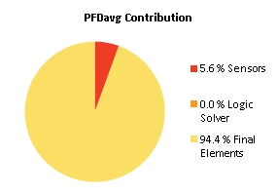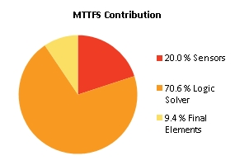
Note: The results shown in this SIL verification Summary are based on detailed calculations. All SIL verification assumptions including used reliability data are documented in the SIL verification Details report.

SIF-309 SIL2| 423PI301 LL => Stop Compressor (423PU001)

Project Name |  | Hybrit Pilot Plant | SIF Tag | SIF-309
Unit / Process Area |  |  | SIF Name | SIL2| 423PI301 LL => Stop Compressor (423PU001)
Mission Time |  | 15 years
Safety Instrumented Function Performance  Target SIL TBD  Target RRF 1  Achieved SIL 2  PFDavg 3.04E-04  SIL (PFDavg) 3  SIL (Arch. Constraints IEC 61511) 2  SIL (Systematic Capability) N/A  Achieved RRF 3287.3  MTTFS (years) 23.49 |  |  | PFDavg MTTFS SIL Limit  AC CAP  Sensor Part 1.36E-04 988.53 3 N/A  Logic Solver Part 3.11E-06 27.05 2 N/A  Final Element Part 1.66E-04 218.3 2 N/A
Remarks | The SIF operates in Low demand mode.
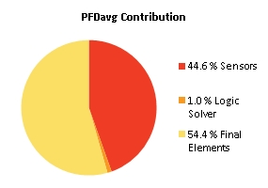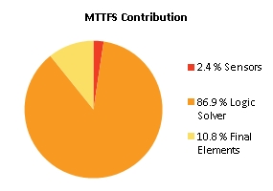
Note: The results shown in this SIL verification Summary are based on detailed calculations. All SIL verification assumptions including used reliability data are documented in the SIL verification Details report.

SIF-310 SIL2|421TI304 HH => Stop Compressor (423PU001)

Project Name |  | Hybrit Pilot Plant | SIF Tag | SIF-310
Unit / Process Area |  |  | SIF Name | SIL2|421TI304 HH => Stop Compressor (423PU001)
Mission Time |  | 15 years
Safety Instrumented Function Performance  Target SIL TBD  Target RRF 1  Achieved SIL 2  PFDavg 1.58E-03  SIL (PFDavg) 2  SIL (Arch. Constraints IEC 61511) 2  SIL (Systematic Capability) N/A  Achieved RRF 633.8  MTTFS (years) 21.54 |  |  | PFDavg MTTFS SIL Limit  AC CAP  Sensor Part 1.41E-03 205.17 2 N/A  Logic Solver Part 3.11E-06 27.05 2 N/A  Final Element Part 1.66E-04 218.3 2 N/A
Remarks | The SIF operates in Low demand mode.
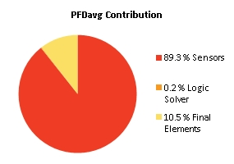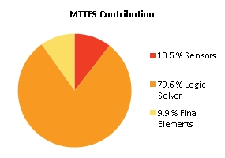
Note: The results shown in this SIL verification Summary are based on detailed calculations. All SIL verification assumptions including used reliability data are documented in the SIL verification Details report.

SIF-311 SIL1| 421PI301 > H2 => close 421SV503

Project Name |  | Hybrit Pilot Plant | SIF Tag | SIF-311
Unit / Process Area |  |  | SIF Name | SIL1| 421PI301 > H2 => close 421SV503
Mission Time |  | 15 years
Safety Instrumented Function Performance  Target SIL 2  Target RRF 100  Achieved SIL 2  PFDavg 8.78E-03  SIL (PFDavg) 2  SIL (Arch. Constraints IEC 61511) 2  SIL (Systematic Capability) N/A  Achieved RRF 113.8  MTTFS (years) 20.66 |  |  | PFDavg MTTFS SIL Limit  AC CAP  Sensor Part 7.89E-04 154.33 2 N/A  Logic Solver Part 3.11E-06 27.05 2 N/A  Final Element Part 8.00E-03 202.18 2 N/A
Remarks | The SIF operates in Low demand mode.
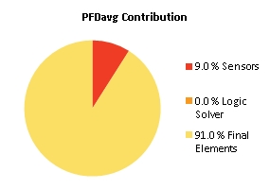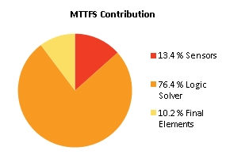
Note: The results shown in this SIL verification Summary are based on detailed calculations. All SIL verification assumptions including used reliability data are documented in the SIL verification Details report.

SIF-312 SIL2 | Tryck i koksgasledning SSAB (411PI302) L2 => Block & bleed to SSAB

Project Name |  | Hybrit Pilot Plant | SIF Tag | SIF-312
Unit / Process Area |  |  | SIF Name | SIL2 | Tryck i koksgasledning SSAB (411PI302) L2 => Block & bleed to SSAB
Mission Time |  | 15 years
Safety Instrumented Function Performance  Target SIL TBD  Target RRF 1  Achieved SIL 1  PFDavg 1.56E-02  SIL (PFDavg) 1  SIL (Arch. Constraints IEC 61511) 2  SIL (Systematic Capability) N/A  Achieved RRF 64.2  MTTFS (years) 20.86 |  |  | PFDavg MTTFS SIL Limit  AC CAP  Sensor Part 4.71E-04 95.6 2 N/A  Logic Solver Part 3.11E-06 27.05 2 N/A  Final Element Part 1.51E-02 2017.84 2 N/A
Remarks | The SIF operates in Low demand mode.
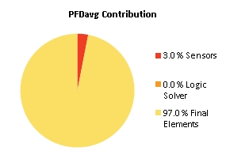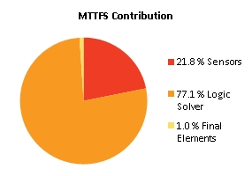
Note: The results shown in this SIL verification Summary are based on detailed calculations. All SIL verification assumptions including used reliability data are documented in the SIL verification Details report.

SIF-313 SIL2 | Tryck i koksgasledning SSAB (411PI302) H2 => Block & bleed to SSAB

Project Name |  | Hybrit Pilot Plant | SIF Tag | SIF-313
Unit / Process Area |  |  | SIF Name | SIL2 | Tryck i koksgasledning SSAB (411PI302) H2 => Block & bleed to SSAB
Mission Time |  | 15 years
Safety Instrumented Function Performance  Target SIL TBD  Target RRF 1  Achieved SIL 1  PFDavg 1.56E-02  SIL (PFDavg) 1  SIL (Arch. Constraints IEC 61511) 2  SIL (Systematic Capability) N/A  Achieved RRF 64.2  MTTFS (years) 20.86 |  |  | PFDavg MTTFS SIL Limit  AC CAP  Sensor Part 4.71E-04 95.6 2 N/A  Logic Solver Part 3.11E-06 27.05 2 N/A  Final Element Part 1.51E-02 2017.84 2 N/A
Remarks | The SIF operates in Low demand mode.

Note: The results shown in this SIL verification Summary are based on detailed calculations. All SIL verification assumptions including used reliability data are documented in the SIL verification Details report.

SIF-314 SIL1 | Tryck L2 i pipeline P1 <-> P3 (341PI687) => close 341SV686

Project Name |  | Hybrit Pilot Plant | SIF Tag | SIF-314
Unit / Process Area |  |  | SIF Name | SIL1 | Tryck L2 i pipeline P1 <-> P3 (341PI687) => close 341SV686
Mission Time |  | 15 years
Safety Instrumented Function Performance  Target SIL TBD  Target RRF 1  Achieved SIL 2  PFDavg 7.30E-03  SIL (PFDavg) 2  SIL (Arch. Constraints IEC 61511) 2  SIL (Systematic Capability) N/A  Achieved RRF 136.9  MTTFS (years) 19.09 |  |  | PFDavg MTTFS SIL Limit  AC CAP  Sensor Part 4.71E-04 95.6 2 N/A  Logic Solver Part 3.11E-06 27.05 2 N/A  Final Element Part 6.83E-03 201.94 2 N/A
Remarks | The SIF operates in Low demand mode.
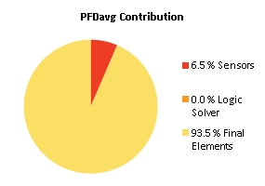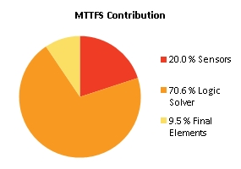
Note: The results shown in this SIL verification Summary are based on detailed calculations. All SIL verification assumptions including used reliability data are documented in the SIL verification Details report.

SIF-315 SIL1 | Motortemperatur lindning 1 (423PU001-TI1) => Stop Compressor (423PU001)

Project Name |  | Hybrit Pilot Plant | SIF Tag | SIF-315
Unit / Process Area |  |  | SIF Name | SIL1 | Motortemperatur lindning 1 (423PU001-TI1) => Stop Compressor (423PU001)
Mission Time |  | 15 years
Safety Instrumented Function Performance  Target SIL 1  Target RRF 10  Achieved SIL 2  PFDavg 7.83E-04  SIL (PFDavg) 3  SIL (Arch. Constraints IEC 61511) 2  SIL (Systematic Capability) N/A  Achieved RRF 1276.4  MTTFS (years) 19.94 |  |  | PFDavg MTTFS SIL Limit  AC CAP  Sensor Part 6.15E-04 116.43 2 N/A  Logic Solver Part 3.11E-06 27.05 2 N/A  Final Element Part 1.66E-04 218.3 2 N/A
Remarks | The SIF operates in Low demand mode.
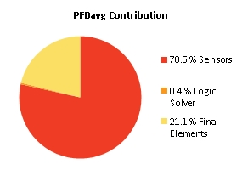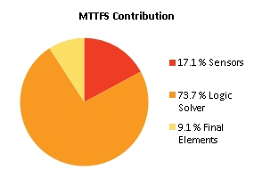
Note: The results shown in this SIL verification Summary are based on detailed calculations. All SIL verification assumptions including used reliability data are documented in the SIL verification Details report.

SIF-316 SIL1 | Motortemperatur lindning 2 (423PU001-TI2) => Stop Compressor (423PU001)

Project Name |  | Hybrit Pilot Plant | SIF Tag | SIF-316
Unit / Process Area |  |  | SIF Name | SIL1 | Motortemperatur lindning 2 (423PU001-TI2) => Stop Compressor (423PU001)
Mission Time |  | 15 years
Safety Instrumented Function Performance  Target SIL 1  Target RRF 10  Achieved SIL 2  PFDavg 7.83E-04  SIL (PFDavg) 3  SIL (Arch. Constraints IEC 61511) 2  SIL (Systematic Capability) N/A  Achieved RRF 1276.4  MTTFS (years) 19.94 |  |  | PFDavg MTTFS SIL Limit  AC CAP  Sensor Part 6.15E-04 116.43 2 N/A  Logic Solver Part 3.11E-06 27.05 2 N/A  Final Element Part 1.66E-04 218.3 2 N/A
Remarks | The SIF operates in Low demand mode.

Note: The results shown in this SIL verification Summary are based on detailed calculations. All SIL verification assumptions including used reliability data are documented in the SIL verification Details report.

SIF-317 SIL1 | Motortemperatur lindning 3 (423PU001-TI3) => Stop Compressor (423PU001)

Project Name |  | Hybrit Pilot Plant | SIF Tag | SIF-317
Unit / Process Area |  |  | SIF Name | SIL1 | Motortemperatur lindning 3 (423PU001-TI3) => Stop Compressor (423PU001)
Mission Time |  | 15 years
Safety Instrumented Function Performance  Target SIL 1  Target RRF 10  Achieved SIL 2  PFDavg 7.83E-04  SIL (PFDavg) 3  SIL (Arch. Constraints IEC 61511) 2  SIL (Systematic Capability) N/A  Achieved RRF 1276.4  MTTFS (years) 19.94 |  |  | PFDavg MTTFS SIL Limit  AC CAP  Sensor Part 6.15E-04 116.43 2 N/A  Logic Solver Part 3.11E-06 27.05 2 N/A  Final Element Part 1.66E-04 218.3 2 N/A
Remarks | The SIF operates in Low demand mode.

Note: The results shown in this SIL verification Summary are based on detailed calculations. All SIL verification assumptions including used reliability data are documented in the SIL verification Details report.

SIF-318 SIL1 | Lagertemperatur (423PU001-TI11) => Stop Compressor (423PU001)

Project Name |  | Hybrit Pilot Plant | SIF Tag | SIF-318
Unit / Process Area |  |  | SIF Name | SIL1 | Lagertemperatur (423PU001-TI11) => Stop Compressor (423PU001)
Mission Time |  | 15 years
Safety Instrumented Function Performance  Target SIL 1  Target RRF 10  Achieved SIL 2  PFDavg 1.13E-03  SIL (PFDavg) 2  SIL (Arch. Constraints IEC 61511) 2  SIL (Systematic Capability) N/A  Achieved RRF 883.8  MTTFS (years) 20.09 |  |  | PFDavg MTTFS SIL Limit  AC CAP  Sensor Part 9.63E-04 121.68 2 N/A  Logic Solver Part 3.11E-06 27.05 2 N/A  Final Element Part 1.66E-04 218.3 2 N/A
Remarks | The SIF operates in Low demand mode.
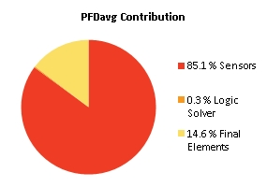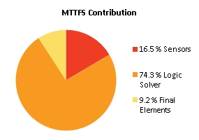
Note: The results shown in this SIL verification Summary are based on detailed calculations. All SIL verification assumptions including used reliability data are documented in the SIL verification Details report.

SIF-319 SIL1 | Lagertemperatur (423PU001-TI12) => Stop Compressor (423PU001)

Project Name |  | Hybrit Pilot Plant | SIF Tag | SIF-319
Unit / Process Area |  |  | SIF Name | SIL1 | Lagertemperatur (423PU001-TI12) => Stop Compressor (423PU001)
Mission Time |  | 15 years
Safety Instrumented Function Performance  Target SIL 1  Target RRF 10  Achieved SIL 2  PFDavg 7.83E-04  SIL (PFDavg) 3  SIL (Arch. Constraints IEC 61511) 2  SIL (Systematic Capability) N/A  Achieved RRF 1276.4  MTTFS (years) 19.94 |  |  | PFDavg MTTFS SIL Limit  AC CAP  Sensor Part 6.15E-04 116.43 2 N/A  Logic Solver Part 3.11E-06 27.05 2 N/A  Final Element Part 1.66E-04 218.3 2 N/A
Remarks | The SIF operates in Low demand mode.

Note: The results shown in this SIL verification Summary are based on detailed calculations. All SIL verification assumptions including used reliability data are documented in the SIL verification Details report.

SIF-320 SIL1 | H2-läckage i kulvert (LKAB) HH (KD184-900)

Project Name |  | Hybrit Pilot Plant | SIF Tag | SIF-320
Unit / Process Area |  |  | SIF Name | SIL1 | H2-läckage i kulvert (LKAB) HH (KD184-900)
Mission Time |  | 15 years
Safety Instrumented Function Performance  Target SIL 1  Target RRF 10  Achieved SIL 1  PFDavg 3.12E-02  SIL (PFDavg) 1  SIL (Arch. Constraints IEC 61511) 2  SIL (Systematic Capability) N/A  Achieved RRF 32  MTTFS (years) 13.73 |  |  | PFDavg MTTFS SIL Limit  AC CAP  Sensor Part 2.36E-03 28.14 2 N/A  Logic Solver Part 3.11E-06 27.05 2 N/A  Final Element Part 2.89E-02 3025.17 2 N/A
Remarks | The SIF operates in Low demand mode.
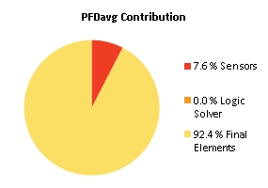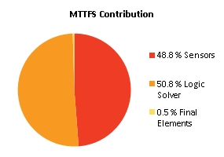
Note: The results shown in this SIL verification Summary are based on detailed calculations. All SIL verification assumptions including used reliability data are documented in the SIL verification Details report.

SIF-321 SIL1 | H2-läckage i kompressorstation HH (KD184-901)

Project Name |  | Hybrit Pilot Plant | SIF Tag | SIF-321
Unit / Process Area |  |  | SIF Name | SIL1 | H2-läckage i kompressorstation HH (KD184-901)
Mission Time |  | 15 years
Safety Instrumented Function Performance  Target SIL 1  Target RRF 10  Achieved SIL 1  PFDavg 1.84E-02  SIL (PFDavg) 1  SIL (Arch. Constraints IEC 61511) 2  SIL (Systematic Capability) N/A  Achieved RRF 54.3  MTTFS (years) 13.31 |  |  | PFDavg MTTFS SIL Limit  AC CAP  Sensor Part 2.36E-03 28.14 2 N/A  Logic Solver Part 3.11E-06 27.05 2 N/A  Final Element Part 1.61E-02 380.73 2 N/A
Remarks | The SIF operates in Low demand mode.
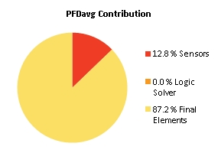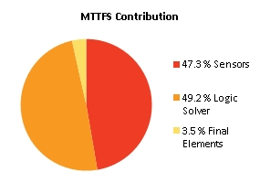
Note: The results shown in this SIL verification Summary are based on detailed calculations. All SIL verification assumptions including used reliability data are documented in the SIL verification Details report.

SIF-322 SIL1 | H2-läckage i tunnelmynning (tunnelport) HH (KD184-910)

Project Name |  | Hybrit Pilot Plant | SIF Tag | SIF-322
Unit / Process Area |  |  | SIF Name | SIL1 | H2-läckage i tunnelmynning (tunnelport) HH (KD184-910)
Mission Time |  | 15 years
Safety Instrumented Function Performance  Target SIL 1  Target RRF 10  Achieved SIL 1  PFDavg 1.89E-02  SIL (PFDavg) 1  SIL (Arch. Constraints IEC 61511) 2  SIL (Systematic Capability) N/A  Achieved RRF 52.9  MTTFS (years) 13.71 |  |  | PFDavg MTTFS SIL Limit  AC CAP  Sensor Part 2.36E-03 28.14 2 N/A  Logic Solver Part 3.11E-06 27.05 2 N/A  Final Element Part 1.66E-02 2206.69 2 N/A
Remarks | The SIF operates in Low demand mode.
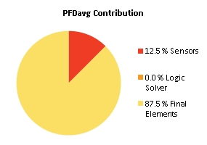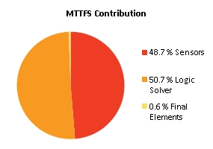
Note: The results shown in this SIL verification Summary are based on detailed calculations. All SIL verification assumptions including used reliability data are documented in the SIL verification Details report.

SIF-323 SIL1 | H2-läckage övre tunnel HH (KD184-911)

Project Name |  | Hybrit Pilot Plant | SIF Tag | SIF-323
Unit / Process Area |  |  | SIF Name | SIL1 | H2-läckage övre tunnel HH (KD184-911)
Mission Time |  | 15 years
Safety Instrumented Function Performance  Target SIL 1  Target RRF 10  Achieved SIL 1  PFDavg 1.89E-02  SIL (PFDavg) 1  SIL (Arch. Constraints IEC 61511) 2  SIL (Systematic Capability) N/A  Achieved RRF 52.9  MTTFS (years) 13.71 |  |  | PFDavg MTTFS SIL Limit  AC CAP  Sensor Part 2.36E-03 28.14 2 N/A  Logic Solver Part 3.11E-06 27.05 2 N/A  Final Element Part 1.66E-02 2206.69 2 N/A
Remarks | The SIF operates in Low demand mode.

Note: The results shown in this SIL verification Summary are based on detailed calculations. All SIL verification assumptions including used reliability data are documented in the SIL verification Details report.

SIF-324 SIL1 | H2-läckage ventilskåp HH (KD184-913)

Project Name |  | Hybrit Pilot Plant | SIF Tag | SIF-324
Unit / Process Area |  |  | SIF Name | SIL1 | H2-läckage ventilskåp HH (KD184-913)
Mission Time |  | 15 years
Safety Instrumented Function Performance  Target SIL 1  Target RRF 10  Achieved SIL 1  PFDavg 1.89E-02  SIL (PFDavg) 1  SIL (Arch. Constraints IEC 61511) 2  SIL (Systematic Capability) N/A  Achieved RRF 52.9  MTTFS (years) 13.71 |  |  | PFDavg MTTFS SIL Limit  AC CAP  Sensor Part 2.36E-03 28.14 2 N/A  Logic Solver Part 3.11E-06 27.05 2 N/A  Final Element Part 1.66E-02 2206.69 2 N/A
Remarks | The SIF operates in Low demand mode.

Note: The results shown in this SIL verification Summary are based on detailed calculations. All SIL verification assumptions including used reliability data are documented in the SIL verification Details report.

SIF-325 SIL2 | High pressure downstream 421RV503 => close 421SV502

Project Name |  | Hybrit Pilot Plant | SIF Tag | SIF-325
Unit / Process Area |  |  | SIF Name | SIL2 | High pressure downstream 421RV503 => close 421SV502
Mission Time |  | 15 years
Safety Instrumented Function Performance  Target SIL 2  Target RRF 100  Achieved SIL 2  PFDavg 3.10E-03  SIL (PFDavg) 2  SIL (Arch. Constraints IEC 61511) 2  SIL (Systematic Capability) N/A  Achieved RRF 322.8  MTTFS (years) 16.29 |  |  | PFDavg MTTFS SIL Limit  AC CAP  Sensor Part 6.57E-07 114155.33 2 N/A  Logic Solver Part 3.11E-06 27.05 2 N/A  Final Element Part 3.09E-03 40.97 2 N/A
Remarks | The SIF operates in Low demand mode.
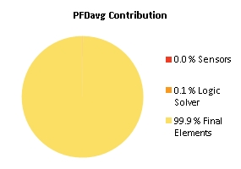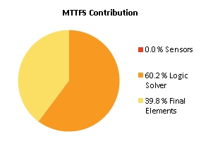
Note: The results shown in this SIL verification Summary are based on detailed calculations. All SIL verification assumptions including used reliability data are documented in the SIL verification Details report.

Abbreviations and Definitions

Abbreviations
MTTFS | Mean Time To Fail Spurious
MTTR | Mean Time To Restore
PFD | Probability of Failure on Demand
PFD_{AVG} | Average Probability of Failure on Demand
PFH | Probability of a Dangerous Failure per Hour
PTI | Proof Test Interval
RRF | Risk Reduction Factor
SIF | Safety Instrumented Function
SIL | Safety Integrity Level
SIS | Safety Instrumented System

Disclaimer, Assumptions, Equipment Data

Disclaimer
The user of the exSILentia® software is responsible for verification of all results obtained and their applicability to any particular situation. Calculations are performed per guidelines in applicable international standards. exida.com L.L.C. accepts no responsibility for the correctness of the regulations or standards on which the tool is based. In particular, exida.com L.L.C. accepts no liability for decisions based on the results of this software. The exida.com L.L.C. guarantee is restricted to the correction of errors or deficiencies within a reasonable period when such errors or deficiencies are brought to its attention in writing. exida.com L.L.C. accepts no responsibility for adjustments made by the user to this automatically generated report.

Assumptions SIL verification (SILver™)
A detailed list of assumptions upon which the exSILentia®’s SILver™ SIL verifications are based are documented in the user guide. The user guide is available as PDF as well as embedded within the exSILentia® software Help menu. The user is assumed to be knowledgeable with regard to the parameter selections and the, potential, impact on the operation of the respective Safety Instrumented Functions and Safety Instrumented System.
Conceptual design selection details are included in the SIL verification Details report.

